[ Please edit the following text / delete as appropriate. Feel free to paste into your school letterhead / add your logo and share with parents in any way. ]

June 2020
Dear parents,

Staying safe and being a good friend on apps, sites and games

Children and young people have spent much more time on devices than ever before during lockdown, so as we approach the summer holidays, here is some information about staying safe online and principles you can help us remind your children about.

There is a handy fridge flyer to help parents at toptipscorona.lgfl.net which you may want to print out and keep.

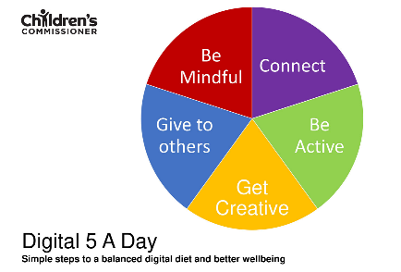
Please do not worry too much about screen time - think instead about screen quality, balance and mental health. The Children's Commissioner has provided a framework called the ‘Digital Five a Day’ with five things to think about each day to help put that into practice.

It is really important children get the opportunity to chat to friends, so it's great to hear that many of them have been chatting online during lockdown. We are sure that this will continue over the summer, so please help us reinforce some key messages about appropriate behaviour to keep everyone safe and happy.

[ edit as appropriate whether your school / local area or not ]
There have been reports of children being upset by bullying on chat apps, as well as some very distressing images being shared between friendship groups. This can usually be avoided if we remind children and young people to look out for their friends, not say anything that they wouldn't like to hear themselves, and always stop or stand up for others if someone gets upset.

Please remind your children never to share scary or rude images, even to complain about them. If they do see something that worries them or that might be wrong, all they need to do is ask for help from a trusted adult. They could talk to you or to us, or they may feel more comfortable talking anonymously to Childline. If you or they are concerned about an adult's behaviour towards a child online, report them to CEOP. And as a parent, you can also contact the NSPCC - O2 advice line on 0808 800 5002.

One more thing - this may sound like more relevant to older children, but the very youngest children need reminding not to get undressed or changed online. There’s a fun song to get this message across at undressed.lgfl.net (plus background information for you).

Thank you for your support - do let us know if you have any questions.

Yours,

