Teaching the ROMANS: Using LGfL Tools to Support Inclusion
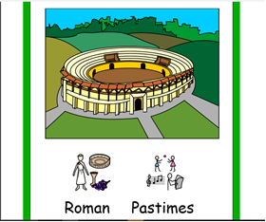
Widgit Pastimes Book
Primary Resource
For the primary resource for this topic, we have chosen The Roman Pastimes symbol based book created by Widgit Software, one of a set of 6 simple books about the Romans, each created for 5 different levels of reader.
We have chosen the Pastime book as it focusses on many diverse areas of Roman lives that learners may be motivated by e.g. leisure and gladiators. All of the Widgit books are very inclusive as many history reference books have very busy pages with text and graphics inter woven. These books contain simple sentences and pictures, with each covering a separate topic. Each book has relevant vocabulary cards at the back.
WHERE CAN I FIND THIS RESOURCE?
- Go to http://www.widgit.lgfl.net
- Click on Worksheets then History
- Go to Romans Books and download the books.
FURTHER RESOURCES | ABOUT THIS RESOURCE
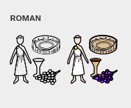  Widgit – Romans Books to download including Pastimes  Pastimes Activities | Through The Widgit site, you can also download many symbols relating the this topic to help make it accessible e.g. for flashcards or vocabulary lists.  WHERE CAN I FIND THIS RESOURCE?  - Go to http://www.widgit.lgfl.net  - Click on Worksheets then History  - Go to Romans Activities and download.  - For the symbols, just do a keyword search on the front page to view and download all 21 symbols relating to the Romans.
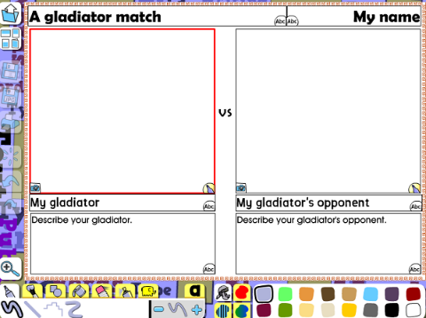  Busy things – Gladiator Match; Writing templates for Childhood | Within the multisensory and highly visual cross curricular resource, Busy Things, there are a range of structured writing frame activities on the Romans for children working at lower literacy levels. Roman Soldiers and battles. To fit in with the theme of Roman Pastimes, we suggest the Gladiators and Entertainment sheet, but any of these can be used to scaffold writing for learners.  WHERE CAN I FIND THIS RESOURCE?  - Go to http://www.busythings.lgfl.net  - Click on a Year group and then History or go through the curriculum browser.
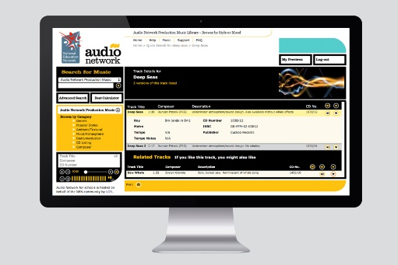Audio Networks – March Imperial (physical) ; Gladiators (Sensory) | Audio Network includes a vast range of professionally recorded music. For this topic, we suggest downloading the Gladiators music and March Imperial. These tracks can be used to immerse learners in the topic, for musical reference, for physical marching activities (to support cross curricular links and PE) or as a sound track for own video and animation.  WHERE CAN I FIND THIS RESOURCE?  - Go to http://www.audio.lgfl.net  - Do a keyword search and then listen to and download the track as an mp3 or wav file.
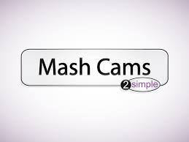  2Simple – Mash cams | This is just for schools who subscribe to Purple Mash.  Using this resource, you can use a mask. This would enable children to show what they have learnt about different Roman characters or this by role playing this person and demonstrating their knowledge verbally rather than in written form.  WHERE CAN I FIND THIS RESOURCE?  - Go to http://www.purplemash.lgfl.net
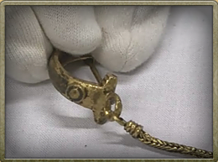  The Romans in London – Roman Dress | The Romans In London resource is extremely rich in multimedia and excellent resources. Particularly motivating and visual resources which may appeal to learners with SEND include the top cards sets based on gladiators. The cross curricular top cards may appeal to learners with collecting habits, includes opportunities for competition and turn taking, enables learners to read for information in a motivating way and includes many maths activity opportunities. Multimedia including images and videos of Roman everyday items and dress also makes other areas of Roman life accessible and enables historical references. Viewing images and videos of Roman dress would be a great springboard for an engaging, practical activity in your classroom as young people could dress in Roman outfits (i.e. sheets and towels!).Young people can see how Romans dressed using these resources before dressing up themselves and perhaps doing Roman dress labelling activities from Busy Things.  WHERE CAN I FIND THIS RESOURCE?  - Go to http://www.romans.lgfl.net  - Click Menu, then Resource Bank  - Click gladiators for the top cards and browse for the appropriate categories for multimedia examples.
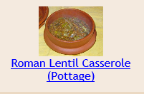  E2BN – Recipes – Cook it | This E2BN resource shows Roman recipes to help you really engage learners with the smells and tastes of Roman life through multisensory teaching. Images of Roman food and Roman cooking and eating utensils (via romans.lgfl.net) can be used as starters before making Roman food which would have many cross curricular links including DT and literacy.  WHERE CAN I FIND THIS RESOURCE?  Go to http://cookit.e2bn.org/historycookbook/index-30-romano-british.html
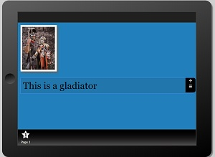App Maker | Learners can use the LGfL Appmaker tool with a database of Roman images from the Romans resources already configured to use. This will enable learners to demonstrate their learning in a motivating and engaging way and final Roman apps can easily be added to websites and sent to parents to share their work.  WHERE CAN I FIND THIS RESOURCE?  Go to http://www.appmaker.lgfl.net .
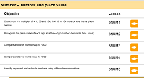Multi Maths – Roman Numerals | The Multemaths Roman Numerals activity can be used with pupils to recognise how number was marked in Roman times and to develop their maths skills. There are also opportunities within this activity to link to the coding curriculum in ICT.  WHERE CAN I FIND THIS RESOURCE?  - Go to multemaths.lgfl.net  - Go to year 5 and Number and Place Value  - The Roman numeral activities will be at the bottom of the page.

