What commercial content will LGfL consider?

We are always on the lookout for exciting new content. However, content providers should note that the high quality of a resource does not guarantee a favourable decision by the LGfL Editorial Board. New additions must complement the portfolio, show clear National Curriculum relevance, and meet the criteria stated in this document.

Please familiarise yourself with the contents of this document before contacting LGfL and before completing the form on page 3.

Further key points to note:

- LGfL’s intention and practice is to purchase licences in perpetuity. LGfL does not generally fund subscription based resources.

- Content must be online and hosted on LGfL servers.

- It must provide a solution to an identified gap in current LGfL content provision.

- It must be of high quality (pedagogically and technically).

- In licensing resources for all LGfL connected schools, LGfL seeks a significant discount which often totals 90 per cent or more when compared to the nominal total revenue generated by equivalent sales to all maintained schools (there are approximately 2,500 LGfL schools).

- Learning resources should be Shibboleth-compliant and device-agnostic (see the final page of this document for more detailed specifications concerning these and other technical aspects).

- Video clips integrated into content shall be hosted using LGfL's school-safe video-hosting platform VideoCentral HD.

- LGfL is not a member of the UK access Management Federation.

- Content hosted on LGfL servers will be subject to the LGfL Access Management Federation.

Content proposal flow chart

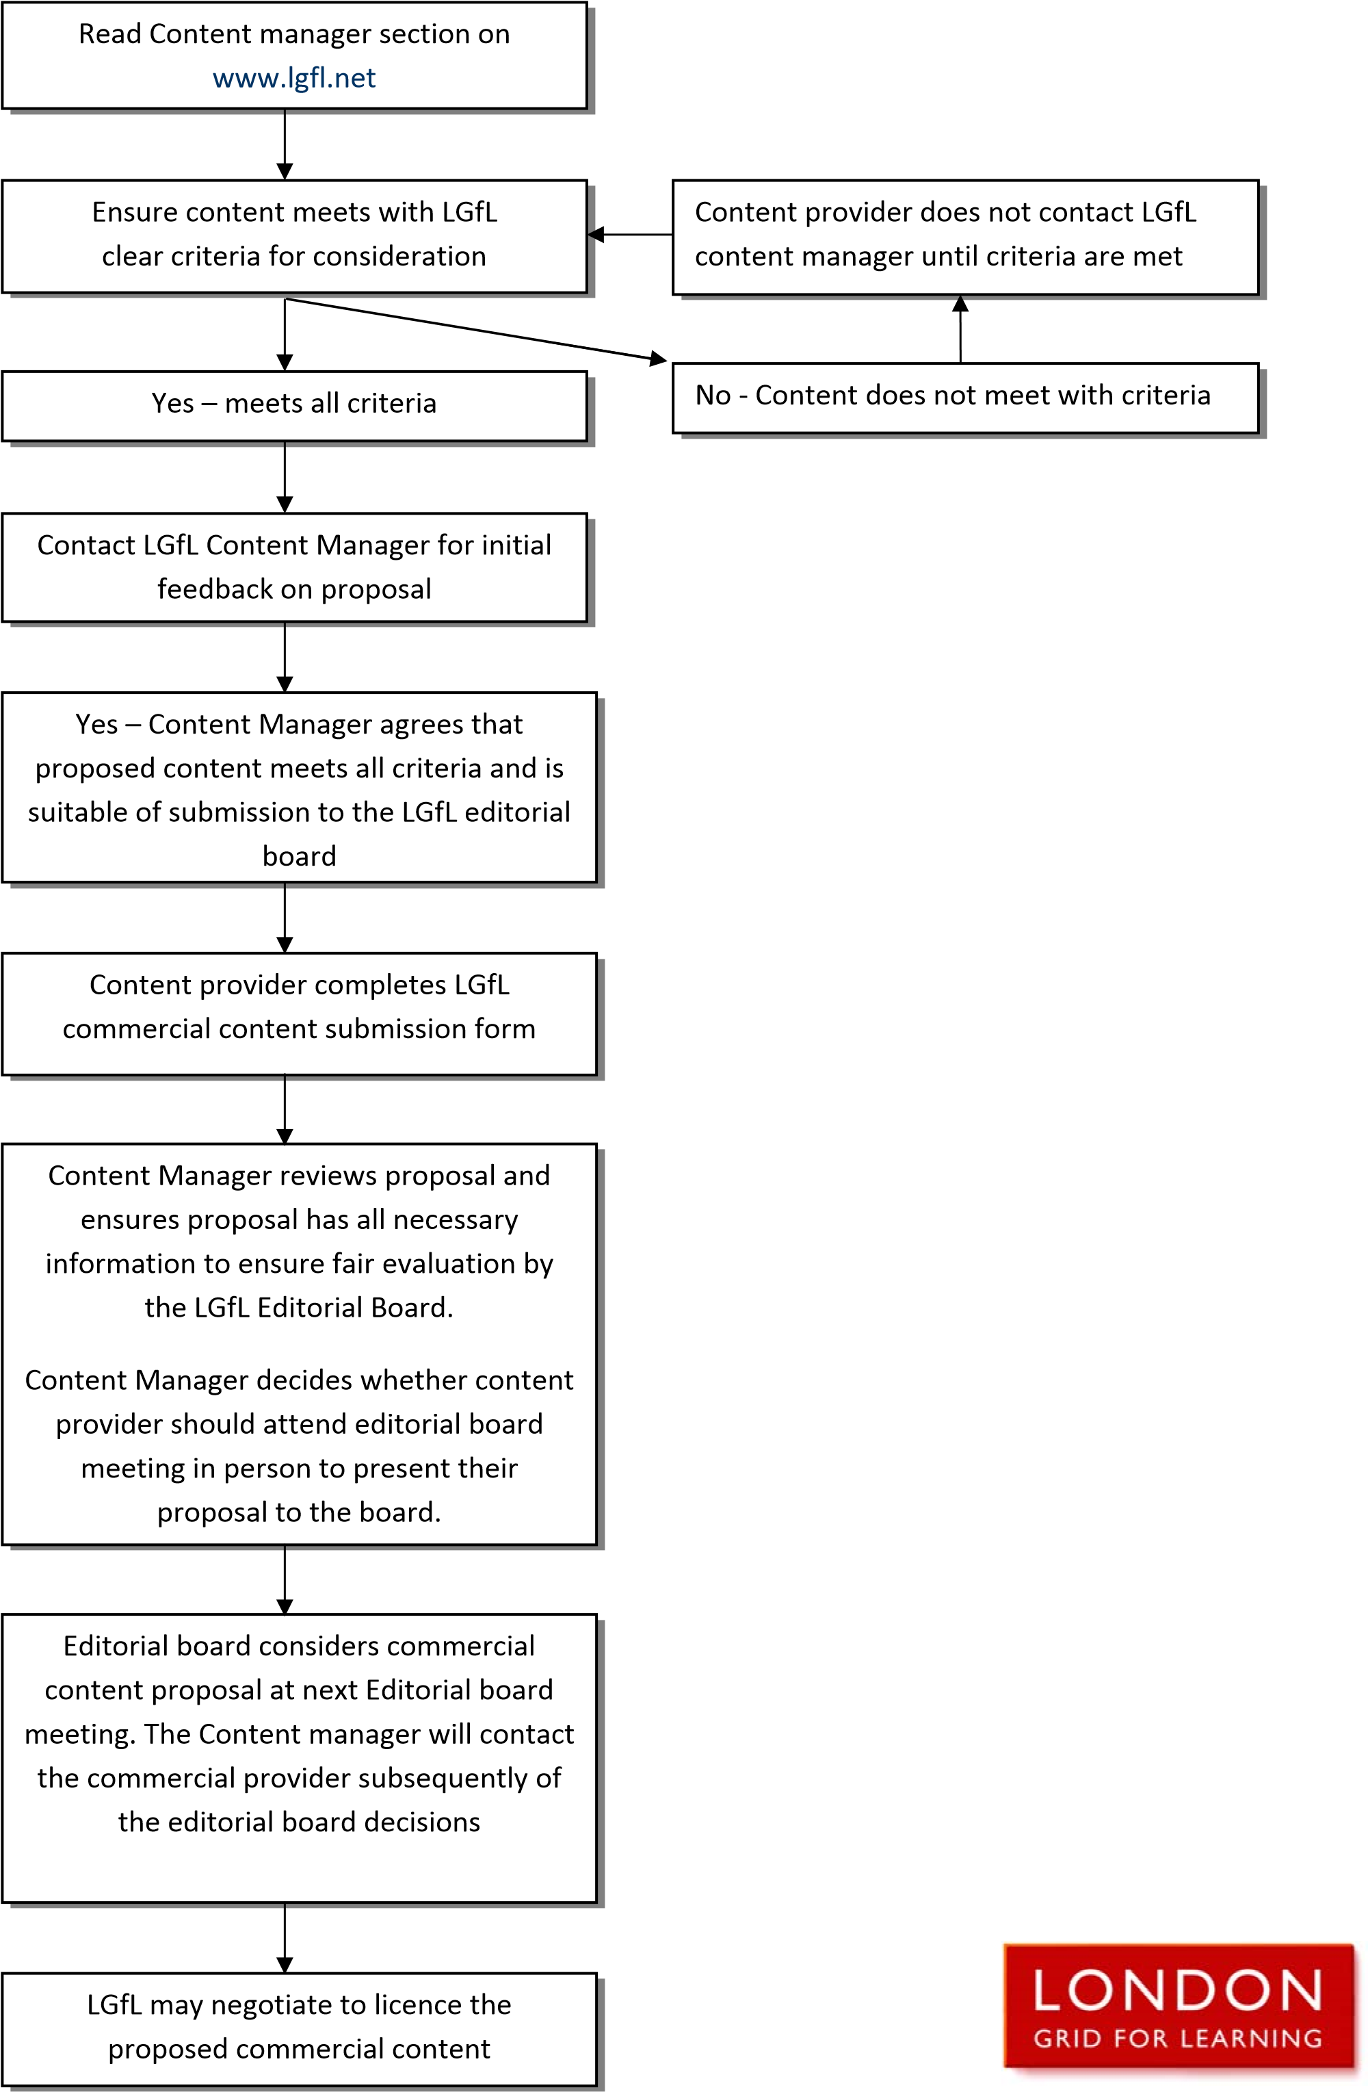

Product name:

General:
Company and contact details:
Arrangements for access by LGfL Editorial Board members:
How often is the product updated or new material added, and how?
What is the standard pricing for schools?
What special pricing offer is being offered to LGfL?
What ICT resources could it be used with?
Is it truly interactive?
How does it utilise broadband potential?
Is it Shibboleth complaint?
Rationale for this product:
Subject covered:
Key Stage(s) covered:
How is it structured pedagogically?
Does it address concepts in new ways?
Does it address a range of learning styles?
Does the student get constructive feedback?
Is there a teacher dashboard for monitoring progress within the resource itself?
How will it ‘raise standards’?
What would you estimate to be the typical number of hours a teacher might use it with a class/ yeargroup per year?
Promotion:
Describe how you will be able to support in marketing and driving take-up and adoption of the resources if they became part of the LGfL learning-resource portfolio:
What is the development timescale?
Describe the timescale of the resource development up to completion with relevant milestones:

Please ensure that the resource is compliant with the requirements of the specification in Appendix 1

Appendix 1
LGfL learning-resource specification (2016)

The LGfL online learning-resource portfolio seeks to offer London teachers an innovative range of online technologies to enhance learning and help teachers be more effective in their everyday roles.

To ensure that teachers are able to maximize the potential of the latest online technologies, the following specification is a contractual requirement for any proposal submitted to the LGfL Editorial Board.

TECHNICAL SPECIFICATIONS:

- Functional on PC and Mac; supported browsers will include as a minimum IE 9+, Chrome 35.0+, Safari 7.0+ and Firefox 30+.

- Minimum support for mobile devices will be full functionality on tablet-sized devices using iOS 7+ and Android 4.0+, and full visibility on mobiles.

ADDITIONAL REQUIREMENTS:

- The online resource shall be device-agnostic: fully functional and visible on the most common devices, including android and apple tablets, which shall normally entail a responsive web design. This shall in general enable visibility and functionality on Apple and Android mobile phones (albeit functionality and database interaction may become impractical at times due to device size). Any deviation to the above shall be agreed with the LGfL Content Manager in advance of signing the contract.

- Resources should be written using standard HTML5, CSS and any appropriate complementary technologies (e.g. JavaScript, jQuery, Bootstrap). Any dependencies on CMS/web-building/blogging platforms such as WordPress, or server-side scripting languages such as PHP, must be discussed with the LGfL Content Manager in advance of signing the contract.

- Adobe Flash must not feature in the resource.

- Any resource employing personalisation, progress-tracking or other user-specific features must harness LGfL’s existing USO authentication technology – preferably through the use of Shibboleth.

- Content must be self-contained and feature only relative links, so that it can be hosted without issue at an http:// or https:// URL, and/or within a sub-directory of an existing website.

- Resources shall not require that data is saved to the web server’s local filesystem, as LGfL employs a load-balanced cluster of servers, which means that anything saved to one node will not be available from the others. Data storage should instead use databases (MSSQL or MySQL) or the USO myDrive cloud-storage system.

Please contact the LGfL Content Manager if further clarification is required.

B. Usher
©LGfL February 2016
bob.usher@lgfl.net

contentmanager.lgfl.net

