All about me (and staying healthy)
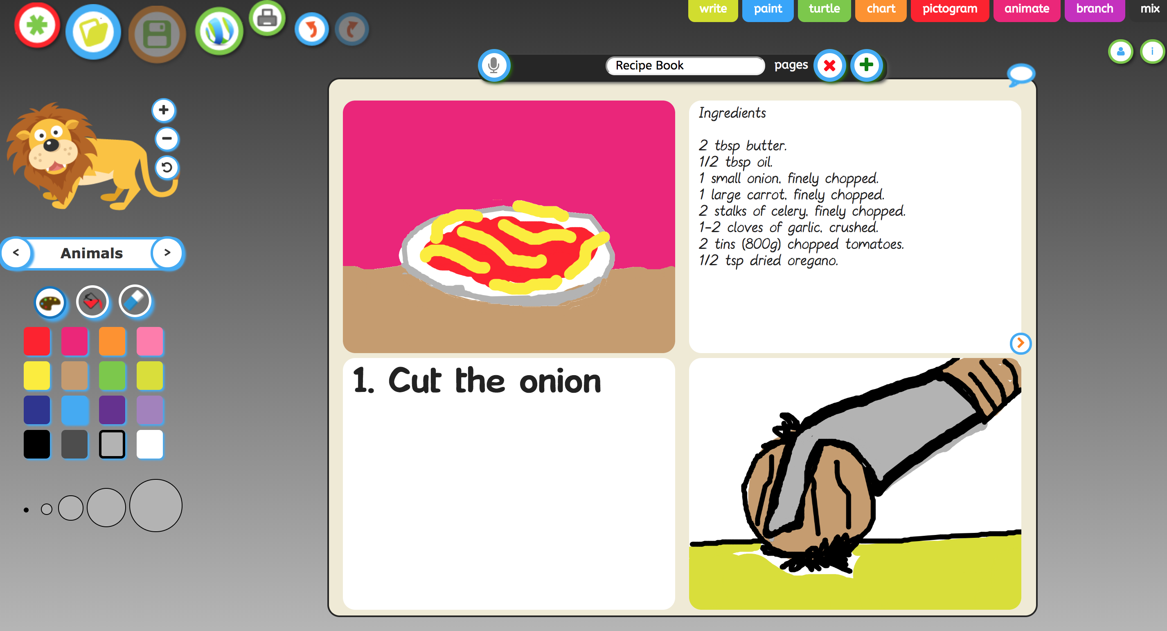 | Use JIT infant tool kit “Mix” tab to create Healthy recipe book, you could use photos or get the children to draw in pictures.  Once made get the children to create a voice over by using the microphone feature (You must be using a device which has either an in-built microphone or a microphone attached.
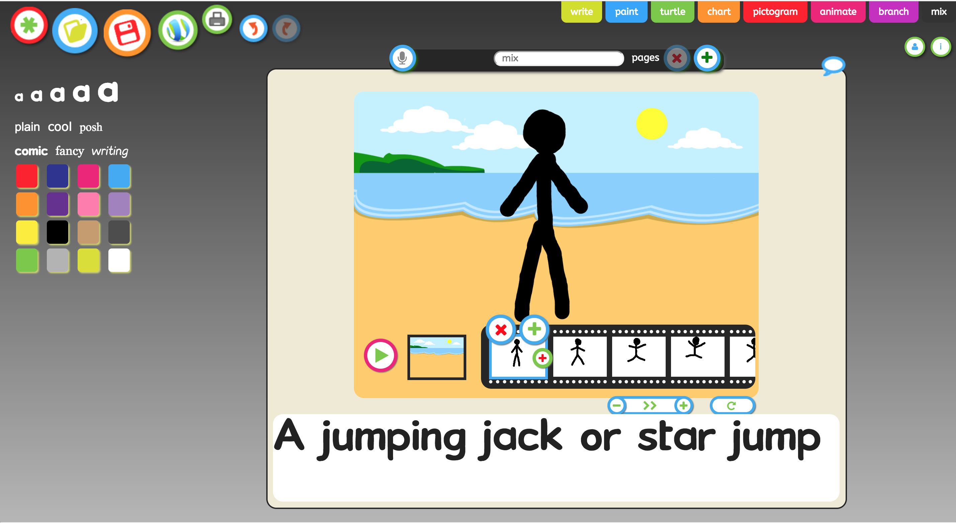 | Use JIT infant tool kit “Animate’ and ‘Mix” tab to create an excise book, you could use photos or get the children to draw in pictures.  Once made get the children to create a voice over by using the microphone feature (You must be using a device which has either an in-built microphone or a microphone attached.
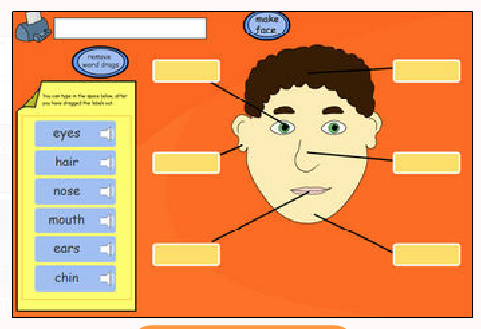 | Explore labelling body parts within this interactive digital activity within I-Board Player.  A labelling activity with a difference. Click the buttons on the face to choose hair style, eyes and lips for the face. Pupils can represent themselves or simply "design" a face. Use the colour bar to select a skin tone (note: on different monitors and through different projectors, tones will vary). Pupils can be asked to drag labels or type their own depending on ability and lesson objectives.
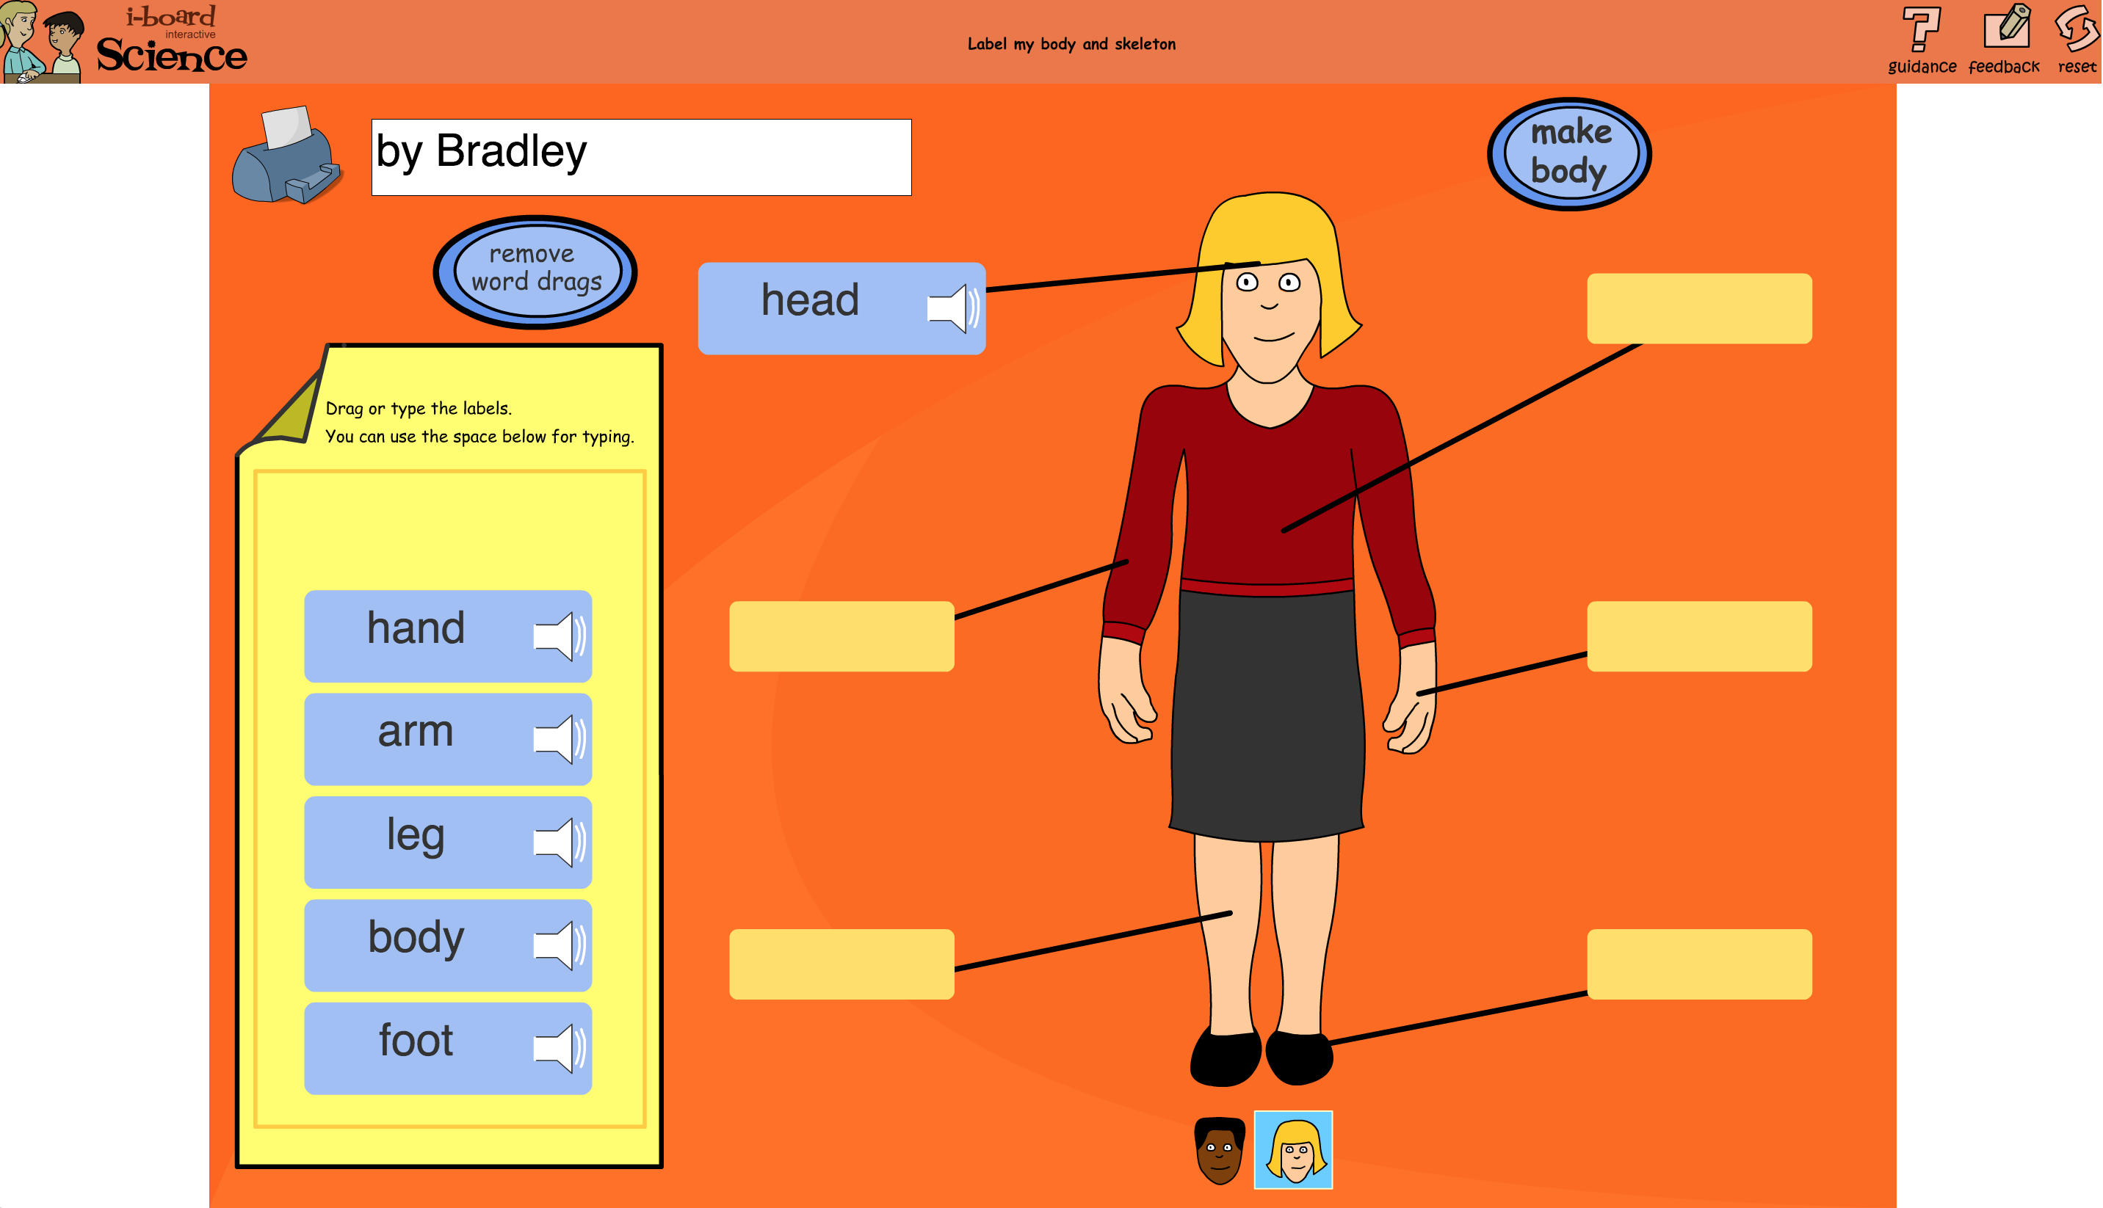 | Explore labelling body parts within this interactive digital activity within I-Board Player.  Another labelling activity with a twist. Construct the skeleton and drag the fader bar to check the bones are in the right place. Choose a boy's or girl's body using the buttons below the skeleton. Pupils can be asked to drag labels or type their own depending on ability and lesson objectives. Some pupils might like to label with the names of the bones rather than the body parts.
 | Use the widget Activities within the Widget resource, select the science tab and download the ‘'Eat More Fruit and Vegetables'’ books and activities. Within this resource you will find a range of information books in both symbol and text formats, Large Flashcards, Key vocabulary/symbol word cards and sequencing flashcards to help explore healthy eating.
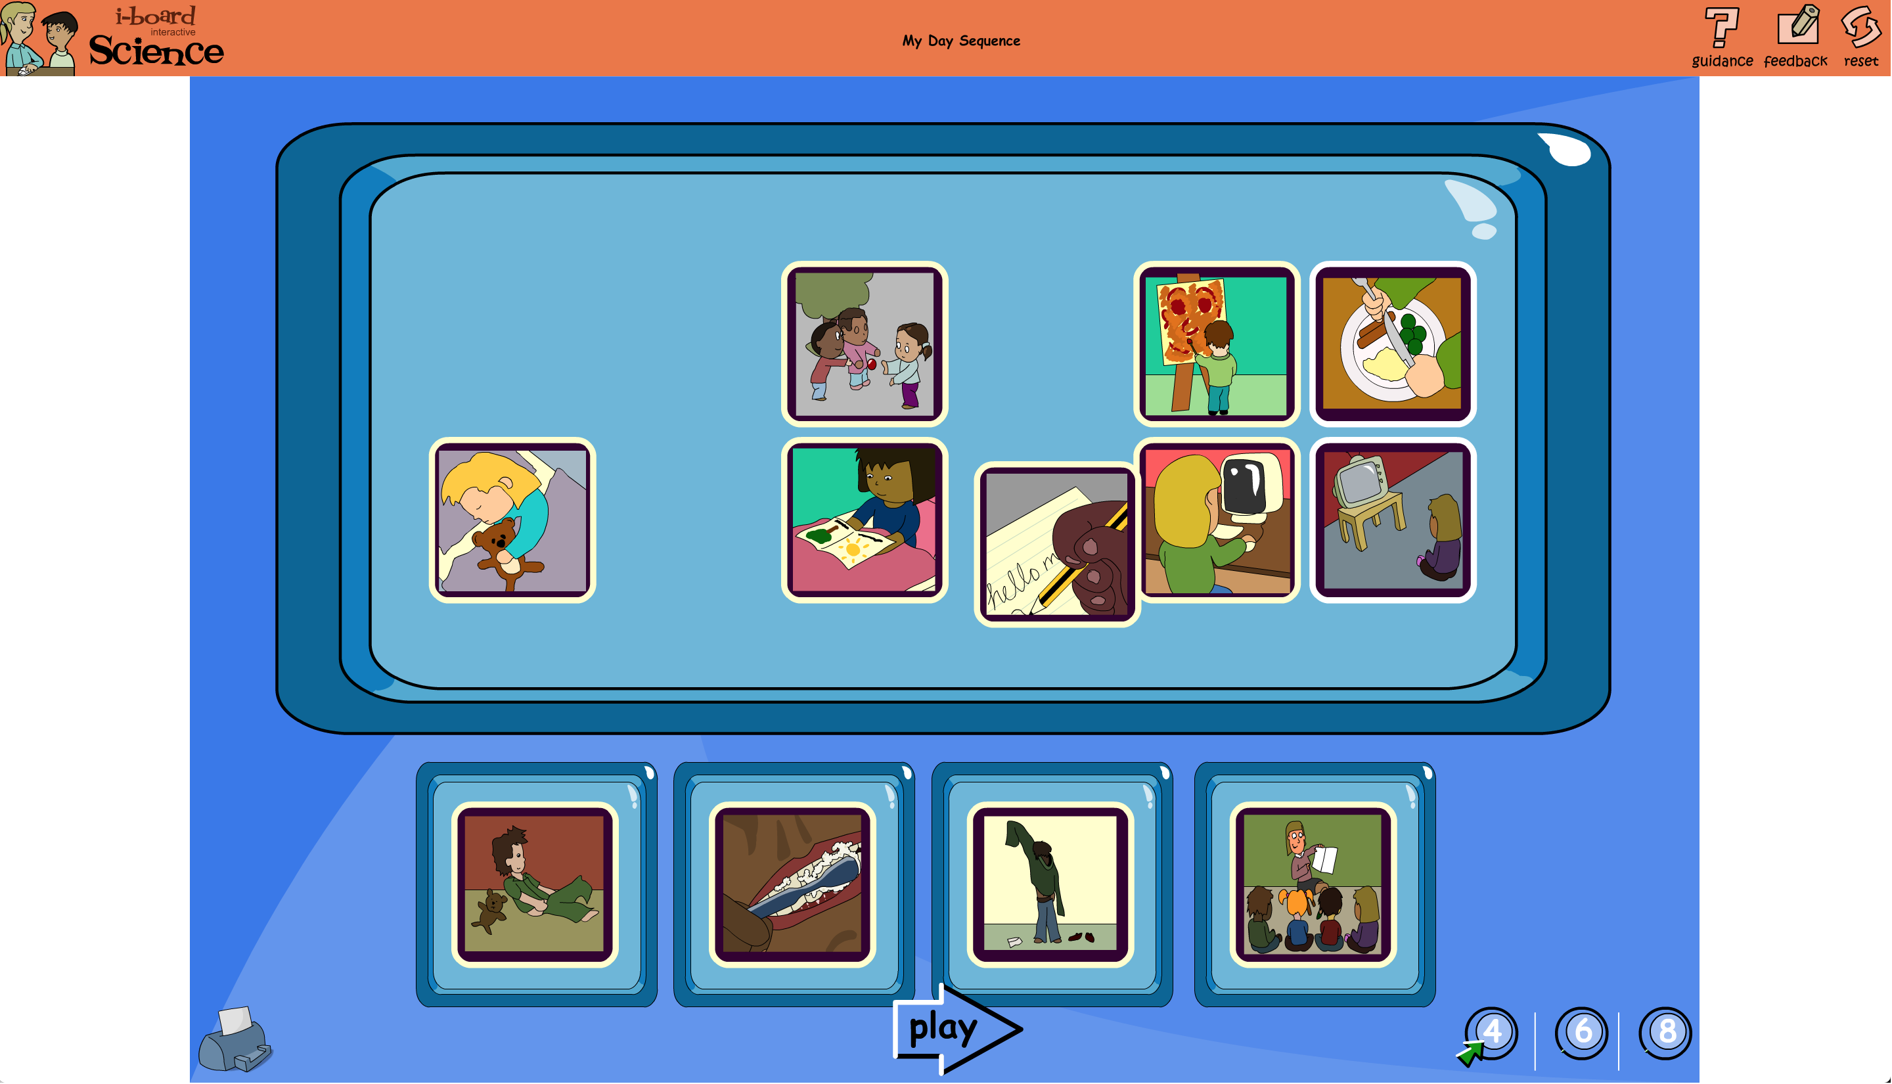 | Explore sequencing within this interactive digital activity within I-Board ‘My Day Sequence”  Click each picture and hear the activity. Choose between 4, 6 and 8 activities for your day and put them in the right order. Listen to the playback to check your choices.
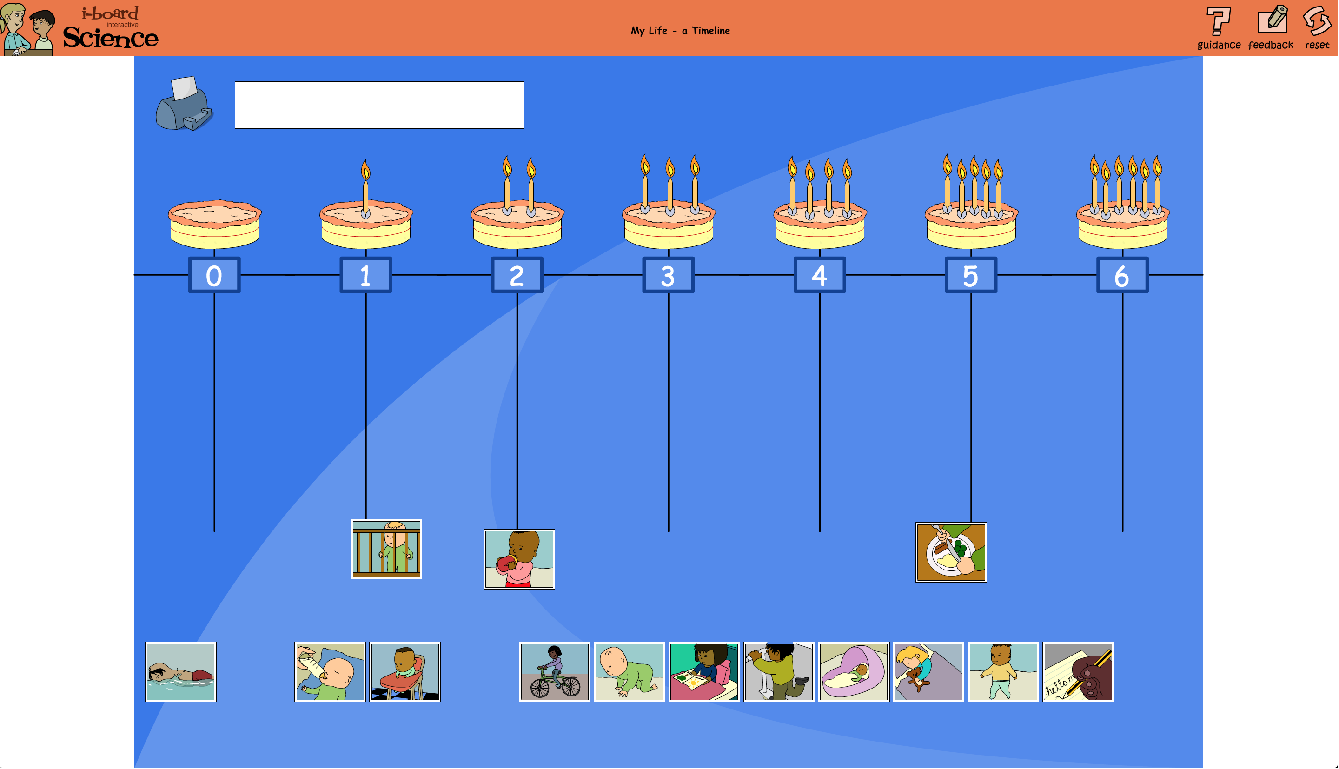 | Explore the growing and the sequence of learning with this speaking online interactive timeline within I-Board Player.  How old do pupils think they were when they learnt key skills? Which picture best represents each stage?
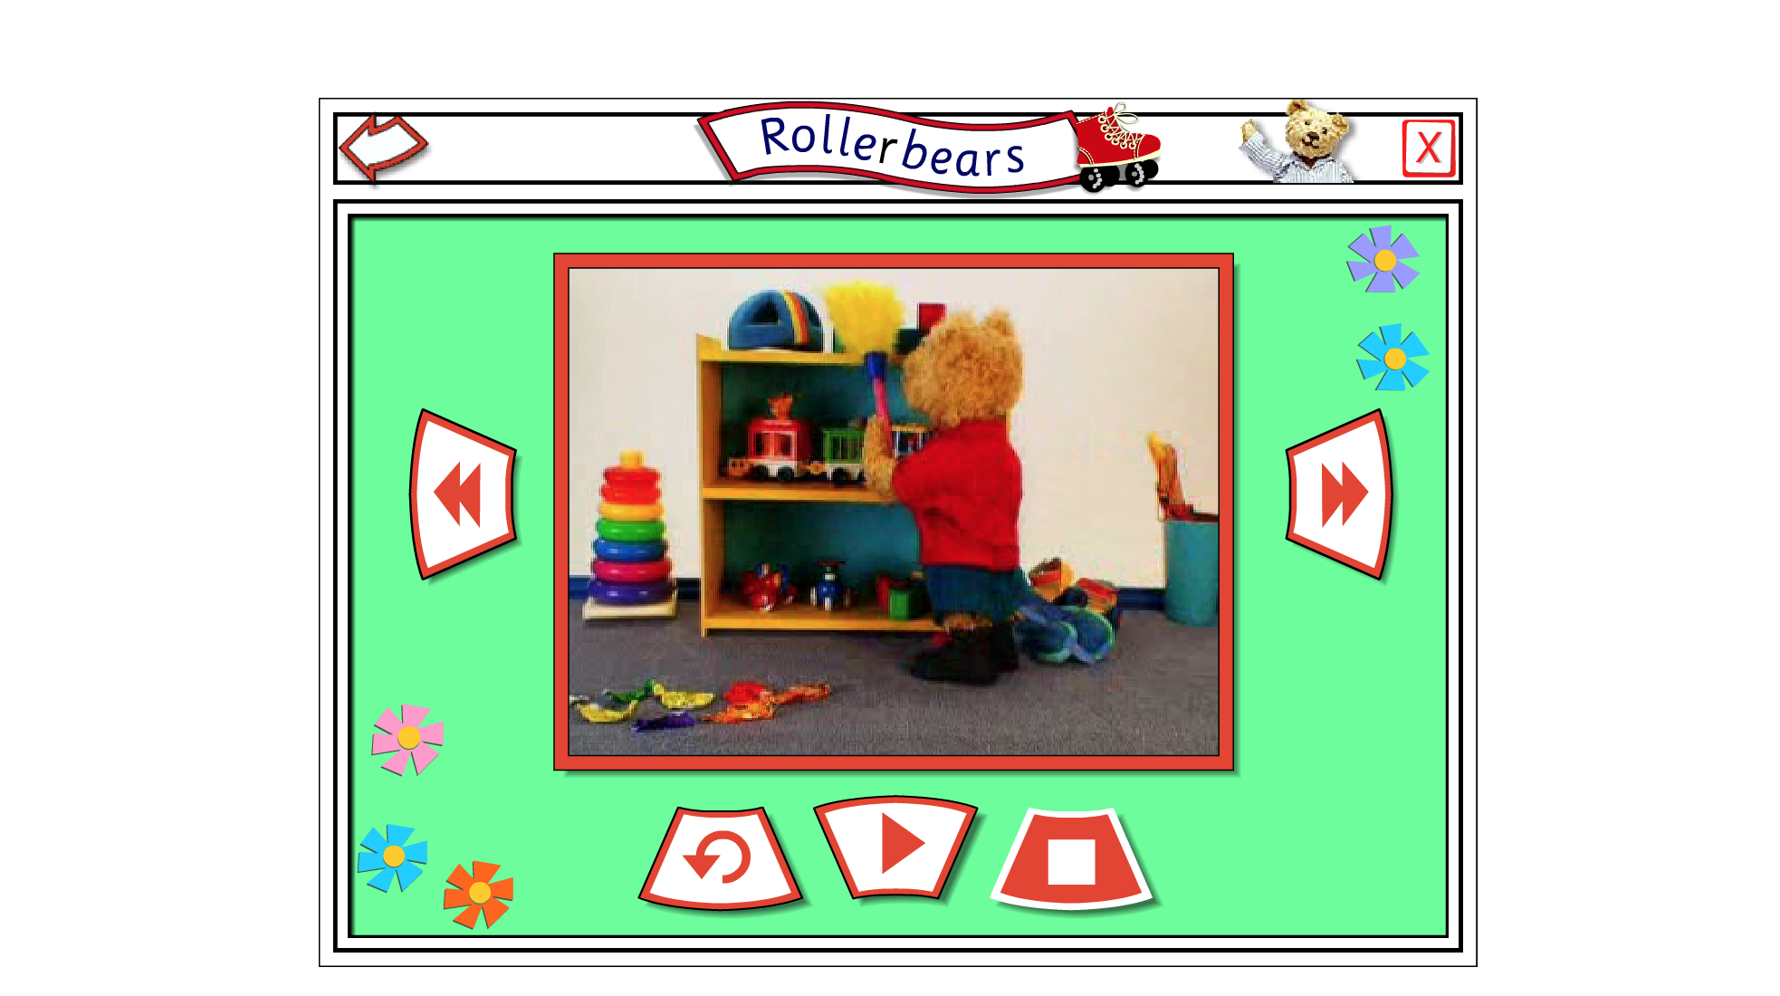 | Follow PB Bear as he gos on a Roller skating adventure and complete the tasks via our PB Bear resource.  The story can be told via a video or a talking book can be used in two ways: you can watch straight through or click on one of the ‘hotspots’. This will stop the video and an activity, coming naturally out of the story, will appear over the video.
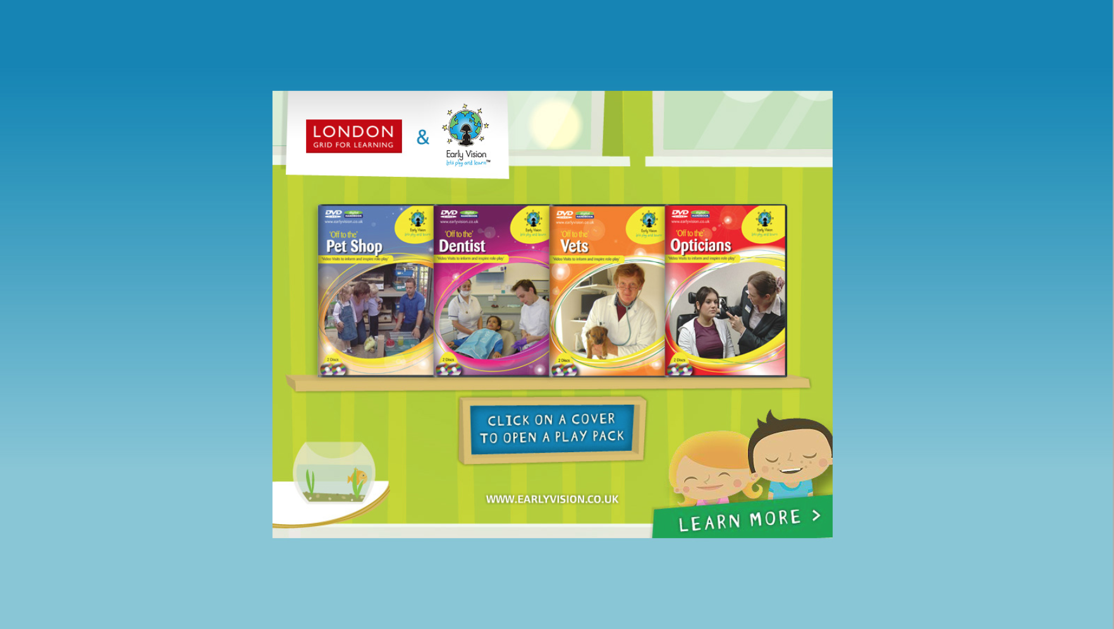 | Within the Early vision resource, you have 2 digital books relating to keeping healthy, the daywork of a dentist and the day in the life of an optician. Early Vision videos feature real life scenarios where children get to visit and experience different areas of everyday life.  Within the Early Vision books you will also find digital handbooks with detailed planning to cover all areas.
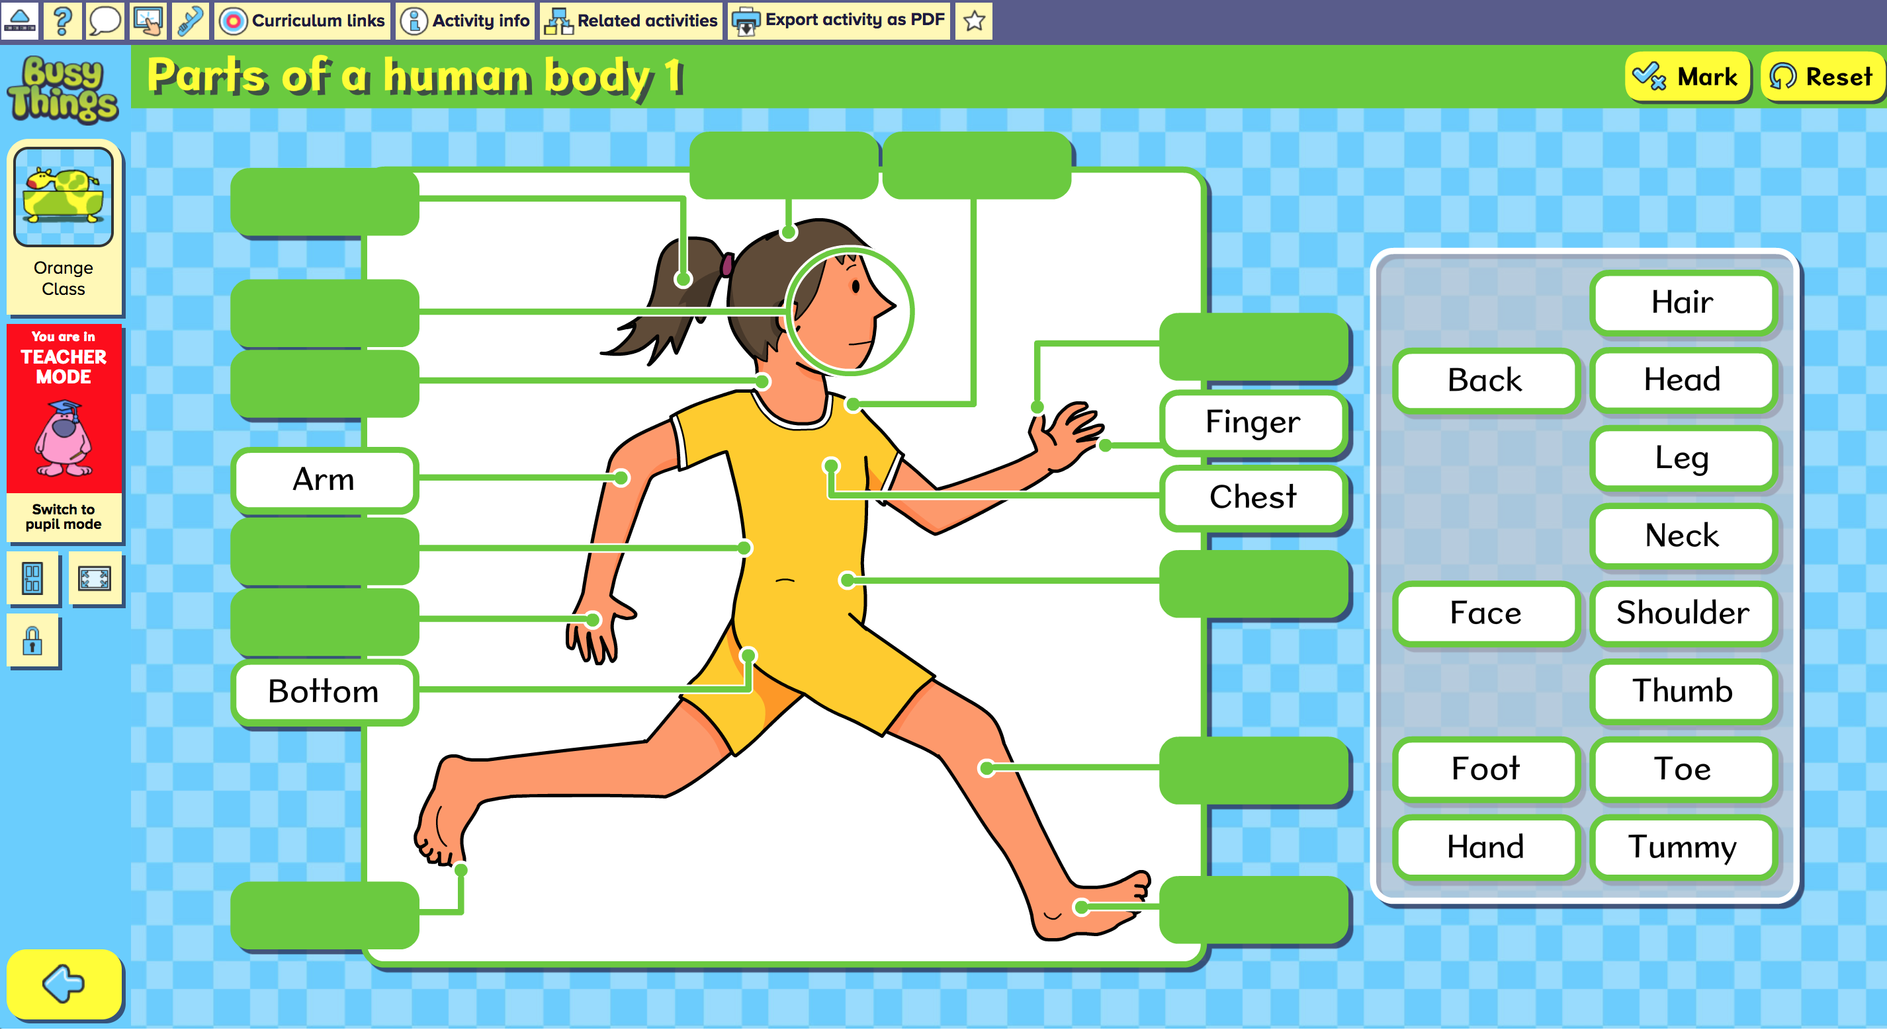 | Explore parts of the human body with this interactive digital labeling tool within ‘Busythings’ ‘Parts of the Body'  Learn and demonstrate knowledge of human anatomy with this labelling activity.
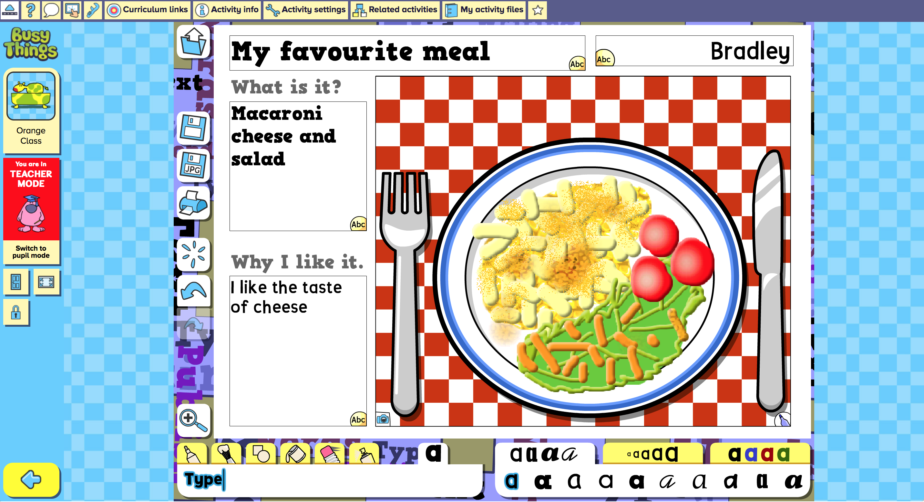 | Talk about you favourite foods with this interactive digital creation tool within ‘Busythings’ ‘My Favourite meal'  Draw and write about your favourite meal. It can be breakfast, dinner or tea. Discussion points: Is it healthy? Do you have something from each food group? What do you like to drink with it?
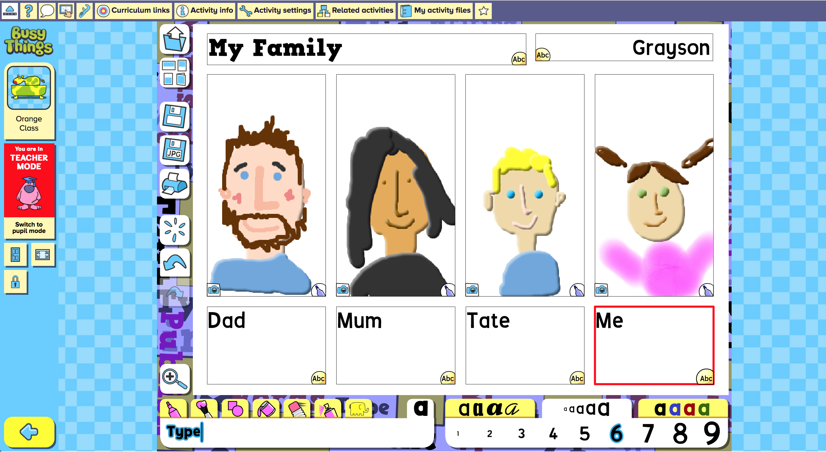 | Explore writing for a purpose and using digital tools with this My Family digital activity within BusyThings.  Draw pictures of people in your family and write about them.

