Animals
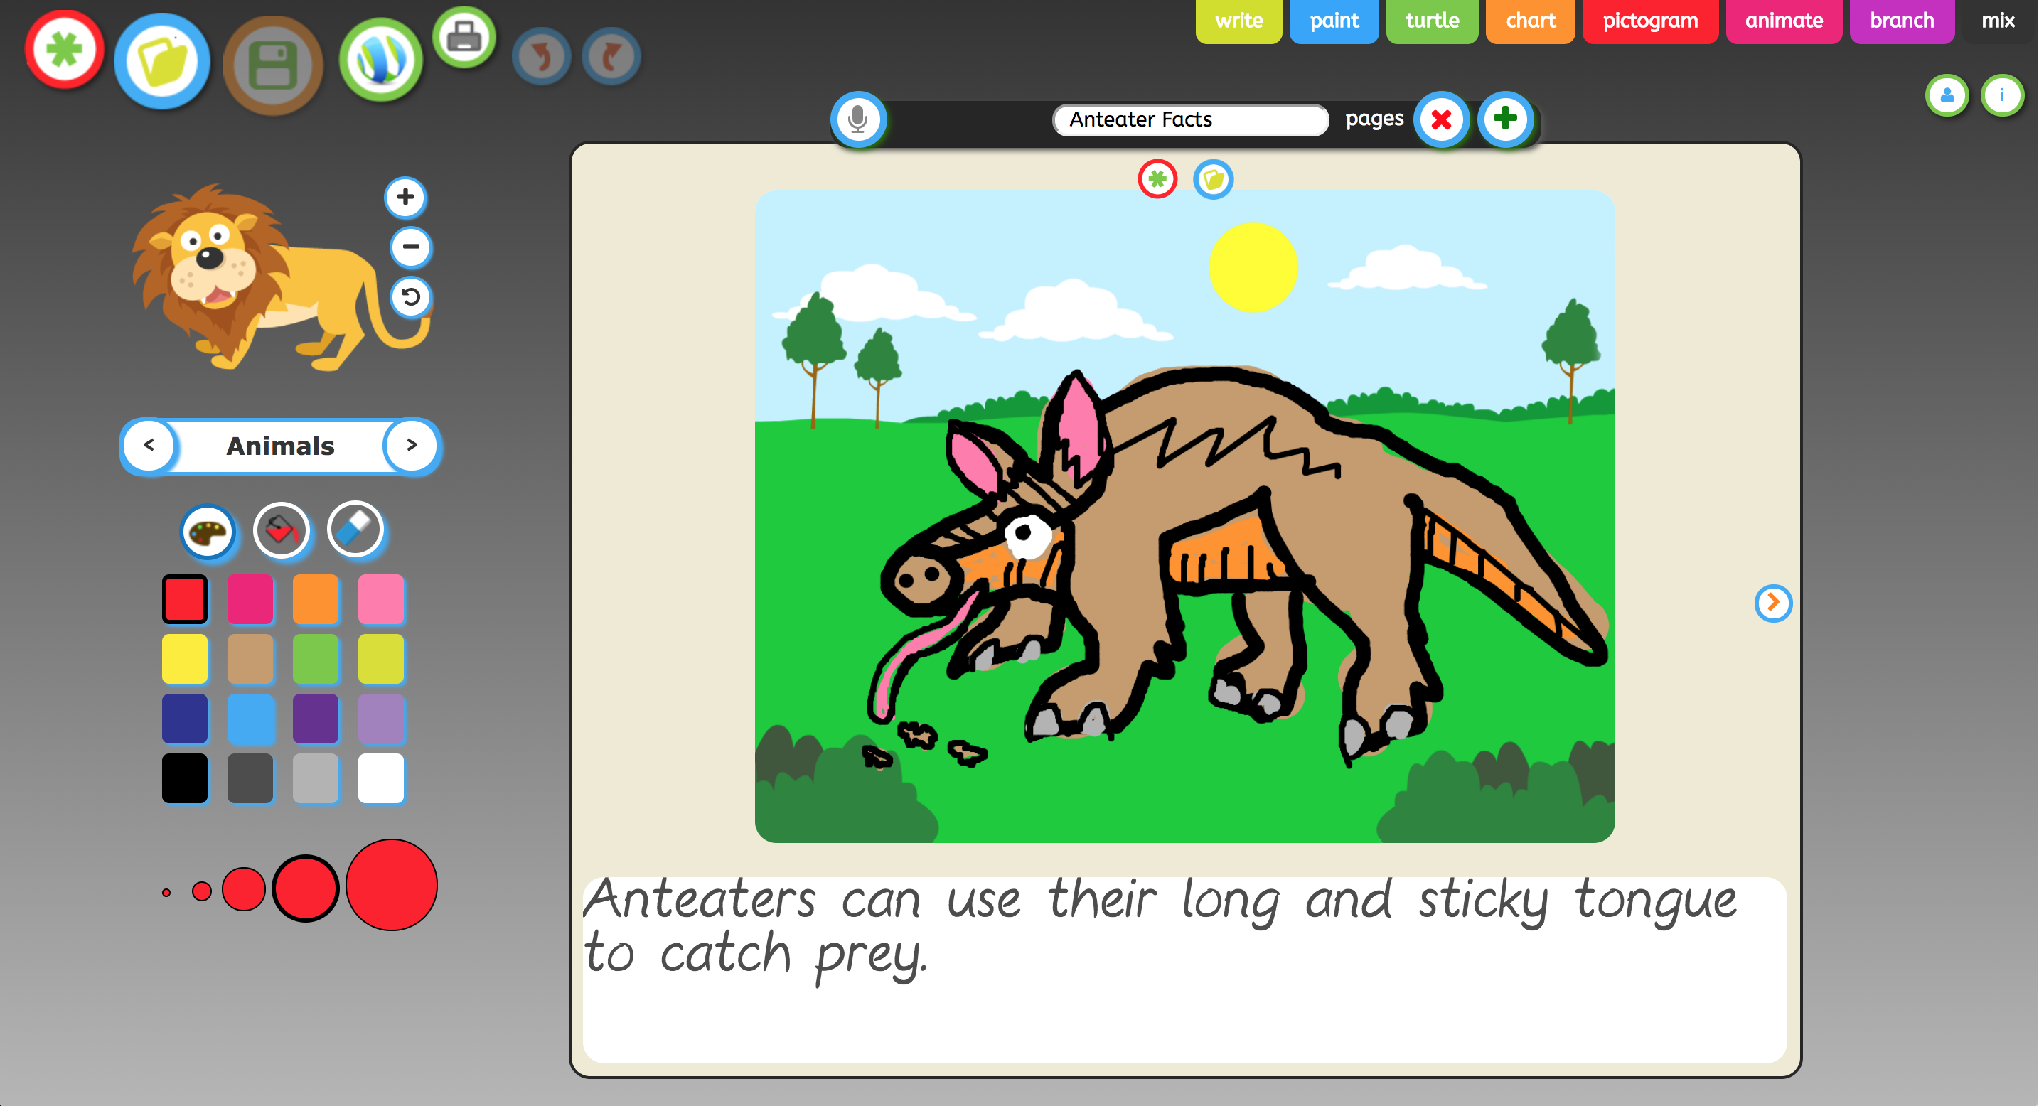 | Use JIT infant tool kit “Paint, Animate and Mix” tabs to create a simple fact book about a self selected animal by creating a series of digital drawings and for older children text  Once made get the children to create a voice over by using the microphone feature (You must be using a device which has either an in-built microphone or a microphone attached.
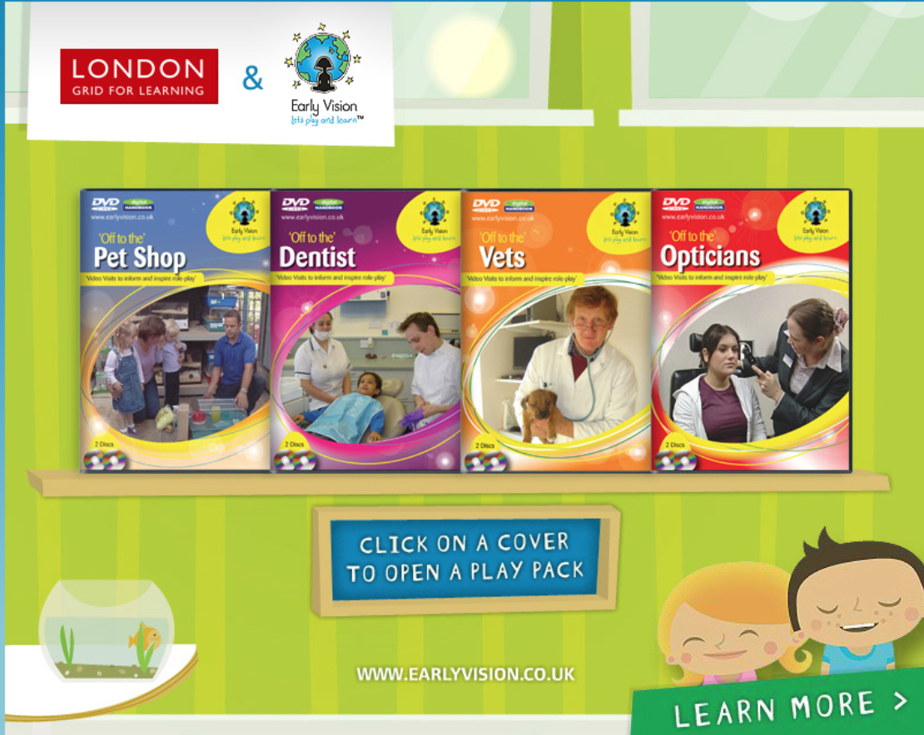 | Within the Early vision resource, you have 2 digital books relating to animals, The daywork of a Vet and The day in the life of a pet shop. Early Vision videos feature real life scenarios where children get to visit and experience different areas of everyday life.  Within the Early Vision books you will also find digital handbooks with detailed planning to cover all areas.
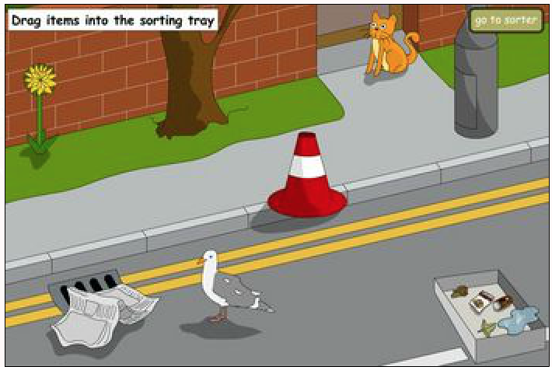 | Explore the life cycle of living/non-living, within this activity within I-Board.The early scientific concept of living/non-living can be explored using this open sorting activity. Help pupils make observations about the characteristics of the objects that can be collected or noted on a "science walk". Once you have dragged items into the sorting tray you can move onto the sorting screen and see if you got the answers right
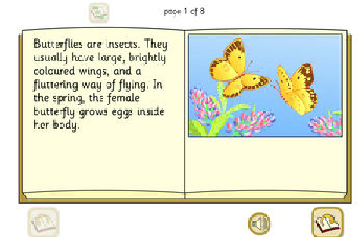 | Explore the life cycle of Butterflies, within this speaking online book with I-Board.  One of a set of six 'listen-and-read' explanation books. Pupils can learn about the life cycle of a butterfly by browsing through this book. Turn the pages and click the loudspeaker to hear the text narrated. There are a range of other i-board activities based around butterflies, such as an interactive Butterflies life cycle.
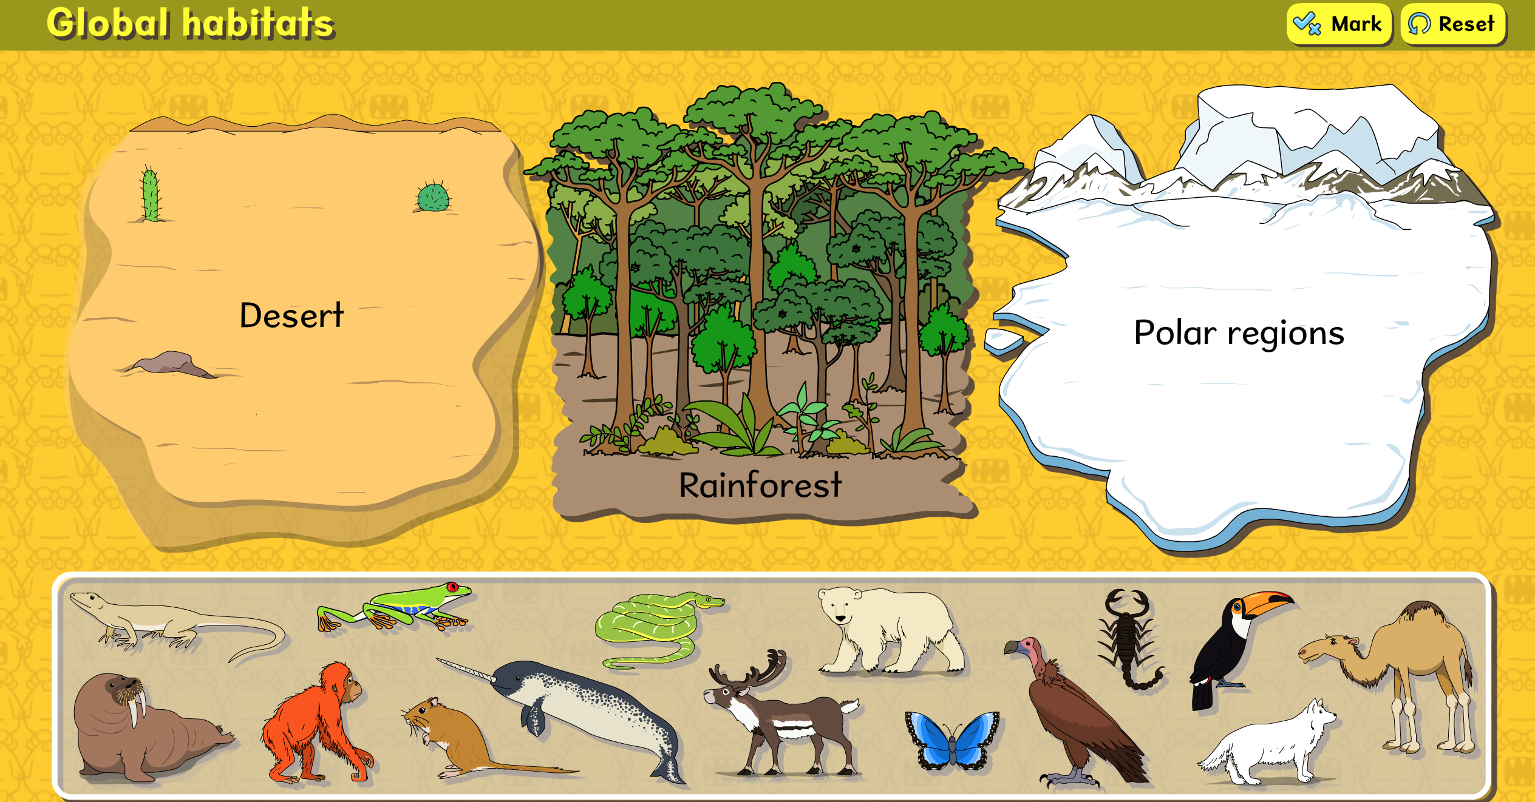 | Explore the habitats of various animals with this online quiz within the Busythings resource.  The classifying activity is designed to Increase and demonstrate geographical and animal diversity knowledge.
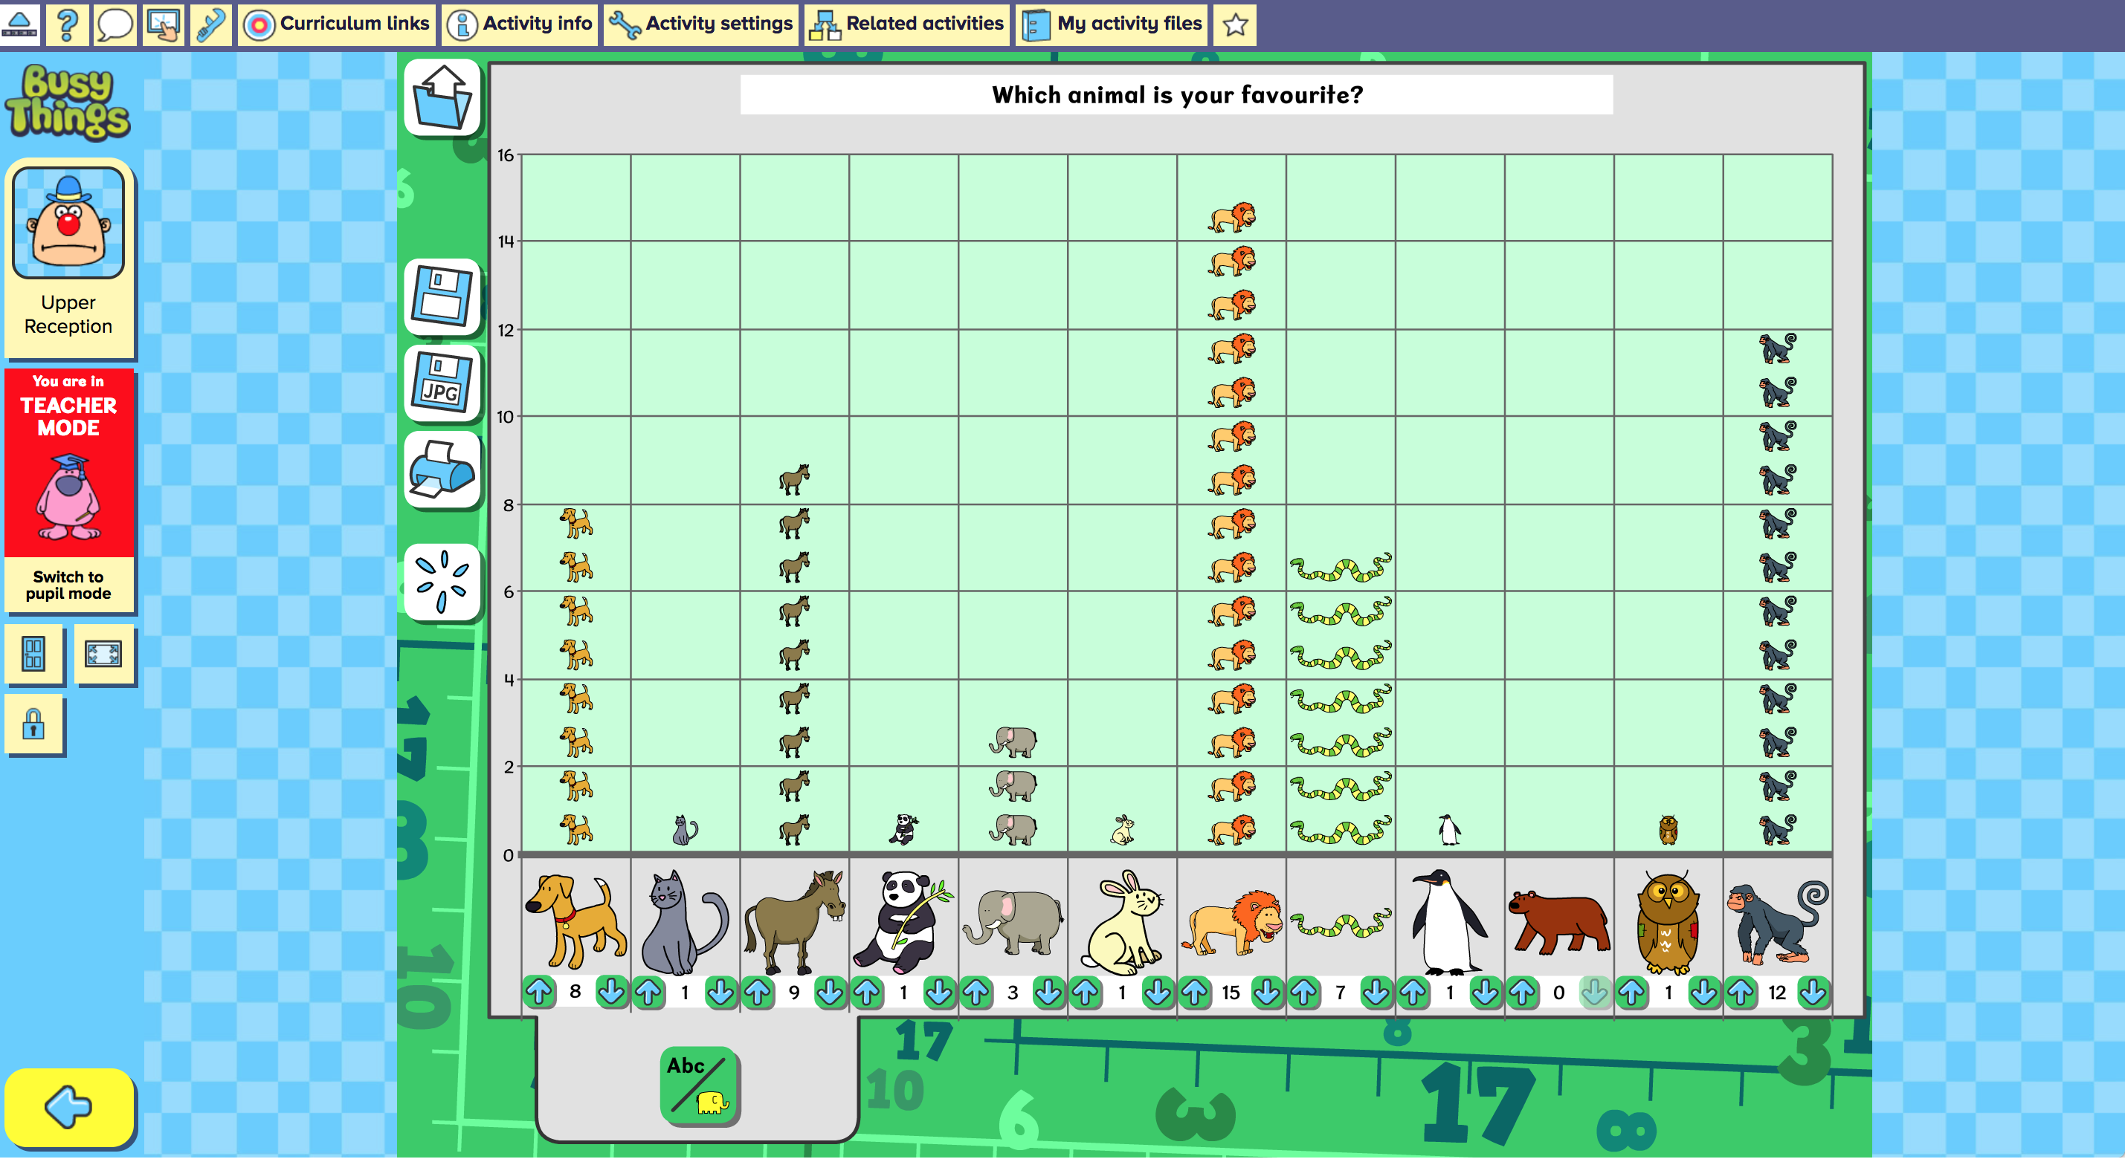 | Explore handing data with animals pictogram within the Busythings resource.  Use this graph project to construct a pictogram of people's preferences (Early Years)
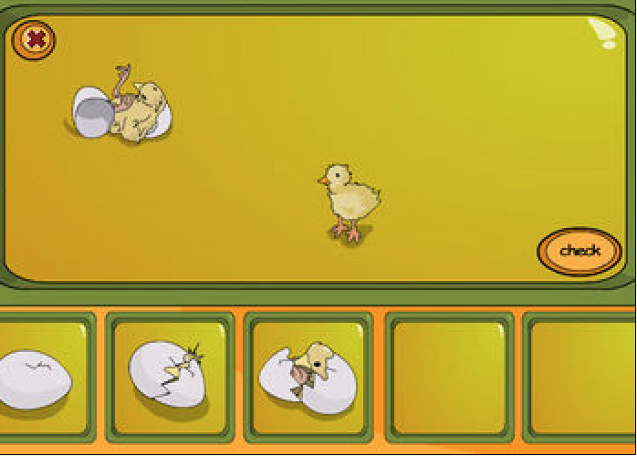 | Explore how to the life cycle of a chicken via ‘Hatching Chick’ within this interactive digital activity within I-Board.  Ask pupils to explain the changes in the picture each step of the way. Drag the pictures into sequence and click ‘check'.
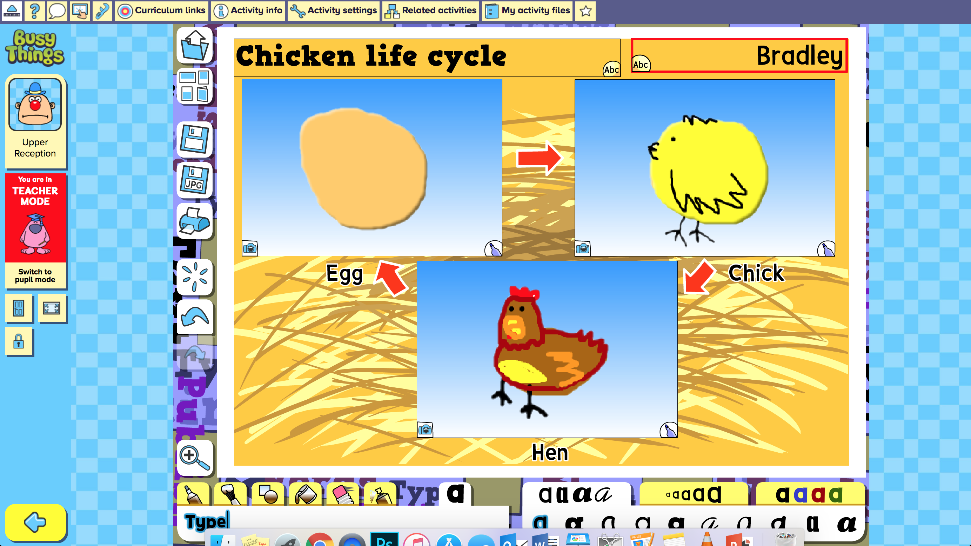 | Explore the life cycle of chickens with this interactive digital life cycle tool within ‘Busythings’.  Choose a template and draw in the stages of a chicken's life cycle, or if you are lucky to have live chicken in your local environment then take pictures and add them to the life cycle.
Create you very own animal with this printable resource found in Busythings.

Make your own animal Use paper fasteners, cardboard, scissors and glue to build your own hinged, crazy creatures from Animal Muddle. 13 animals over 6 pages. Full colour.

