Fairy Tales
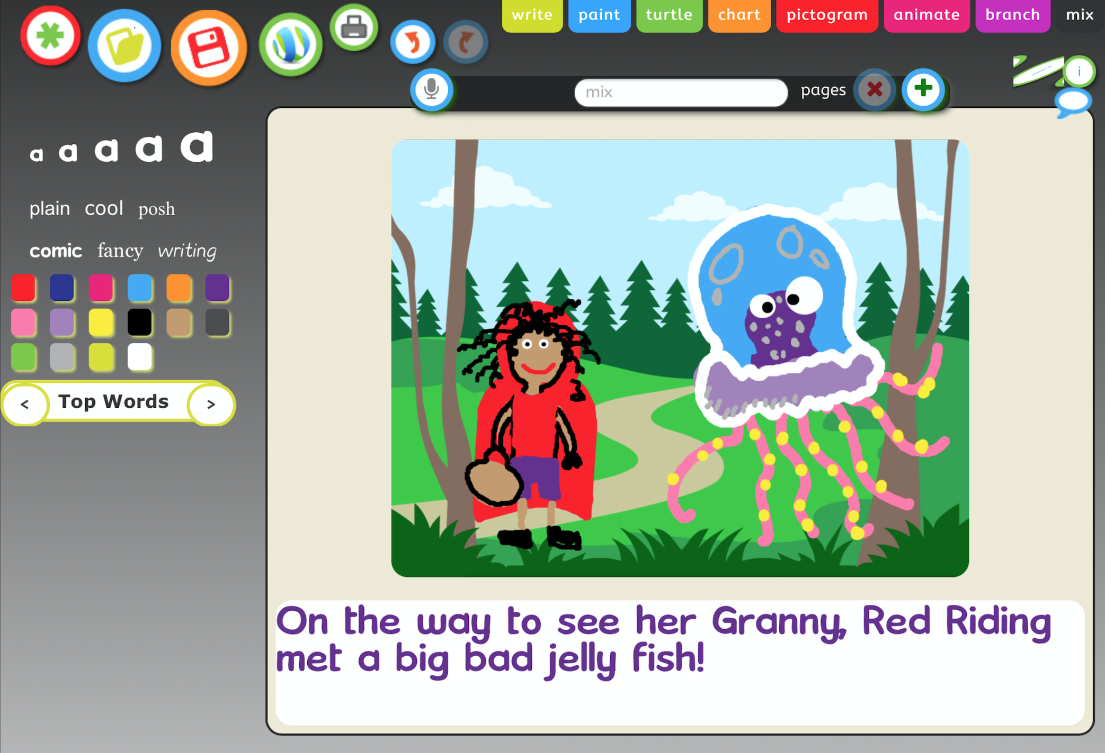 | Use JIT infant tool kit “Paint, Animate and Mix” tabs to retell a familiar tale and then ask the children to remix the fairy tale, you can change the settings by choosing one of the many different backgrounds found with in j2e or change the main characters by exploring the many characters you can find in j2e clip art folder.  Once made get the children to create a voice over by using the microphone feature (You must be using a device which has either an in-built microphone or a microphone attached.

Use JIT infant tool kit ‘Turtle’ tab to take the big bad wolf or Cinderella on a simple adventure using directional tabs.

You could ‘act’ this activity out in the real world asking the children to give each other directions carpet space or on large drawn grids in the outside area.
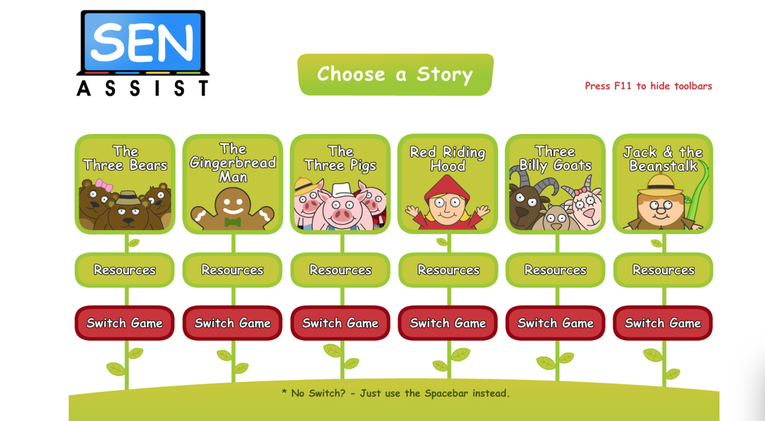 | Use the resource ‘Fairy Tales’ to explore the fairy tales ‘The Ginger beard man’ ‘Goldilocks’ ‘The 3 little pigs’ ‘Red Riding Hood’ ‘Jack and the beanstalk’ and ‘the 3 billy goats guff’ each story has simple animated characters bringing the fairy tales to life, each story is differentiated 4 ways to help support all learnings and each task links to 5 other tasks that relate back to the story, the resource also contains PDF resources that can be printed and would be fantastic to use within a small world environment.
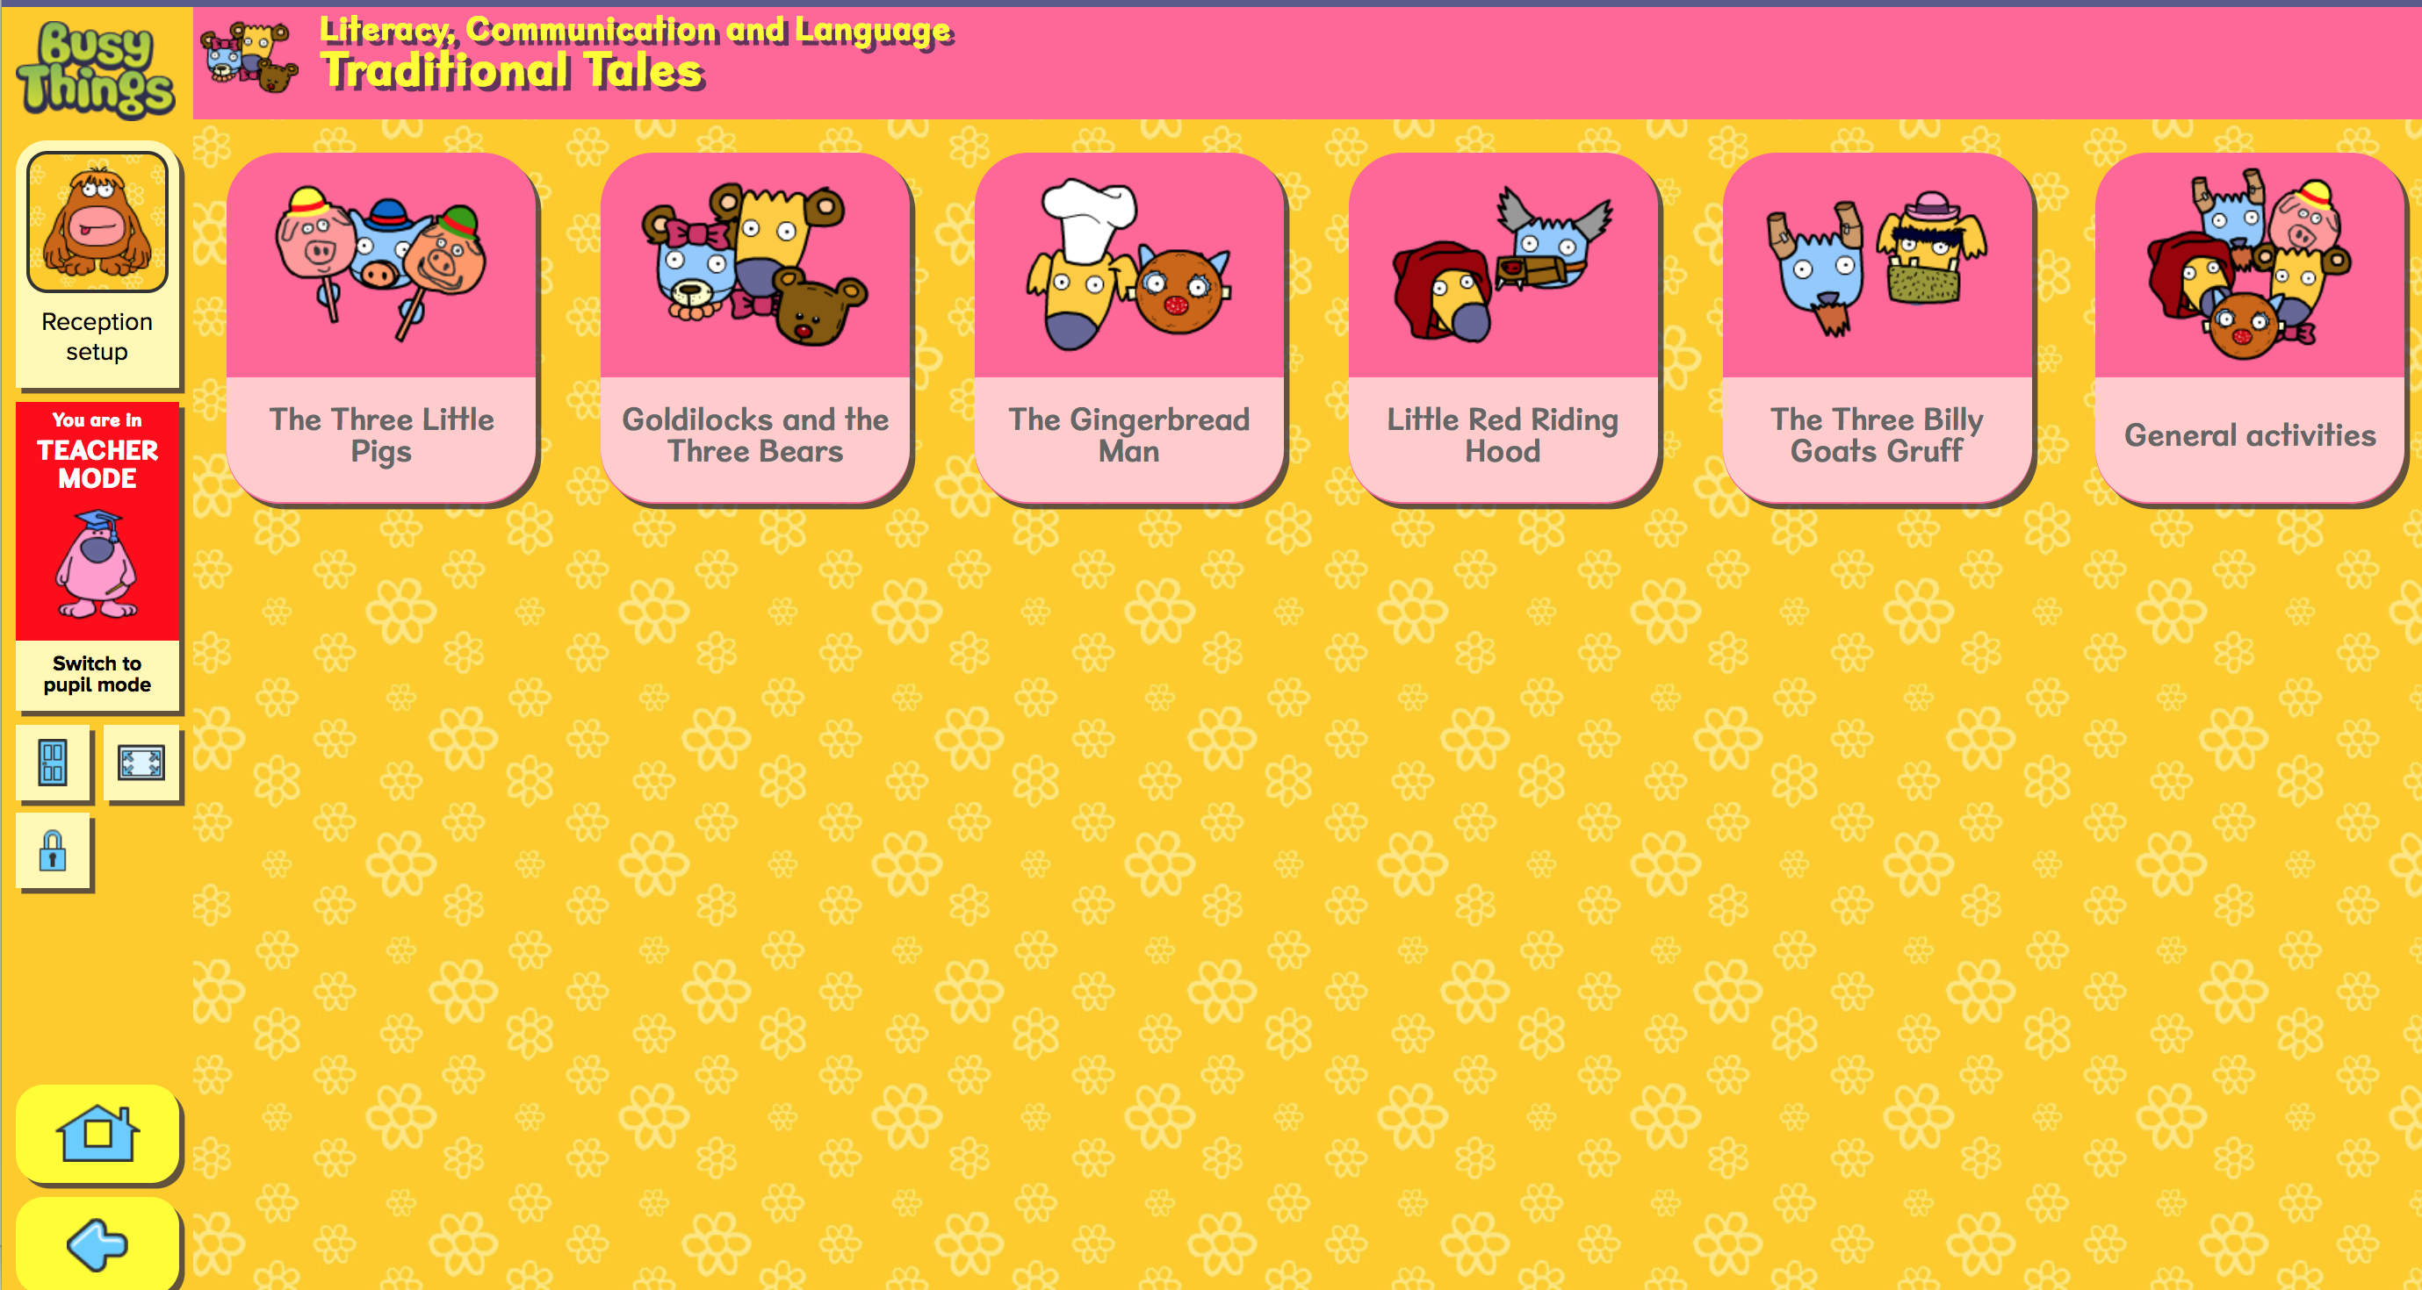 | Use the literacy resources within ‘Busythings’ to find a wealth of exciting activities to explore the topic of traditional fairy tales the stories included are “The 3 little pigs” “Goldilocks and the 3 bears” “The Gingerbread man” “little Red Riding Hood” and “The 3 billygoats gruff” each story is retold in a fun manner, with follow up activities such as sequencing, picture ordering, building your own story scene, there are also a range of printable which can be used to enhance your small world, literacy or art area.
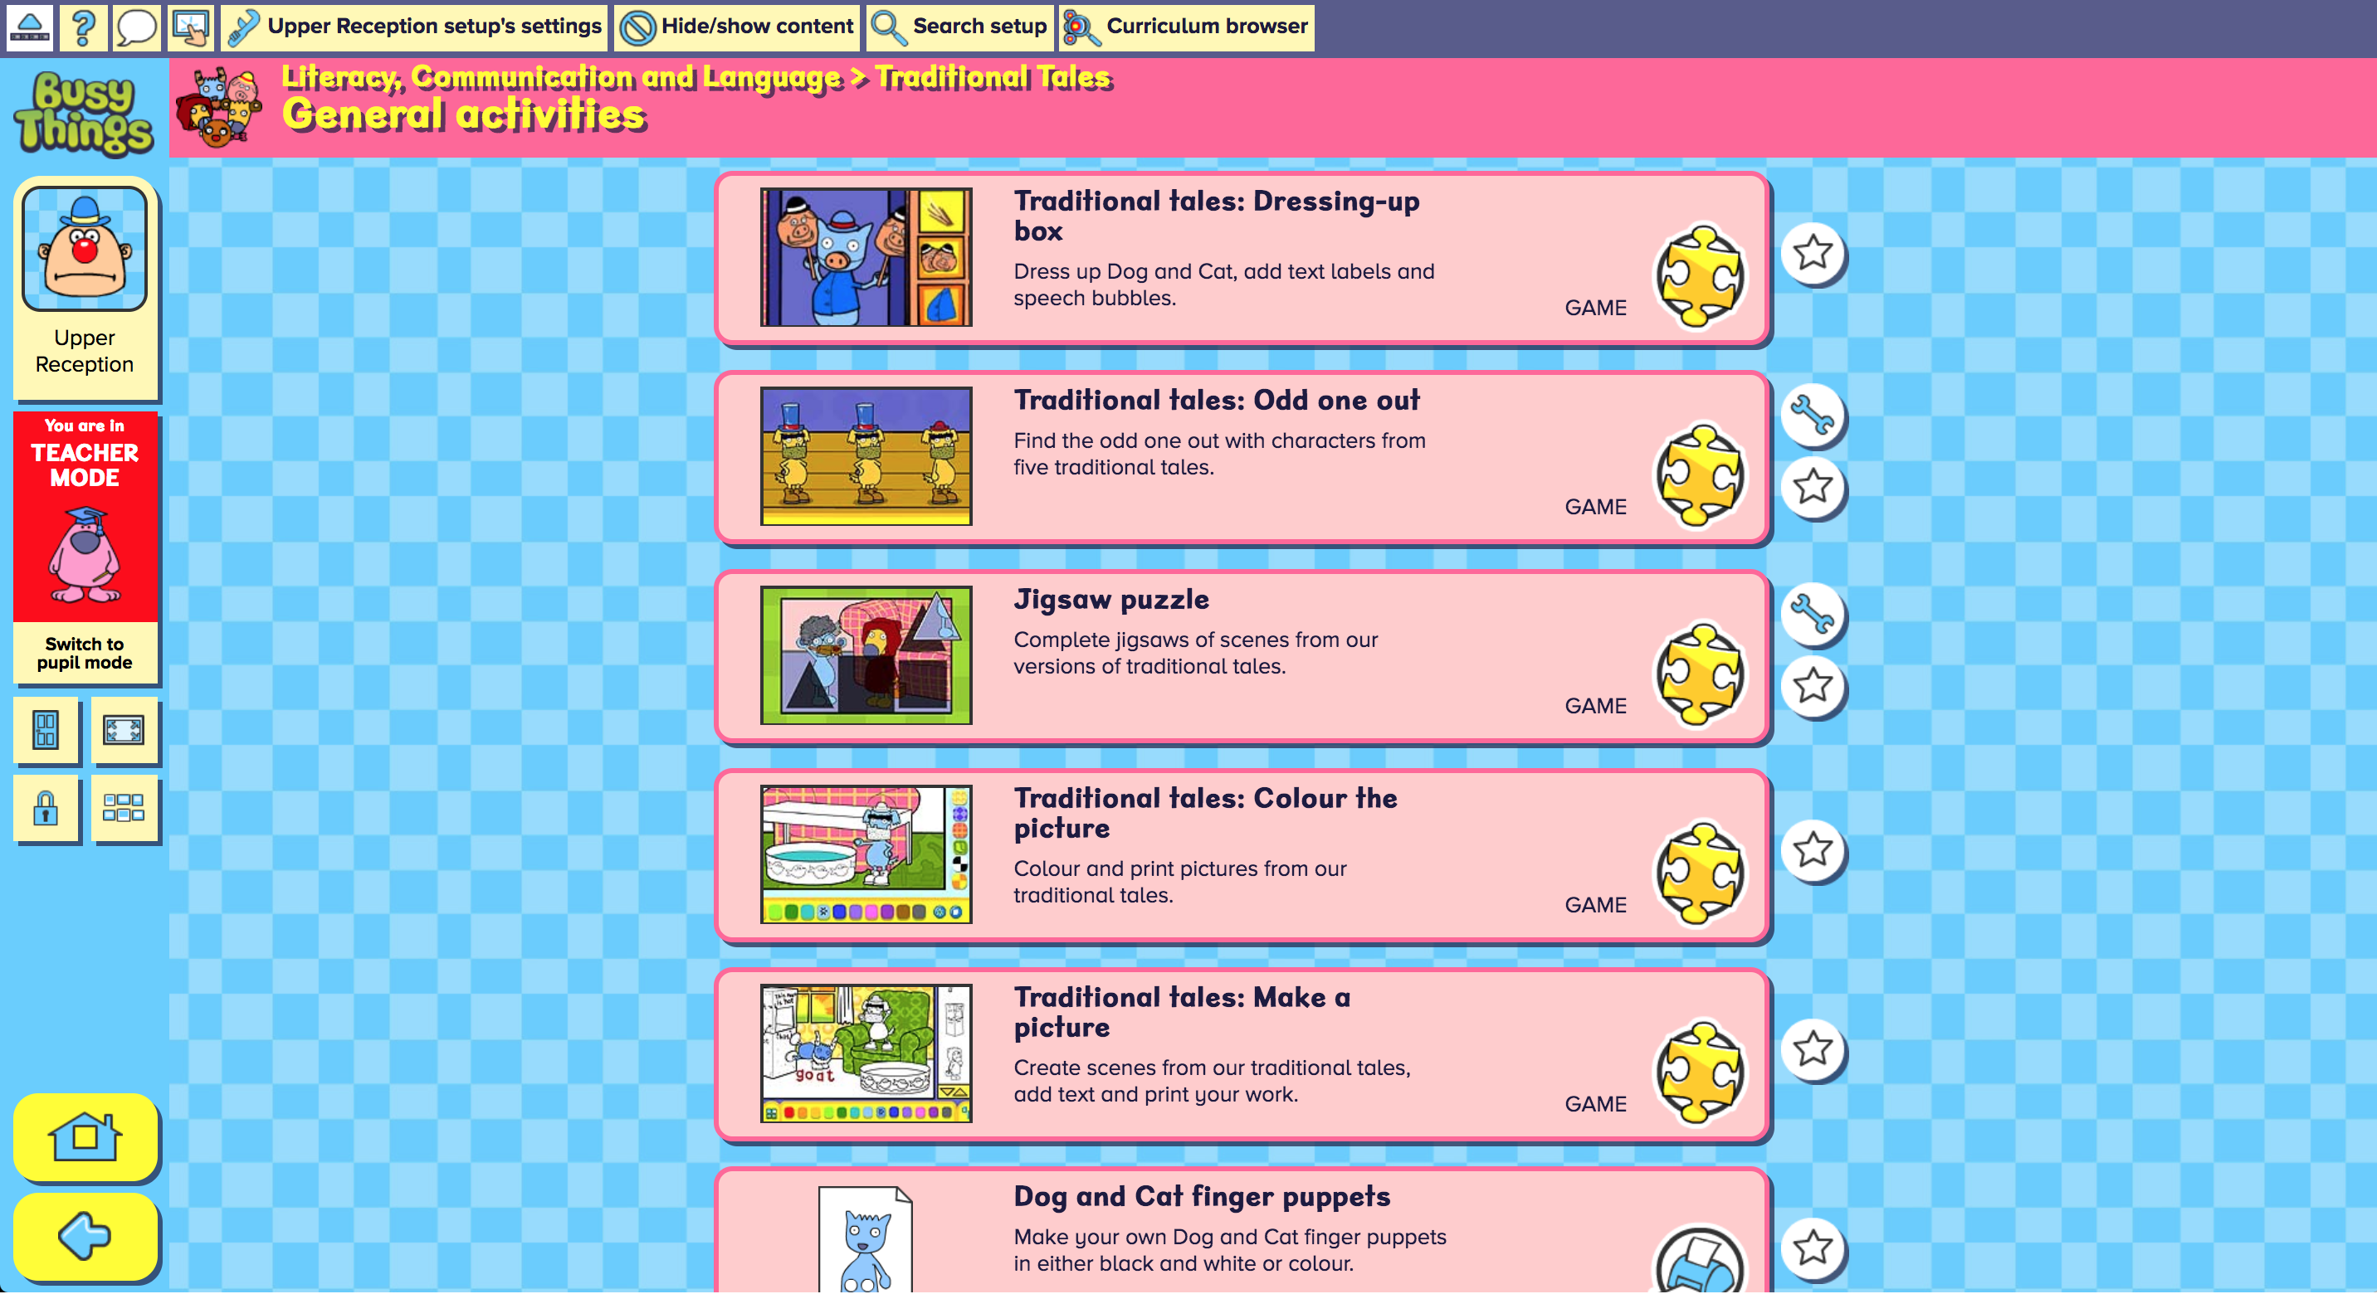 | Use the literacy resources within ‘Busythings’ to find a wealth of exciting activities to explore the topic of traditional fairy tales the stories included are “The 3 little pigs” “Goldilocks and the 3 bears” “The Gingerbread man” “little Red Riding Hood” and “The 3 billygoats gruff” within traditional fairy tale general resources you will find fun activities such as “Odd one out game” and “traditional tales dressing up box.”
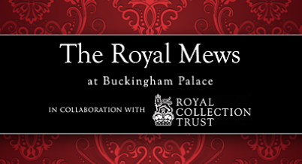 | Explore the world of real life royalty, with ‘The Royal Mews’ resources, which explores the day to day work of key staff member within The Royal Mews, the resources features video explantations centuries old techies and historic documents.  Her Majesty the Queen has granted permission for LGfL to feature high resolution photographs and scans from the Royal Collection and Royal Archive.
 | Within the Resource Widgit you can find pre made resources to o support traditional tales including ‘The Three Pigs’ ‘Snow White’ ‘Red Riding Hood’ ‘Goldilocks’ ‘Cinderella’ and ‘Three Billy Goats Gruff’ each story has a fully comprehensive pack with a variety of differentiated activities, which include the story, sequencing activities, worksheets, crossword, matching activities, drawing, storyboard and play-script, all using the Widgit communication system as a scaffold to support all learners.
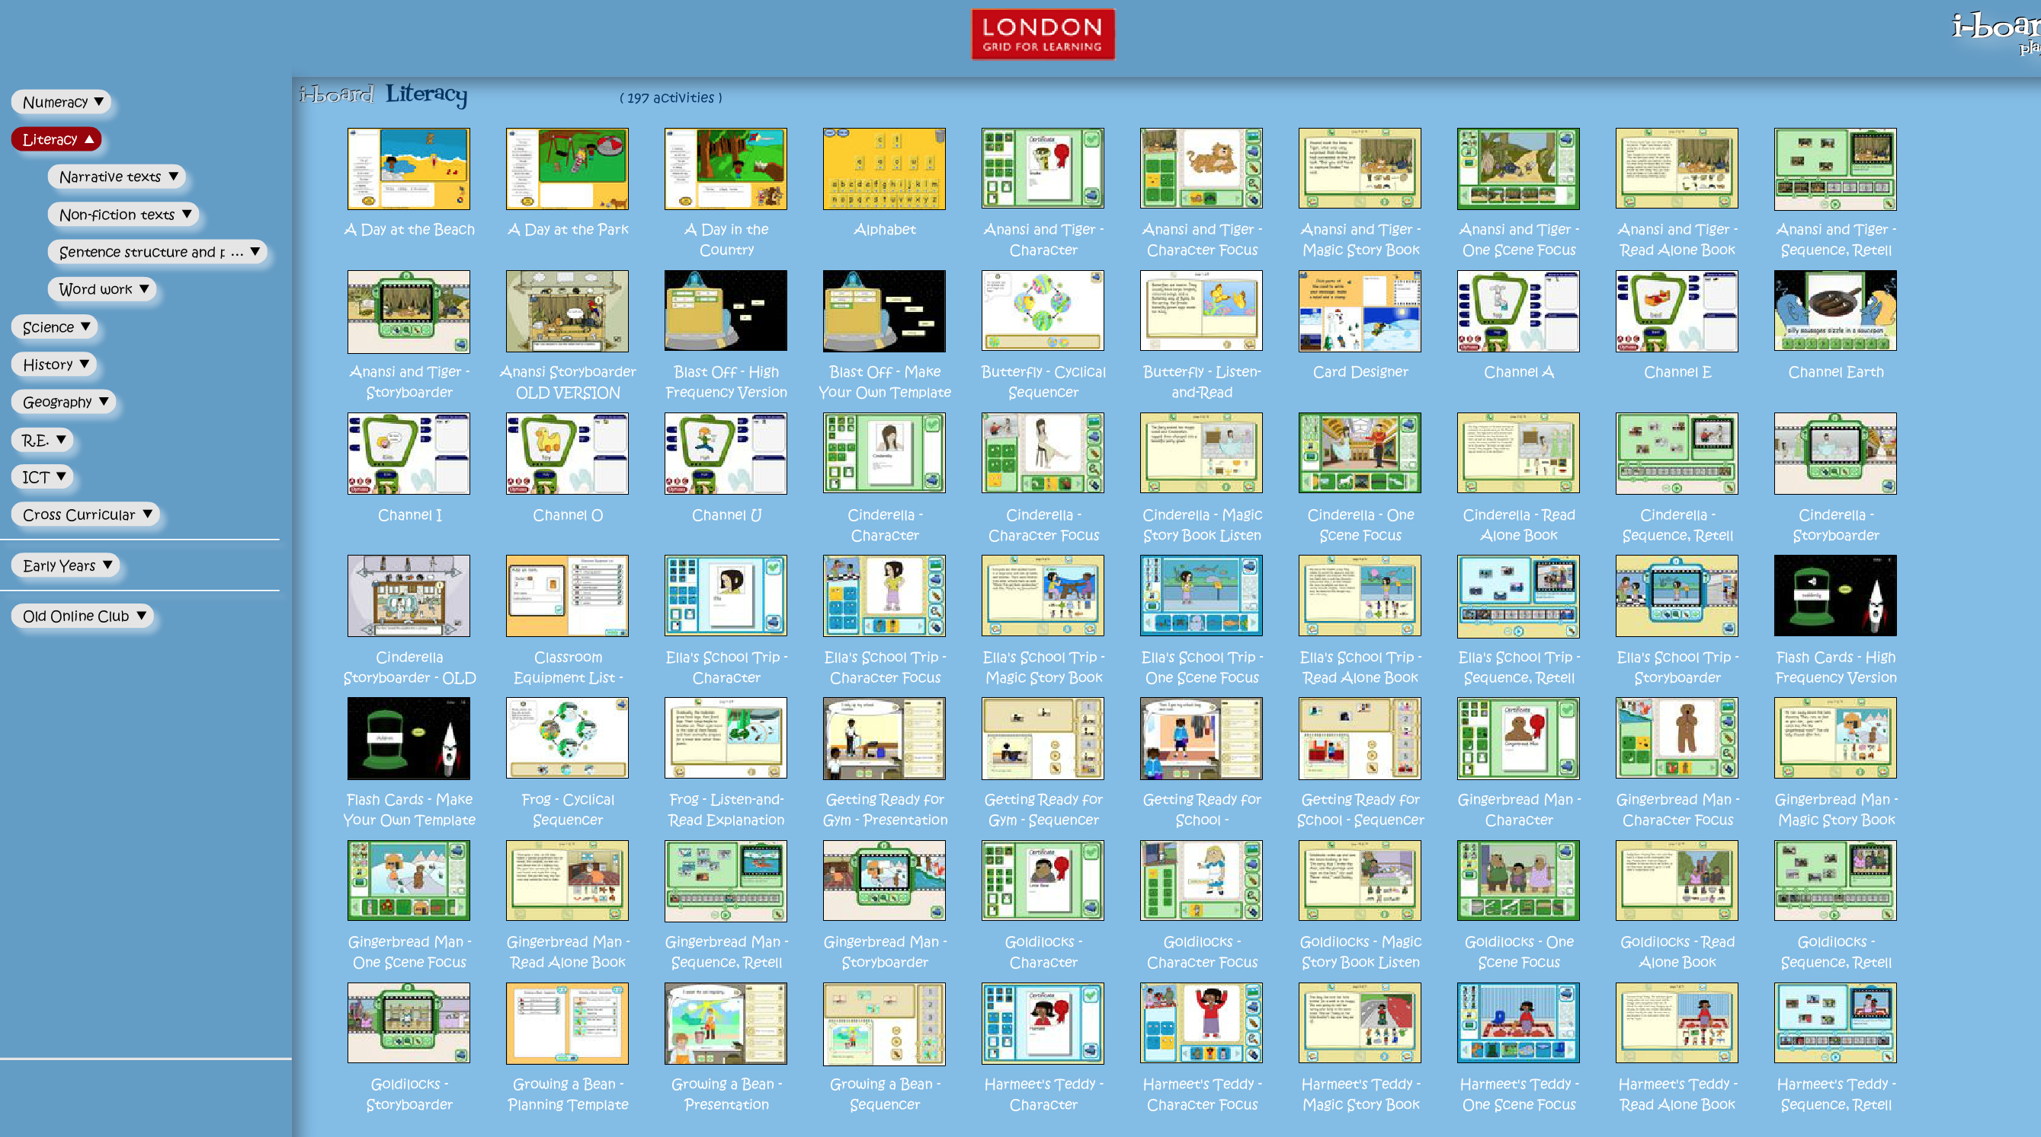 | With the i-Board resources explore a range of traditional stories using the read along books, Cinderella , Anansi and Tiger, The Gingerbread Man, Goldilocks and The Little Red Hen you can also explore retelling and sequencing each story using the digital tools provided.
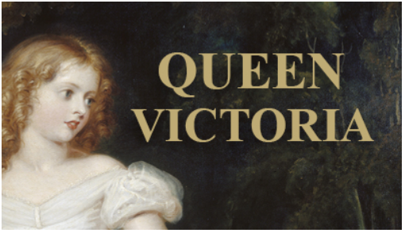 | Linked fiction with non-fiction by exploring the world of real life royalty, with the “QUEEN VICTORIA” resource.  An amazing access to images from the RCT with lessons plans linked to each image.

