Mini-beasts
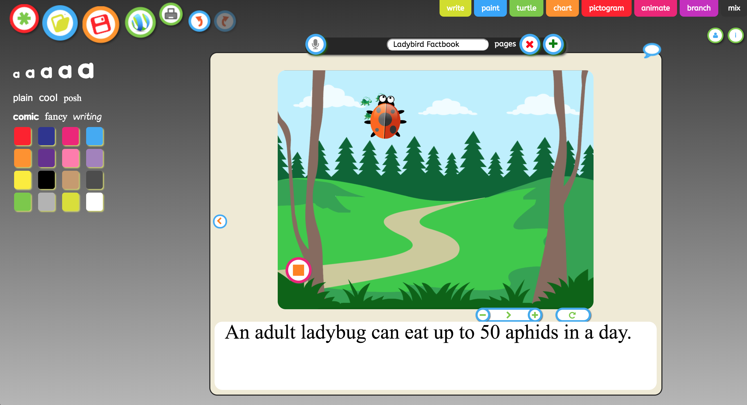 | Use JIT infant tool kit “Paint, Animate and Mix” tabs to create a simple fact book about mini-beasts by creating a series of digital drawings.  Once made get the children to create a voice over by using the microphone feature (You must be using a device which has either an in-built microphone or a microphone attached.
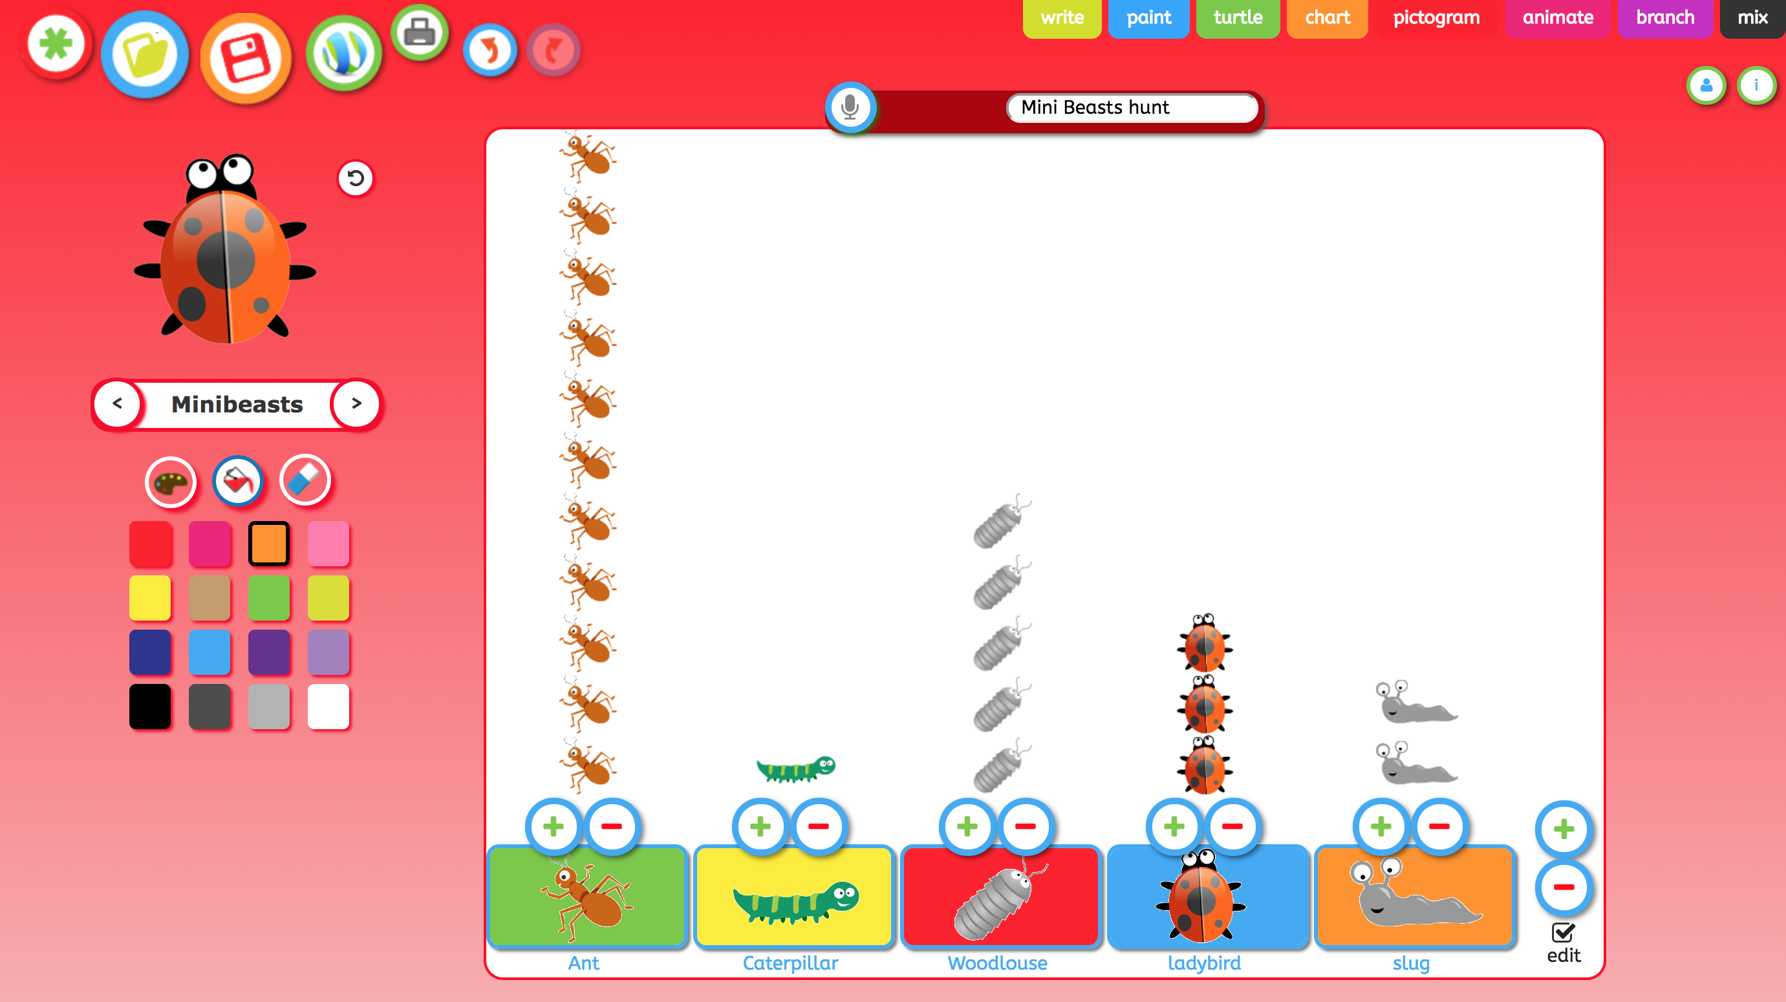 | Within your school environment or local green space, ask your students to go on a mini beasts hunt, ask you students to collect the data by using a simple tally sheet. Once the students are back in class ask your students to curate the data into JIT infant tool kit “Pictogram” , students could draw they own bugs or use the clip art provided, by using the microphone feature (You must be using a device which has either an in-built microphone or a microphone attached) children can take about the amount of bugs and answer simple questions such ‘Which amount of bugs is the most?”
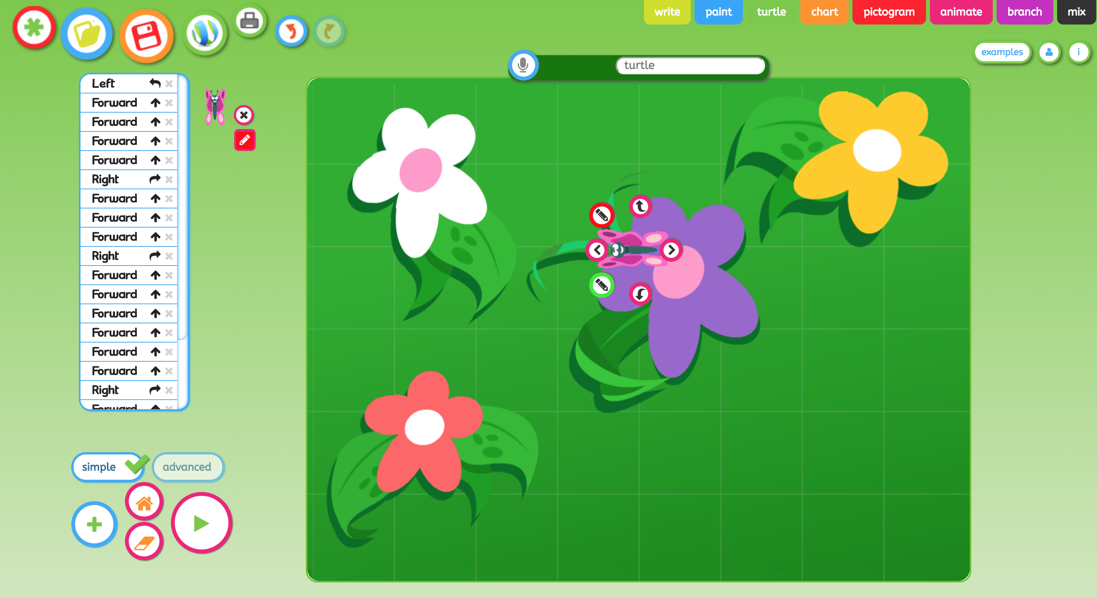 | Use JIT infant tool kit “Turtle” use the butterfly/flowers template, ask your students to give the least amount of instructions/directions to get the butterfly to each flower.  Once made get the children to create a voice over by using the microphone feature (You must be using a device which has either an in-built microphone or a microphone attached.)
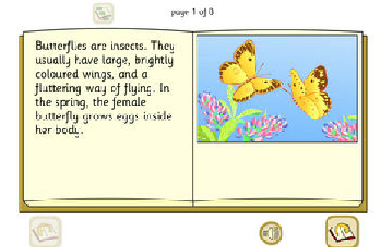 | Explore the life cycle of Butterflies, within this speaking online book with I-Board.  One of a set of six 'listen-and-read' explanation books. Pupils can learn about the life cycle of a butterfly by browsing through this book. Turn the pages and click the loudspeaker to hear the text narrated. There are a range of other i-board activities based around butterflies, such as an interactive Butterflies life cycle.
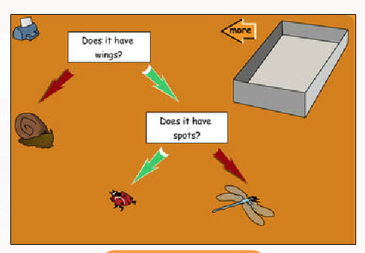 | Explore the properties of mini beasts with this sorting activity within i-Board.  Ask pupils to propose 'yes/no' questions that will sort a number of mini-beasts using a tree diagram. (Tip: start with two or three creatures and add more into the tray once the concept is more secure.) Choose the mini-beasts on the first screen by dragging them into the tray one by one. On the sorting screen, add labels with questions and drag the arrows onto the screen to denote 'yes' or ‘no’.
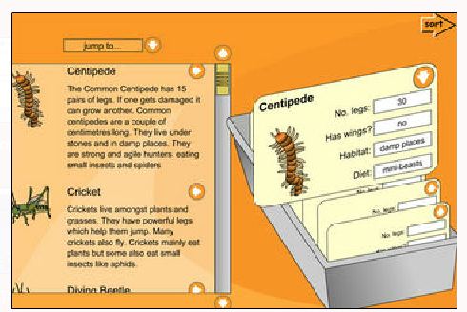 | Explore the properties of mini beasts with this sorting activity within i-Board.  Use the text and pictures to gather the data required for the index cards (click the right pointing arrow to send the picture and title to the card). After completing several cards, ask pupils to propose questions and answer them by sorting them into labelled sets, you could do this as carpet time activity and have your students explore various toy mini beasts and then ask children to describe them, and add the details to the digital card together.
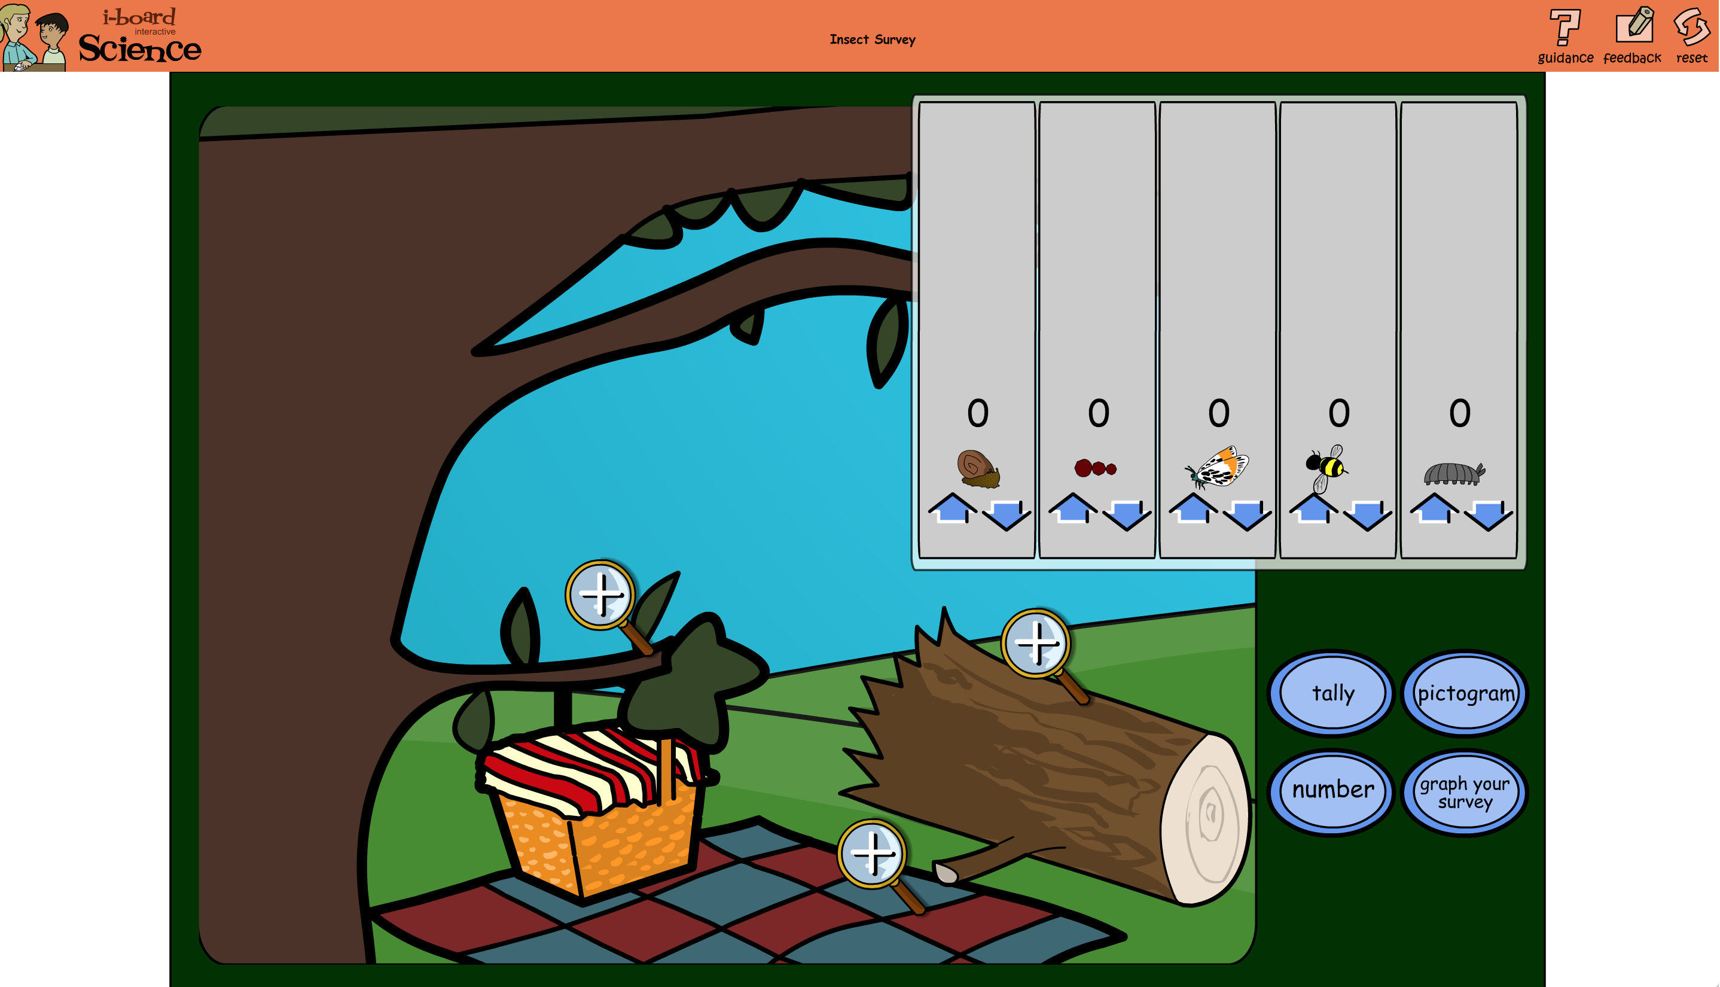 | Explore data handing with mini-beasts, within this activity from I-Board.  Insect Survey Zoom in on different parts of the picture to count the minibeasts. Use the three sets of data to prompt a range of comparison questions.  Investigate which minibeasts are in the scene - where are they found? This could be used as a preliminary activity before carrying out a survey in the school grounds and plotting the results.
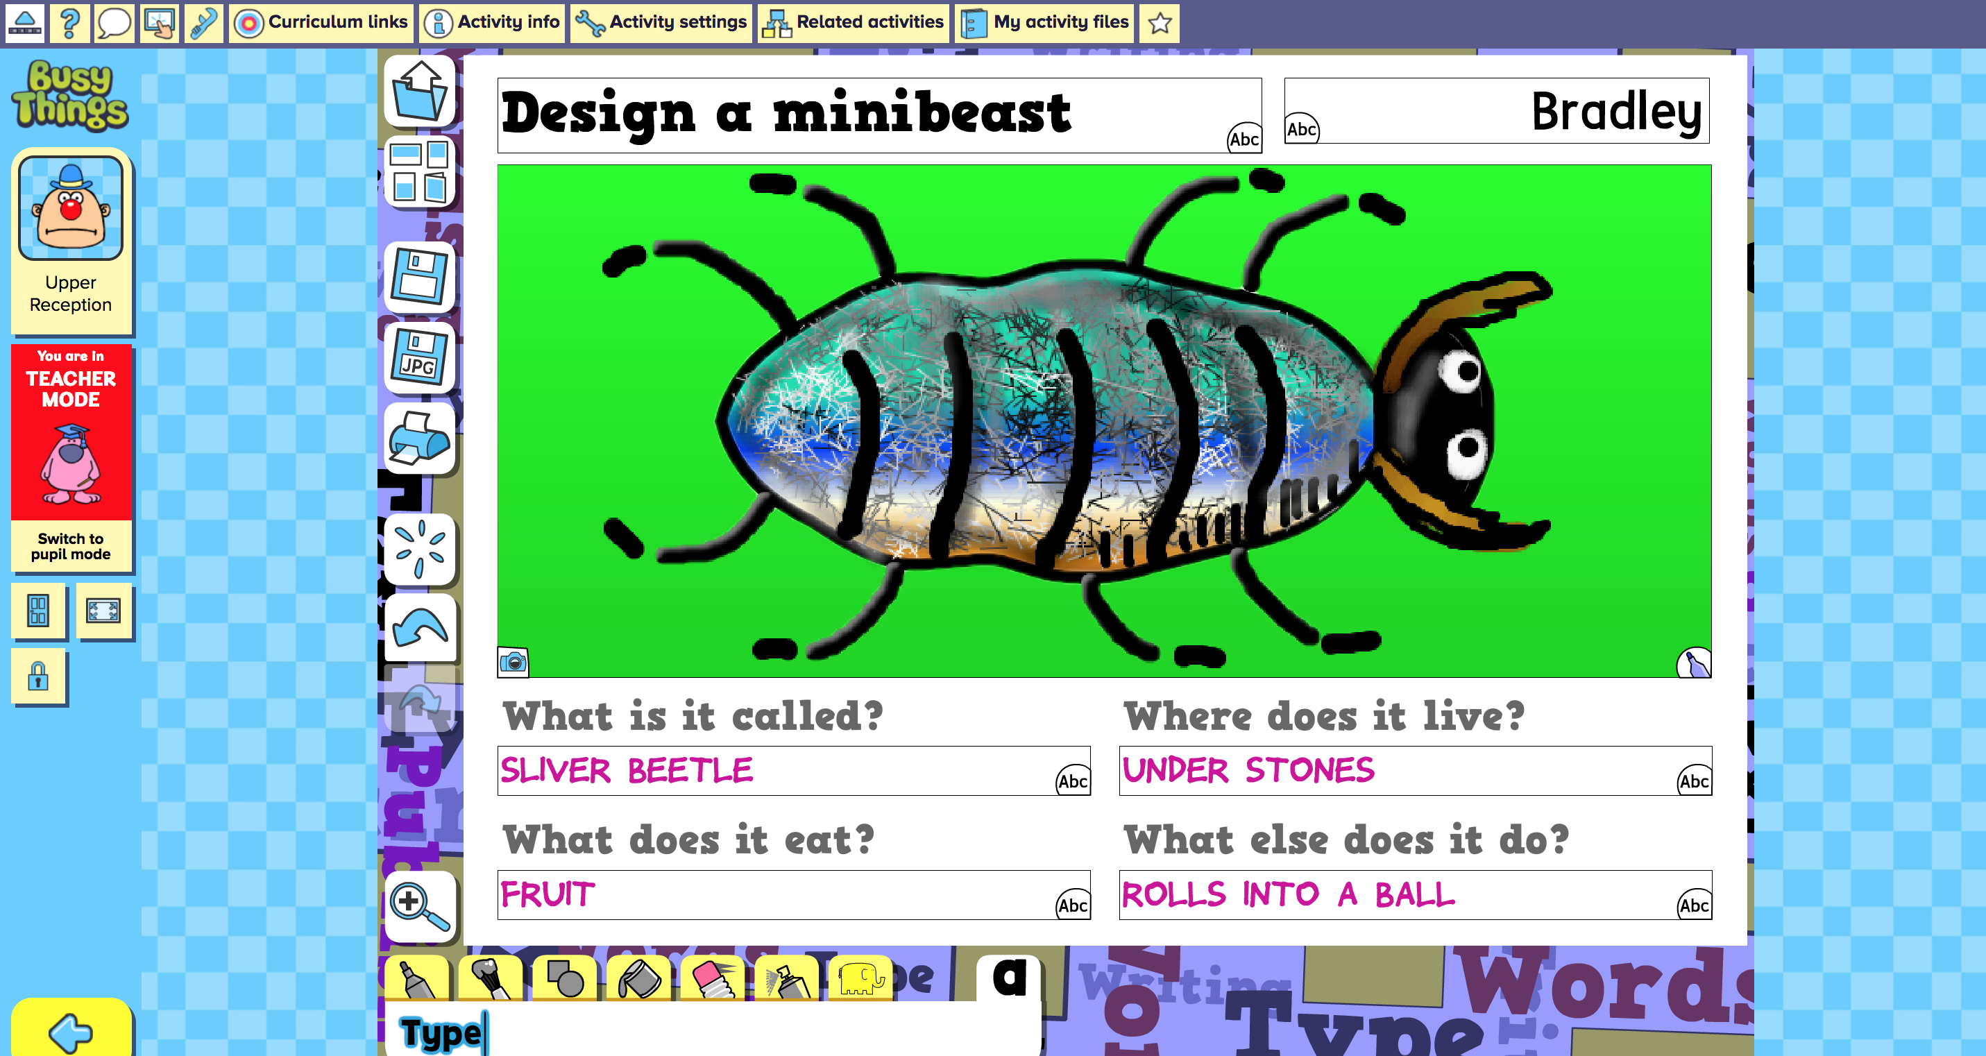 | Explore the properties of mini beasts with this digital activity within BusyThings.  Draw a picture of a mini-beast. Experiment with different colours and textures. Add wings, legs, antennae and eyes! Questions you can ask: What does your mini-beast like to eat? Where does it live? Does it have any special features?  Can it fly?
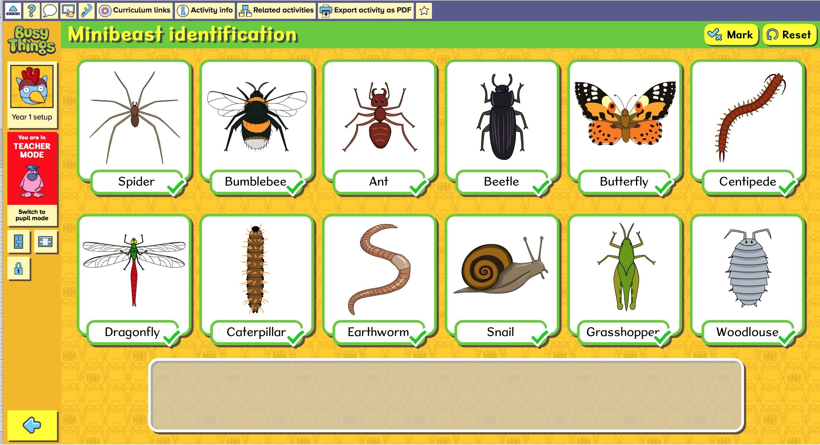 | Explore the properties of mini beasts with this digital activity within BusyThings.  Demonstrate knowledge of mini-beasts with this labelling activity.  You can also sae this activity as a PDF and use as a table top activity
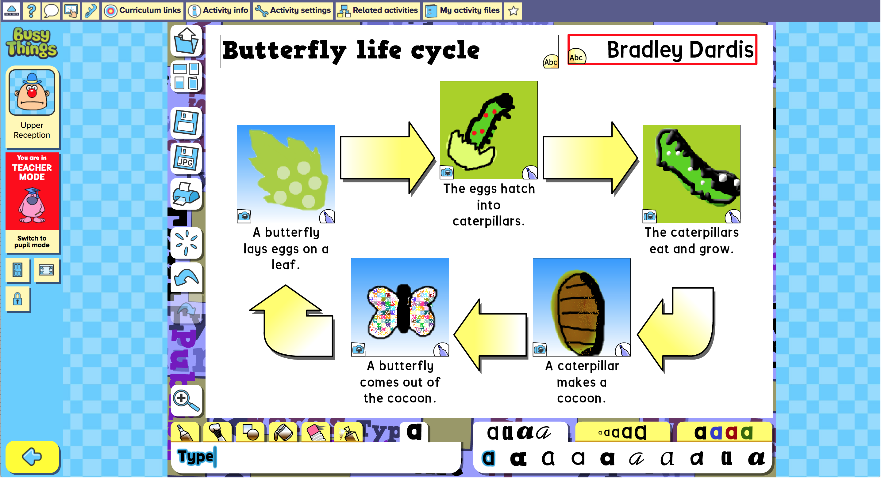 | Explore the life cycle of a butterfly with this interactive digital life cycle tool within ‘Busythings’.  Simple Choose a template and draw in or add photos of the the stages of a butterfly’s life cycle. Questions you could ask you ever Have you seen a butterfly?What colour was it?  Have you ever seen a caterpillar?
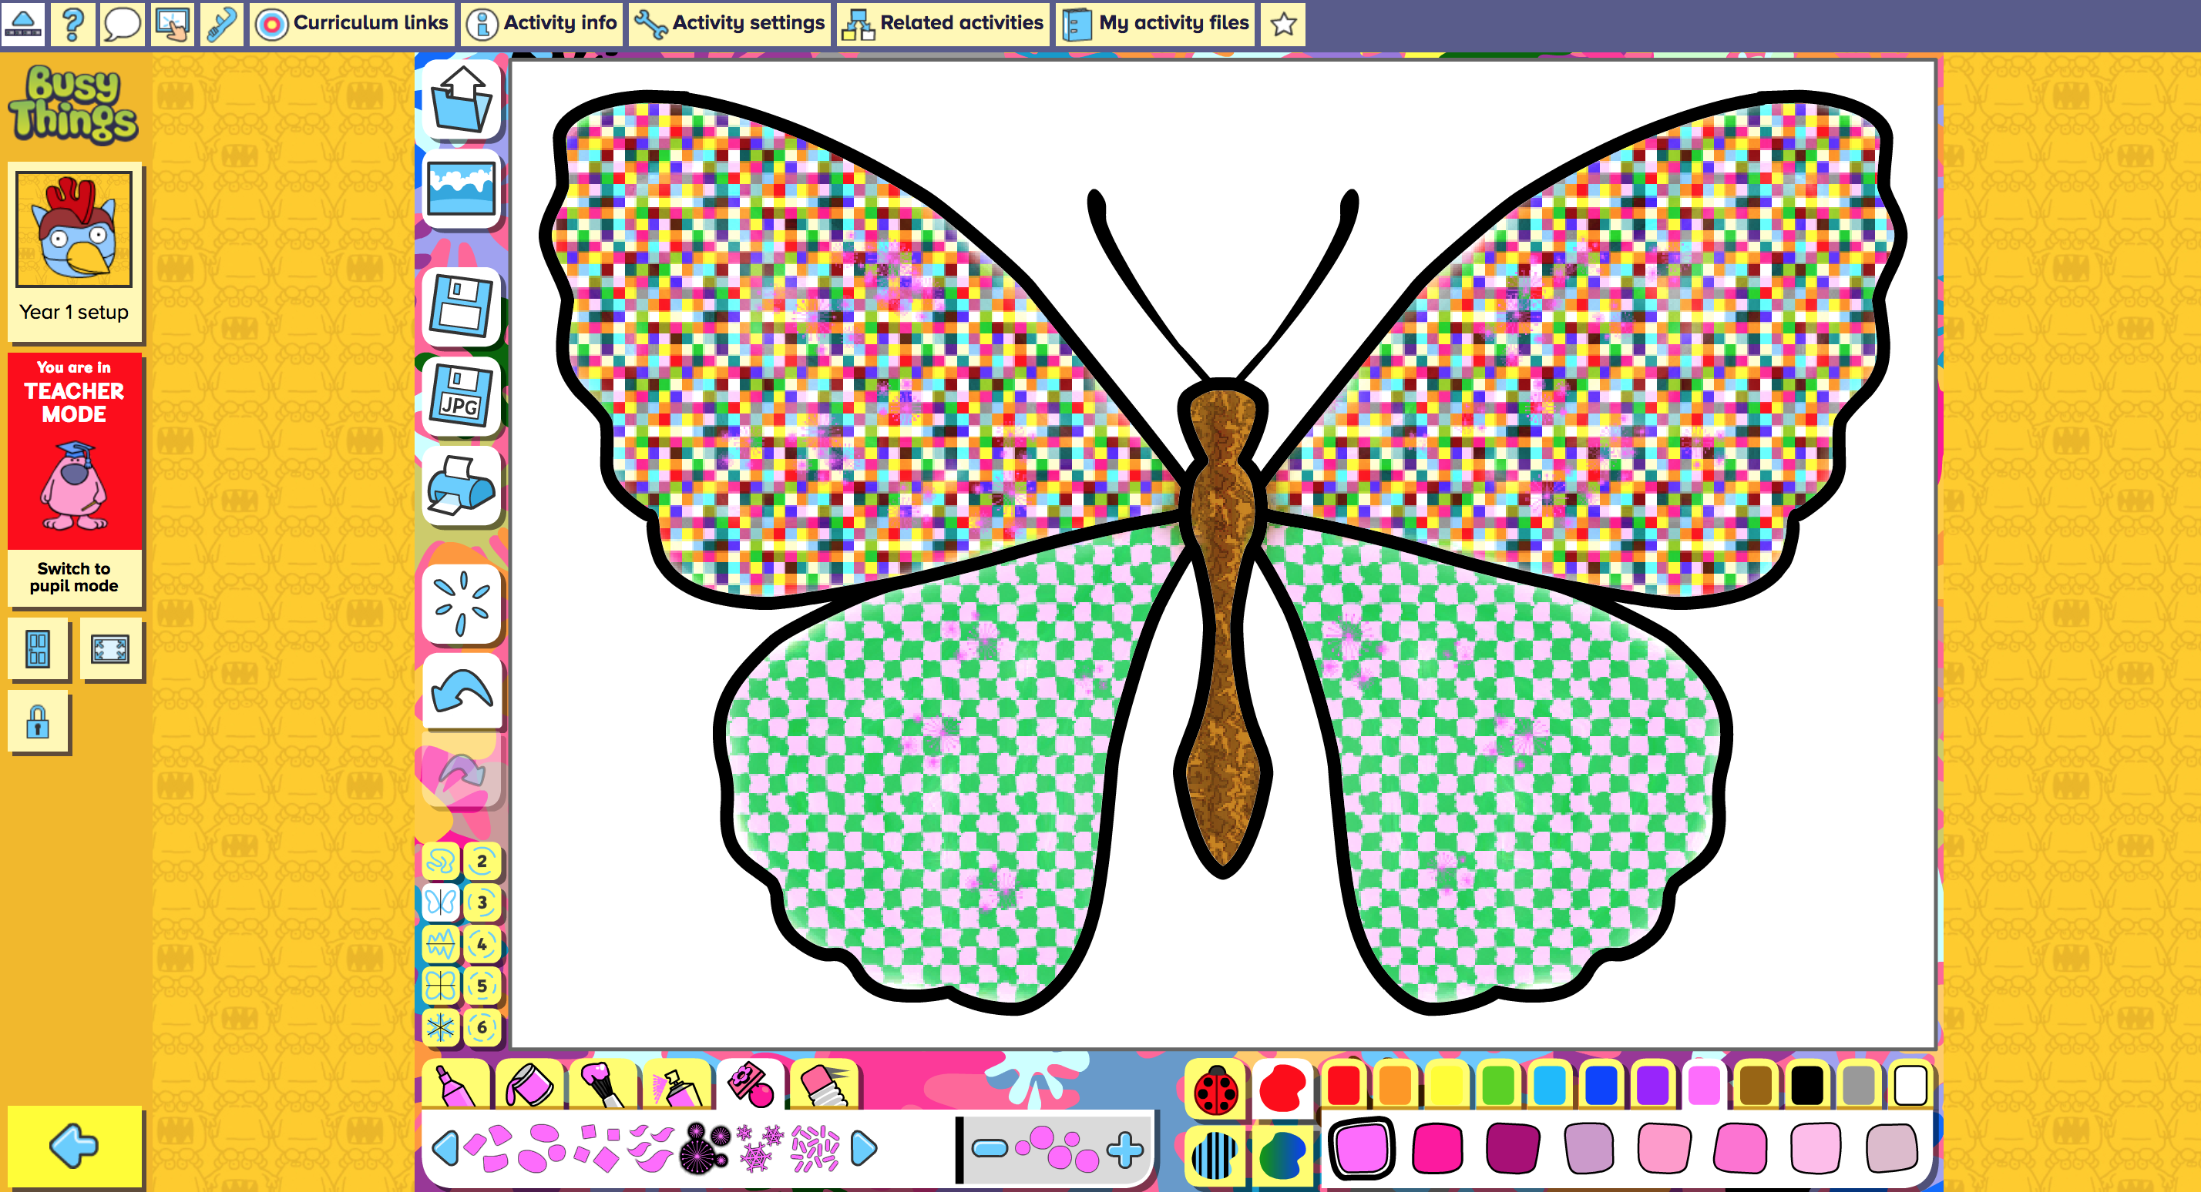 | Explore symmetry and pattern with this Butterfly Choose a mini-beast and colour it in. Try out all the different colours, textures and stamps. Notice how all your marks are symmetrical! Discussion points: What kind of mini-beast have you made? How many legs does your mini-beast have? How many wings does it have? What does your mini-beast like to eat? Where does it like to live?

