Pirates
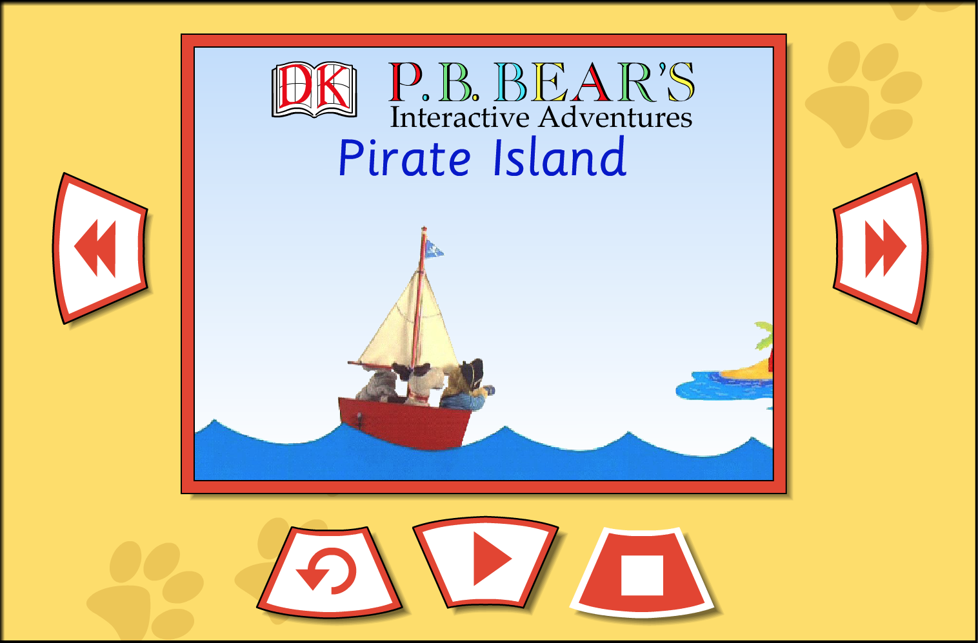 | Join PB Bear on his adventures to Pirate Island, via our PB Bear resource “Pirate Island”.  The story can be told via a video or a talking book can be used in two ways: you can watch straight through or click on one of the ‘hotspots’. This will stop the video and an activity, coming naturally out of the story, will appear over the video.
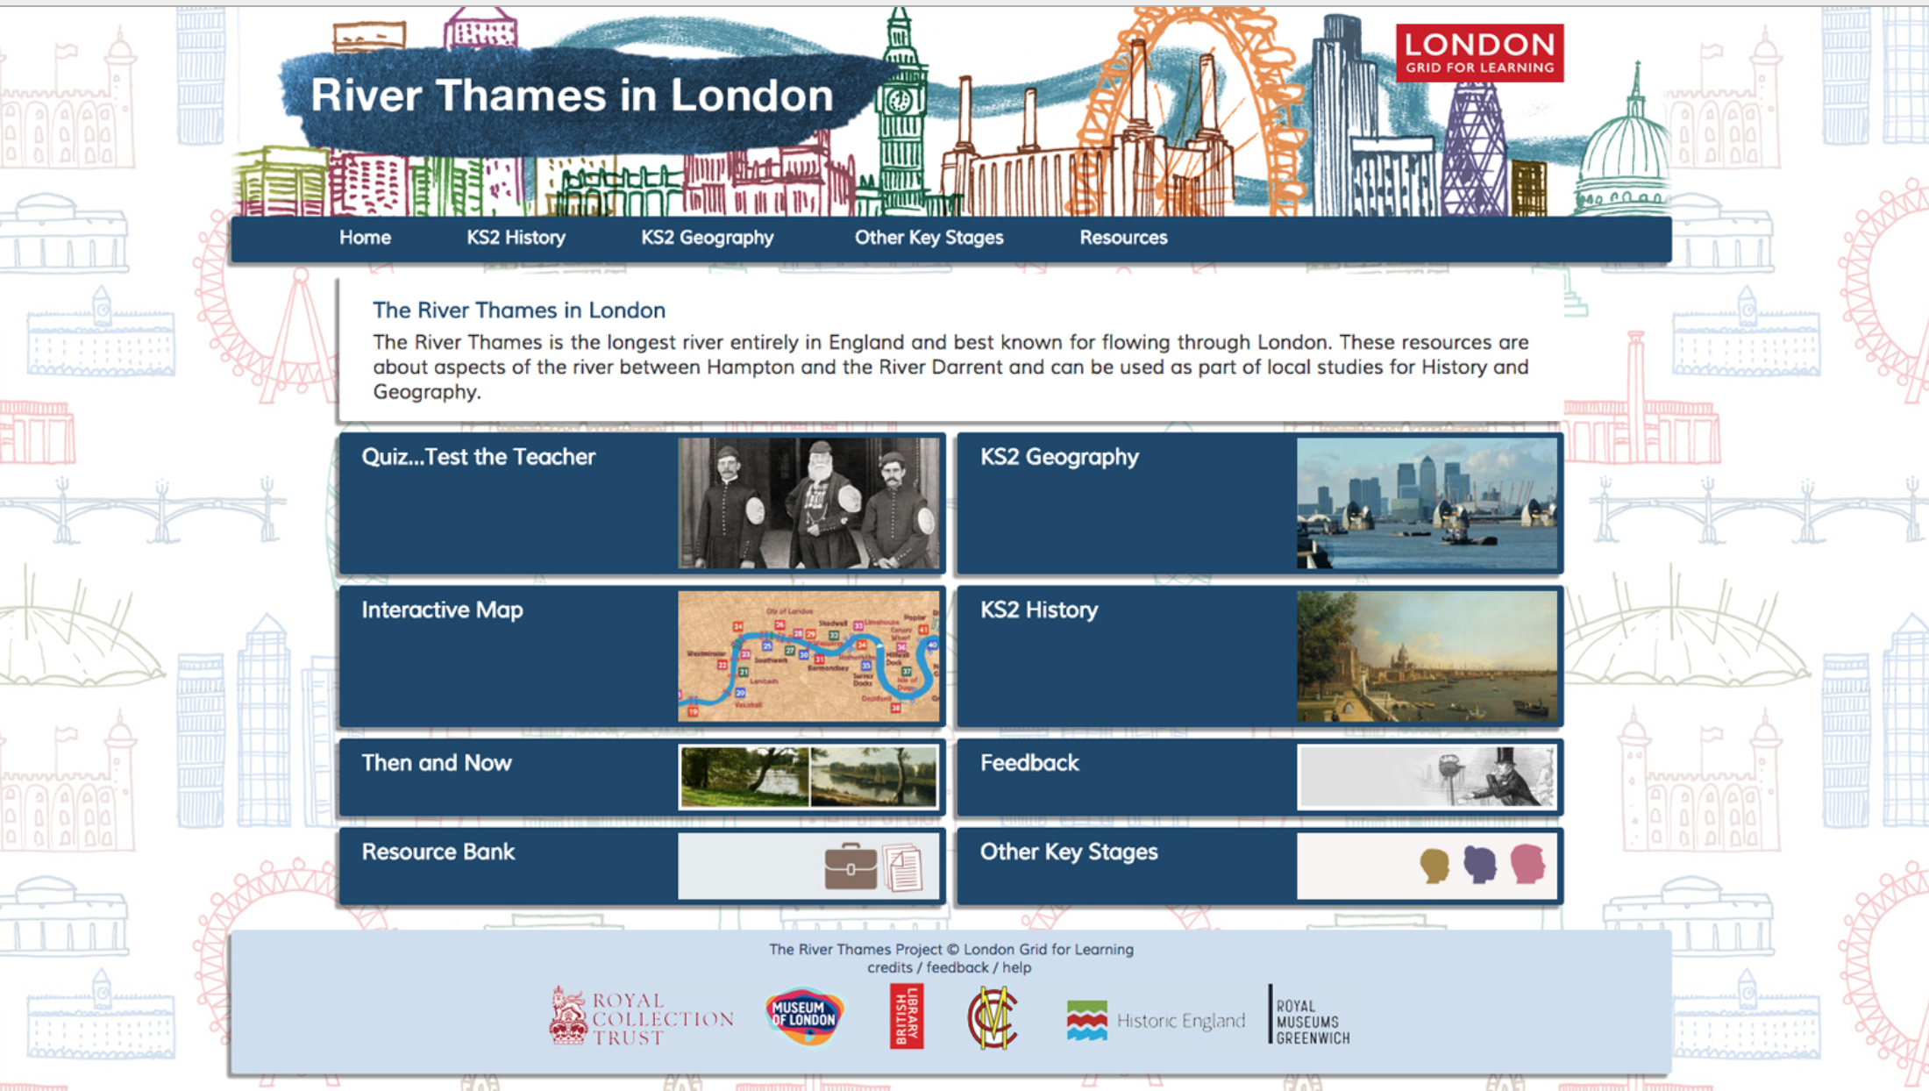 | Explore the River Thames via images and maps with our resource “River Thames in London”
Explore basic mouse skills with this interactive digital activity within the resource ‘Magic School’

Visit the water room to explore under the sea or take a walk around a pirate ship.
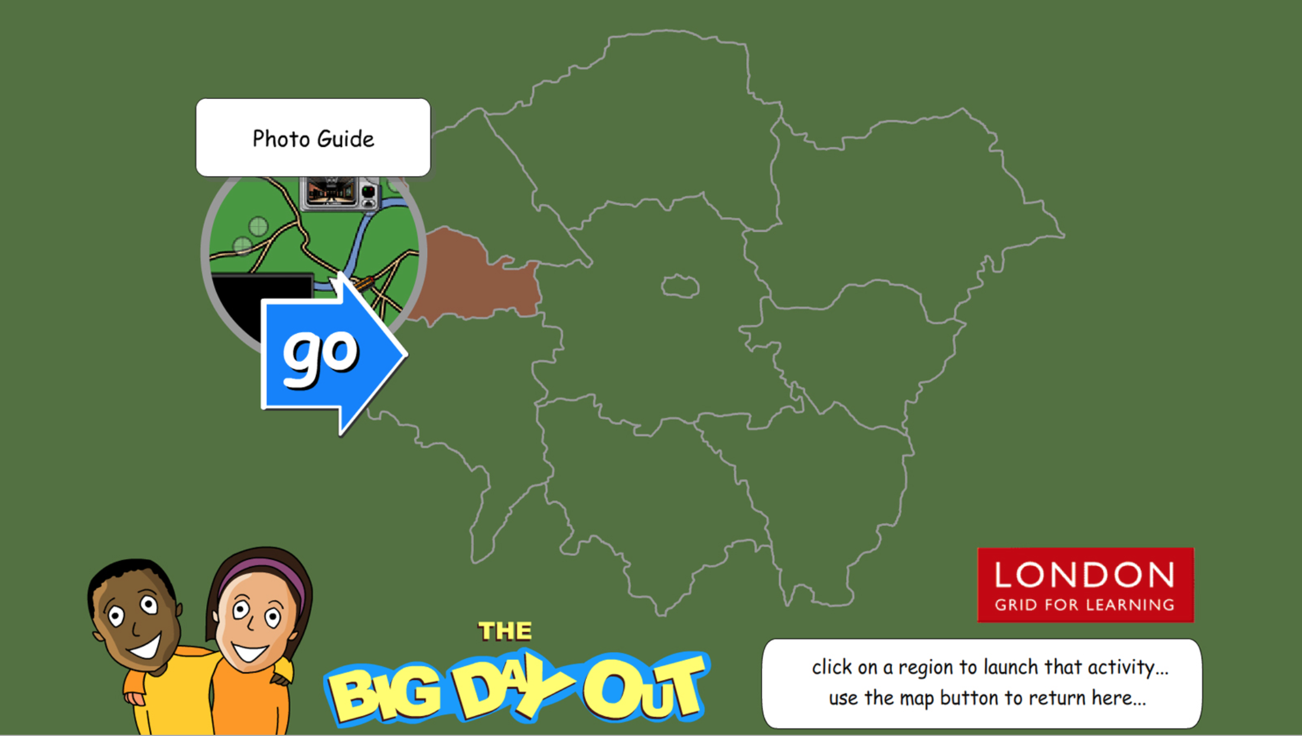 | Explore London and the river Thames with this interactive game within ‘The Big Day Out'  Guide you riverboat along the river Thames to Tower Bridge. Count how many passengers can you pick up along the way before the bridge lowers
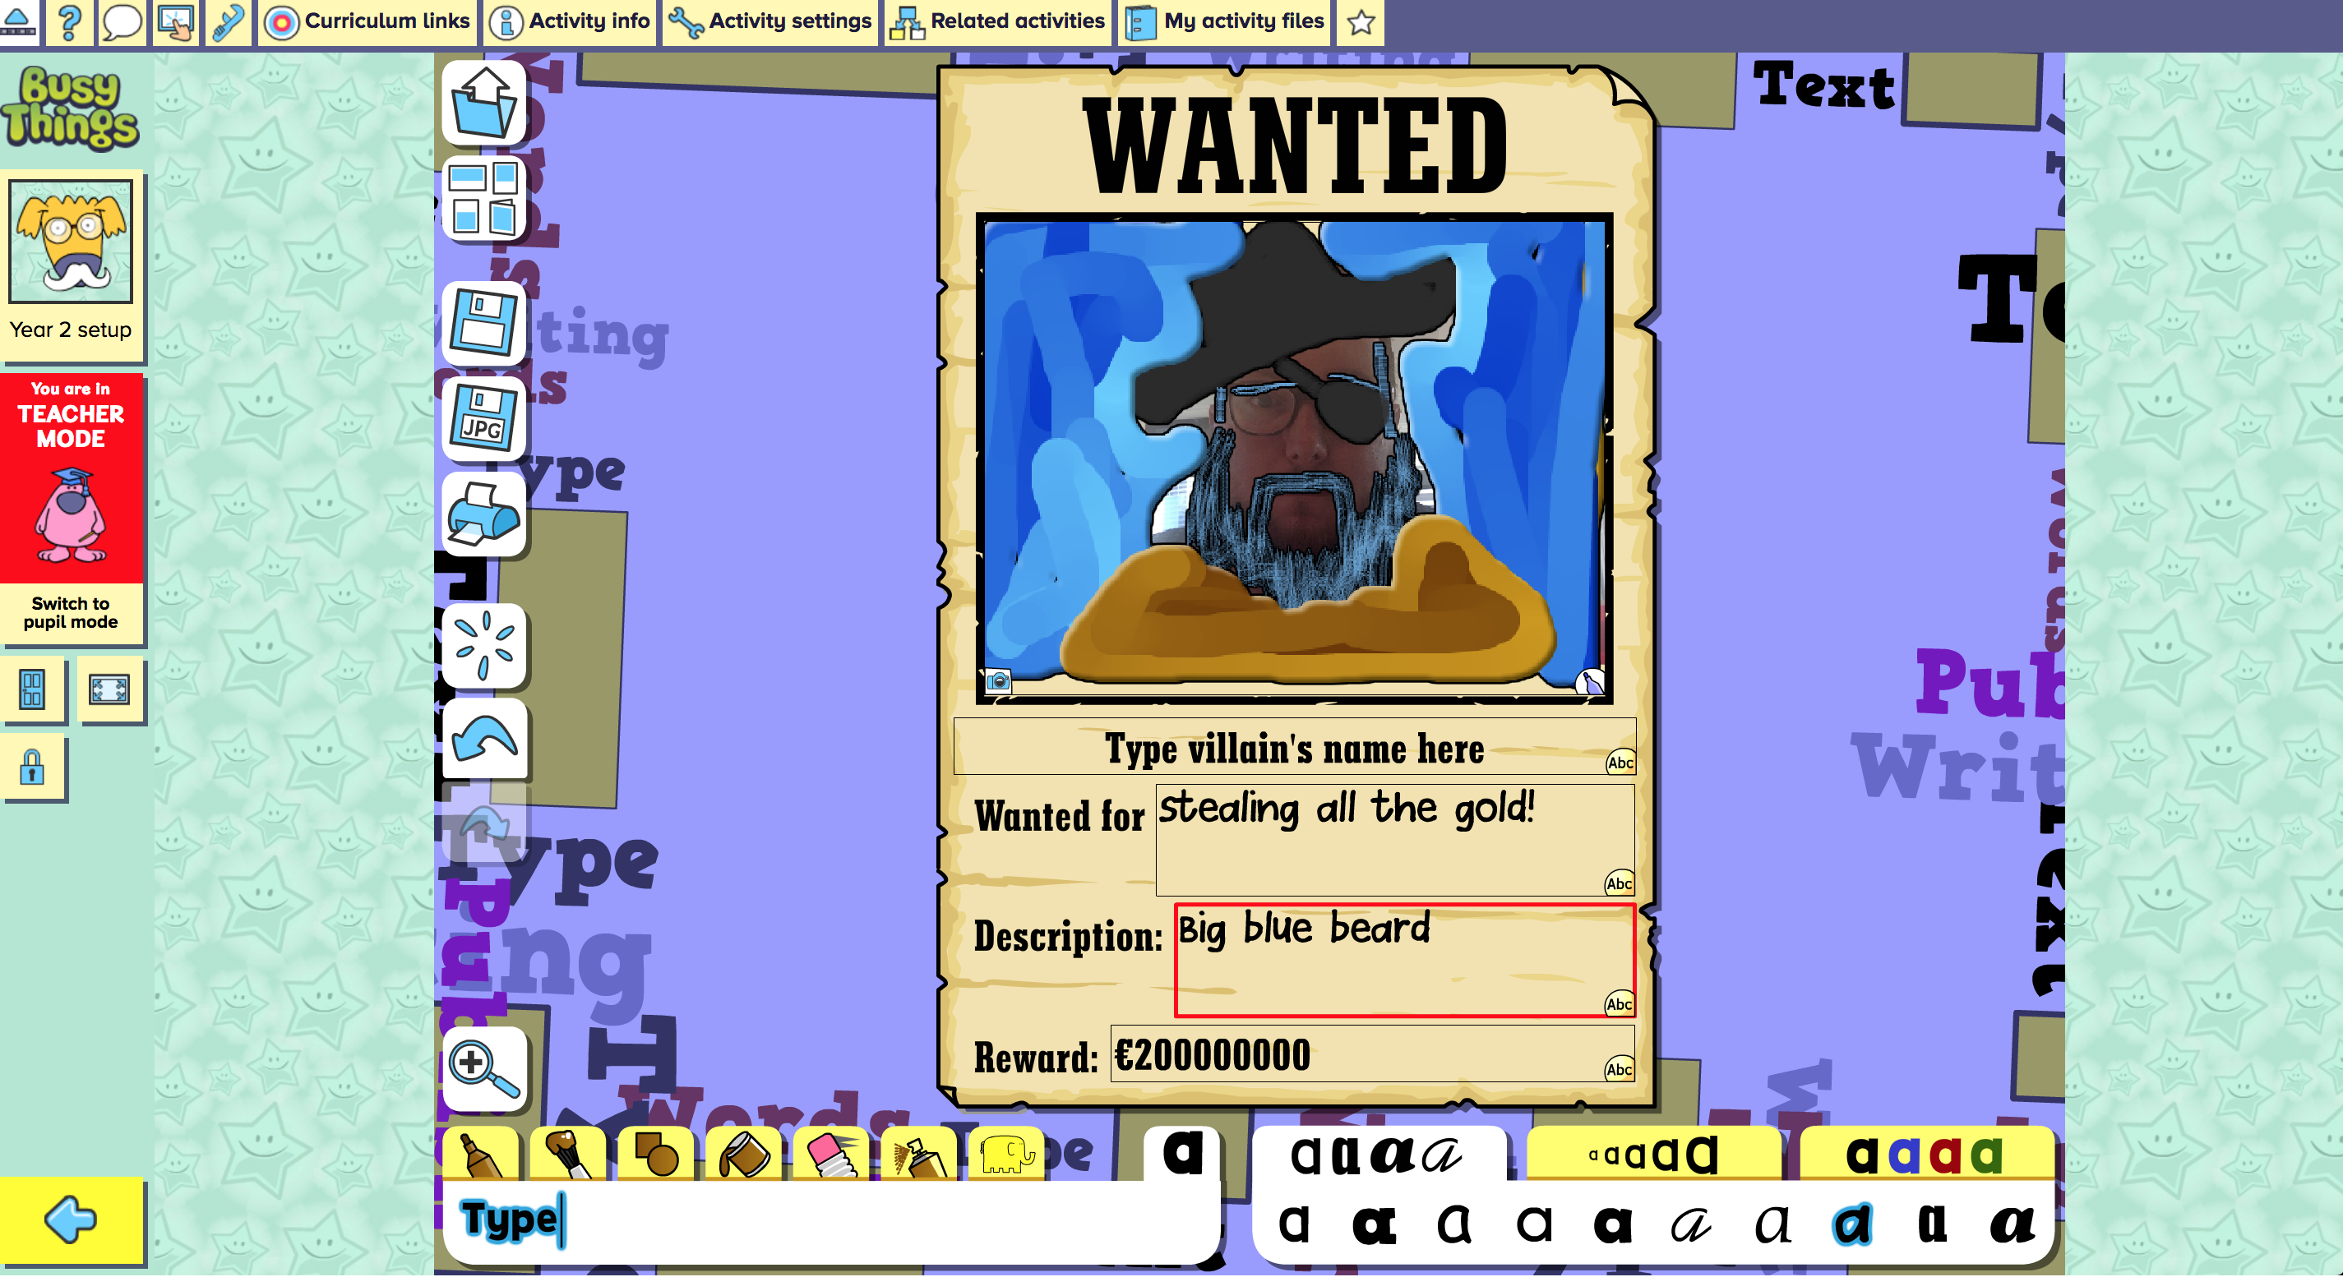 | Explore writing for a purpose and digital skills within Busythings with this interactive “Wanted poster”  You can create your own wanted poster, Draw it all yourself or use some of the stickers to help you.  For added fun, get your students to take photos of each other and drop them into Busythings and edit them using the digital tools.
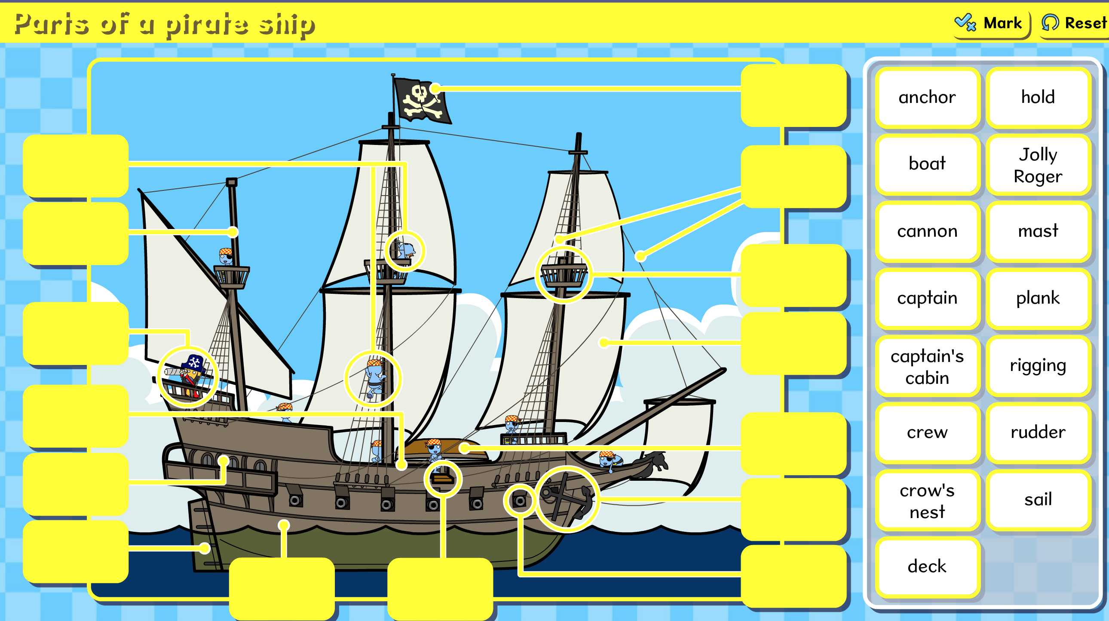 | Learn and demonstrate knowledge with this labelling activity within Busythings resource “Parts of a Pirate Ship”  To enhance this activity have a toy pirate ships in the small world area or create a lager ship outside using wooden blocks, ask children to look at the parts of the ship to help build it.
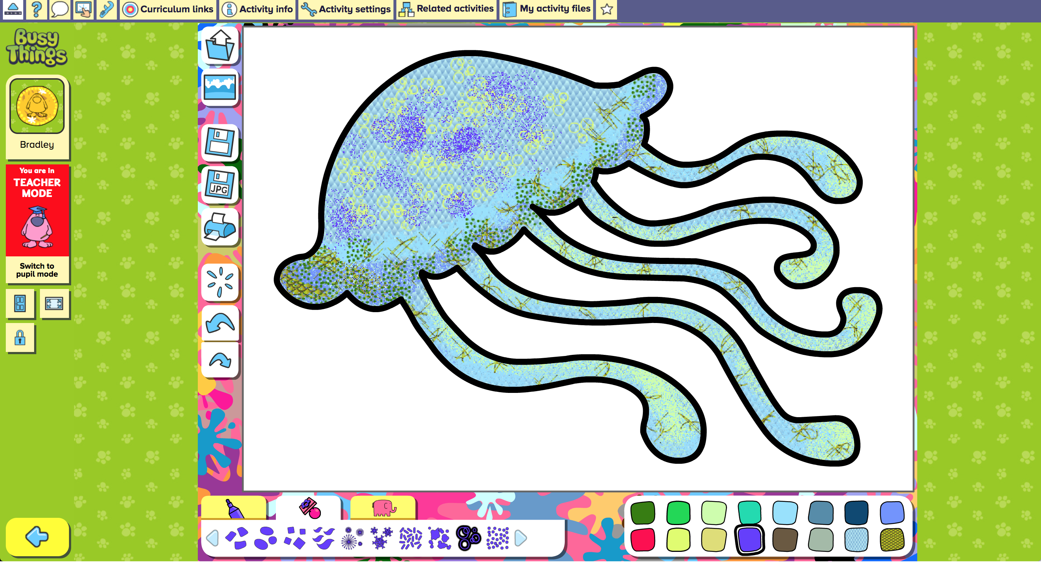 | Explore writing for a purpose and digital skills within Busythings with this interactive template “Sea Creatures”  Make a sea creature. Choose from a fish, shark, octopus, mermaid and many more! Experiment with the different colours, textures and patterns.

