Superheroes
Use JIT infant tool kit “Paint, Animate and Mix” tabs to create a your very own superhero comic book.

Once made get the children to create a voice over by using the microphone feature (You must be using a device which has either an in-built microphone or a microphone attached.
Create you database of favourite heroes or super powers using JIT infant tool kit “Pictogram” tab.
Students can draw they own hero symbols and ask each other about who is there favourite hero and why?students can them add this data into a a Pictogram then using the microphone feature (You must be using a device which has either an in-built microphone or a microphone attached) children can take about the data and answer simple questions such ‘Which hero is the most popular?”
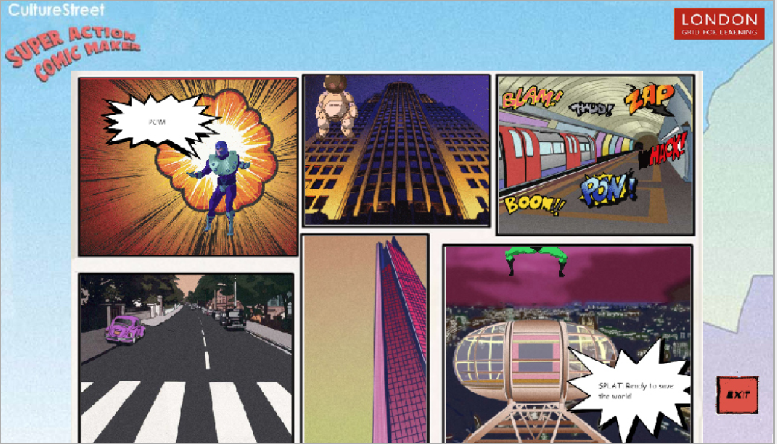 | Create your own comic strip using this simple comic-book maker “Super Action Comic Book Maker”  The resource has a range of comic book clip art that your students can use to make a tale of astonishing adventures.  The strip can be saved online or printed out.
 | Explore various heroic music within our resource AUDIO NETWORK , download your favourite music and get your students to Create super costumes, then use a movie maker app/software and add to create your own superhero movie!
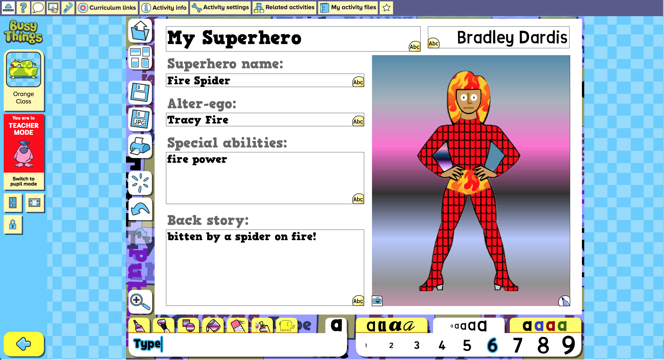 | Explore writing for a purpose and the use of digital creation with this interactive digital template within ‘Busythings’ resource called “My Super Hero”.  Get your students to create and write about your very own superhero choose a superhero and colour him or her in. Experiment with the different colours and fabric textures available. Add boots, gloves, helmets, goggles, emblems and more!
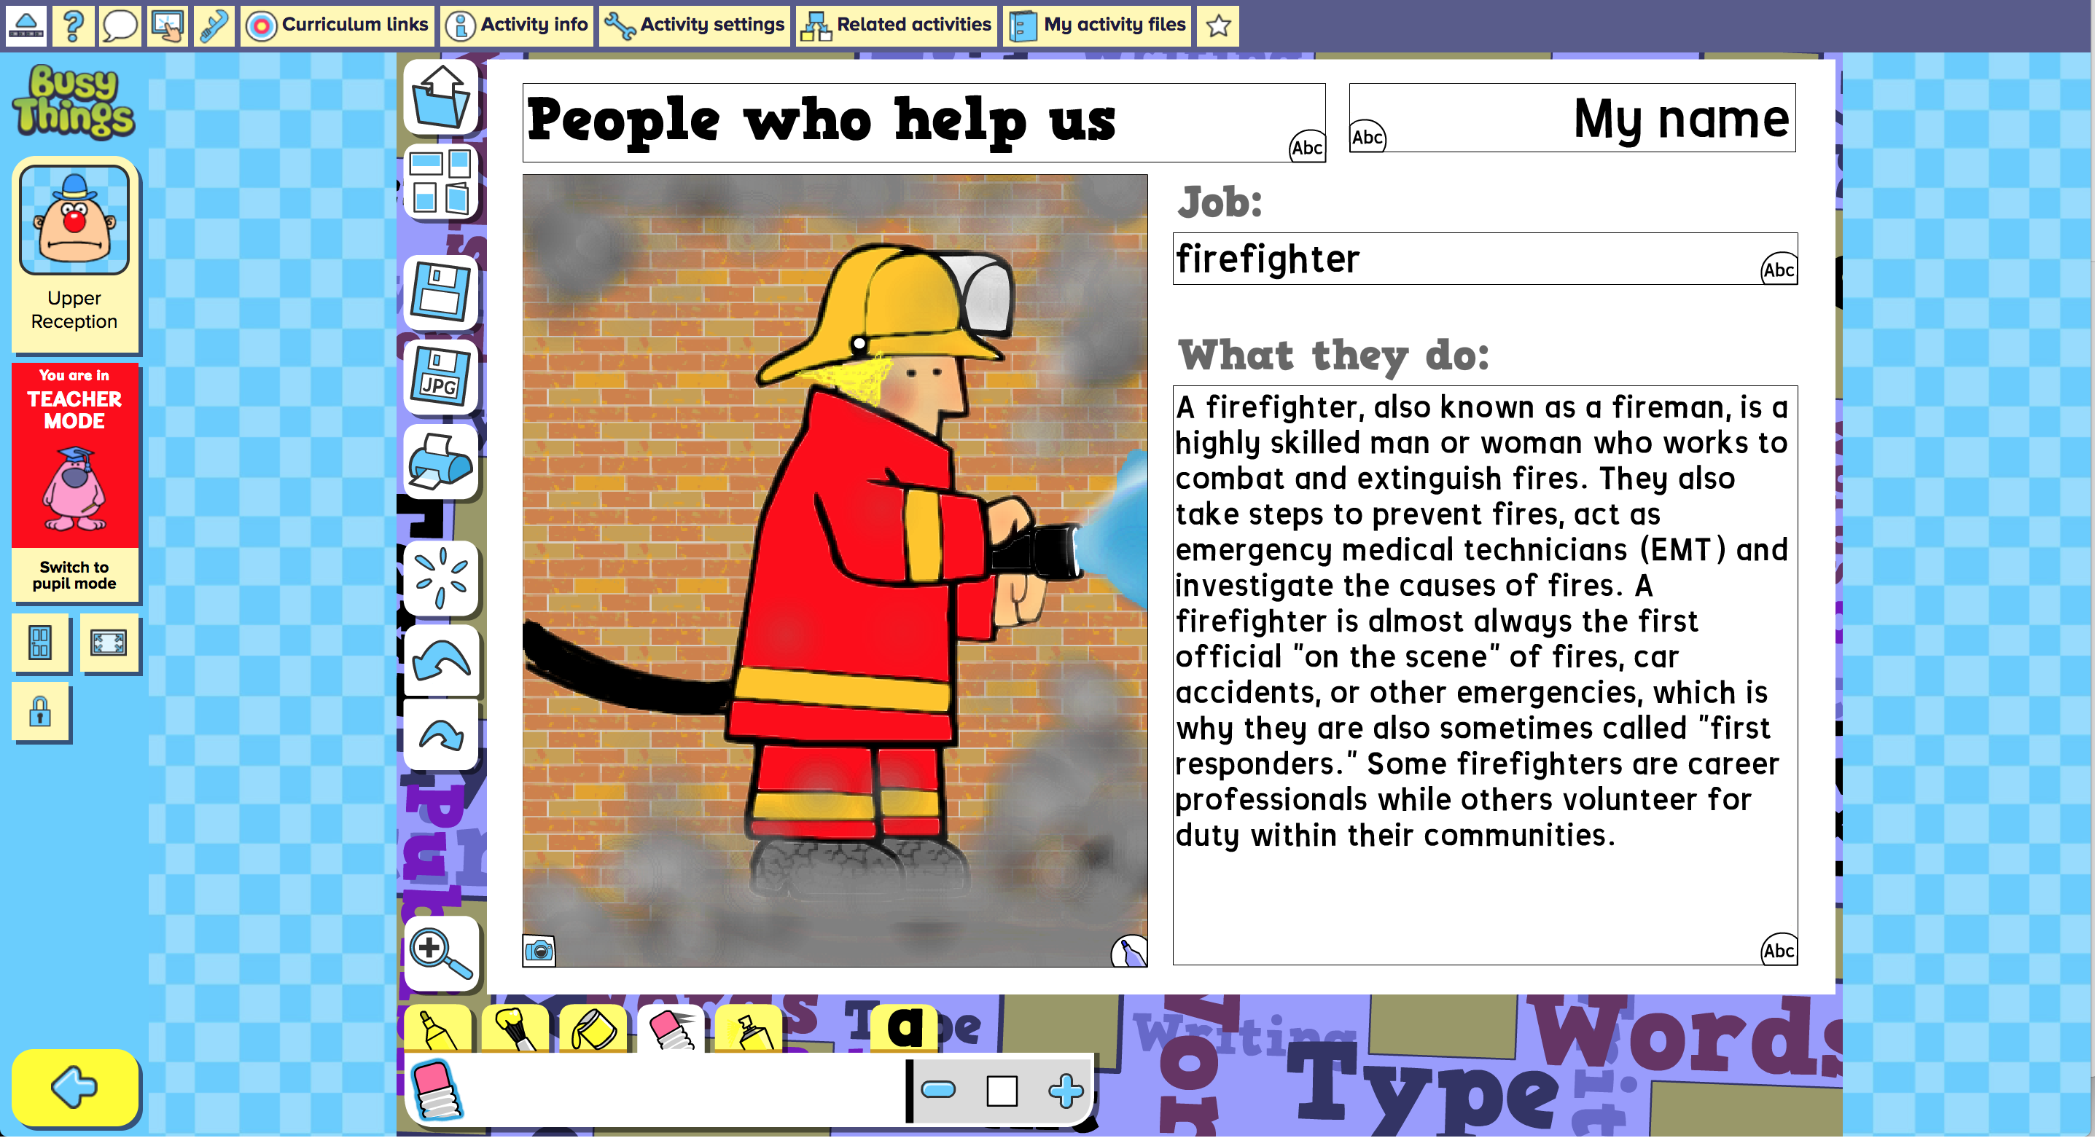 | Explore writing for a purpose and the use of digital creation with this interactive digital template within “Busythings’ resource called “People who help us”.  Choose from a fireman, doctor, bus driver, football coach and many more! Colour in the picture and then write about how these people help us in our lives.
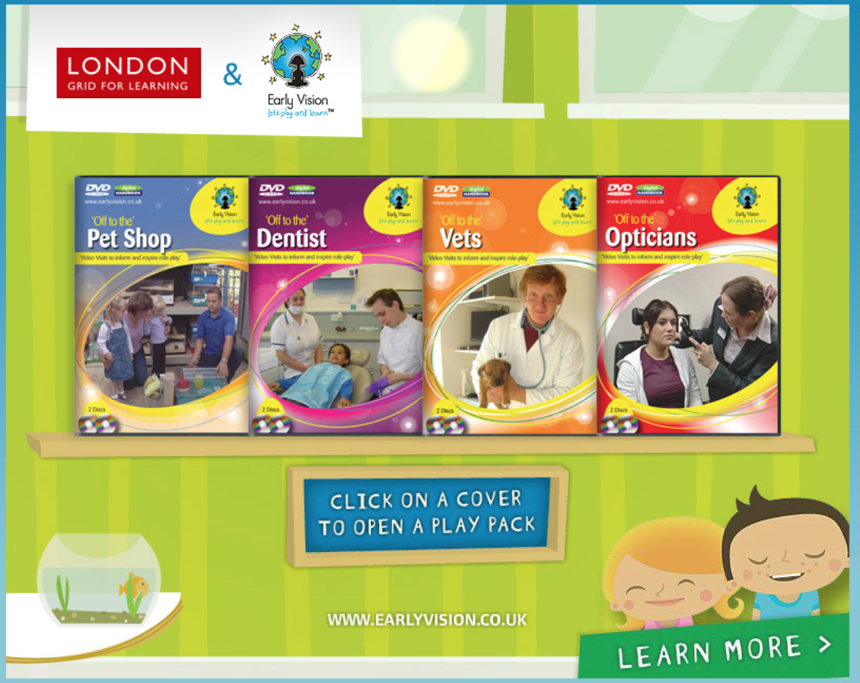 | Within the Early vision resource, you have 2 digital books relating to people who help us, the daywork of a dentist and the day in the life of an optician.  Early Vision videos feature real life scenarios where children get to visit and experience different areas of everyday life.  Within the Early Vision books you will also find digital handbooks with detailed planning to cover all areas.

