My home and Local Area
Go on trip around your local area, take photos with either a camera or tablet (you could even use j2e’s in built camera function) and then use JIT infant tool kit “Mix” tab to create a simple fact book about the important parts of they

Once made get the children to create a narration for the book by using the microphone feature (You must be using a device which has either an in-built microphone or a microphone attached)
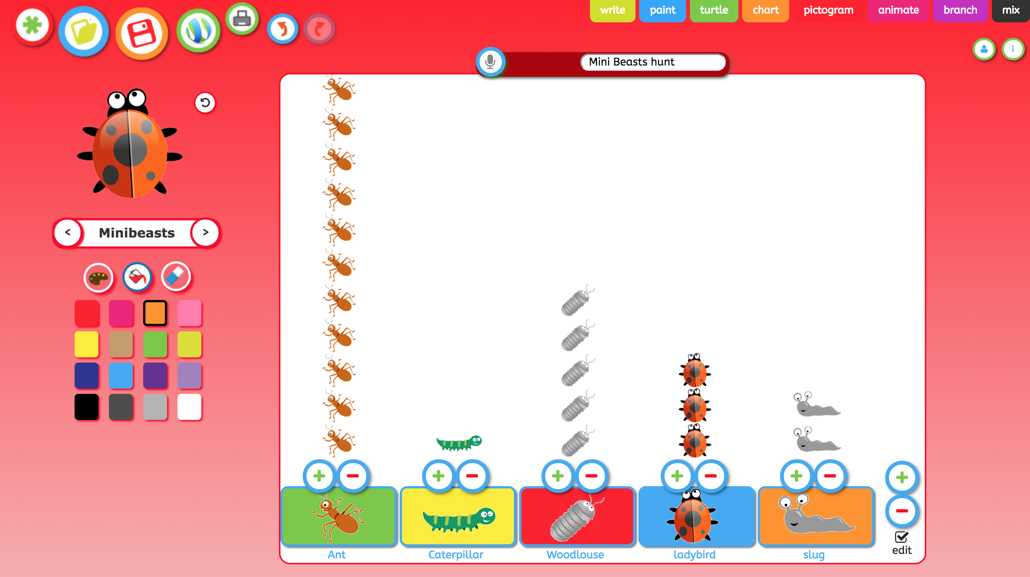 | Ask your students how they travel to school ask your students to curate the data into JIT infant tool kit “Pictogram” , students could draw they own types of transport or use the clip art provided, by using the microphone feature (You must be using a device which has either an in-built microphone or a microphone attached) children can take about the different amounts and answer simple questions such ‘Which type of transport is used the most?”
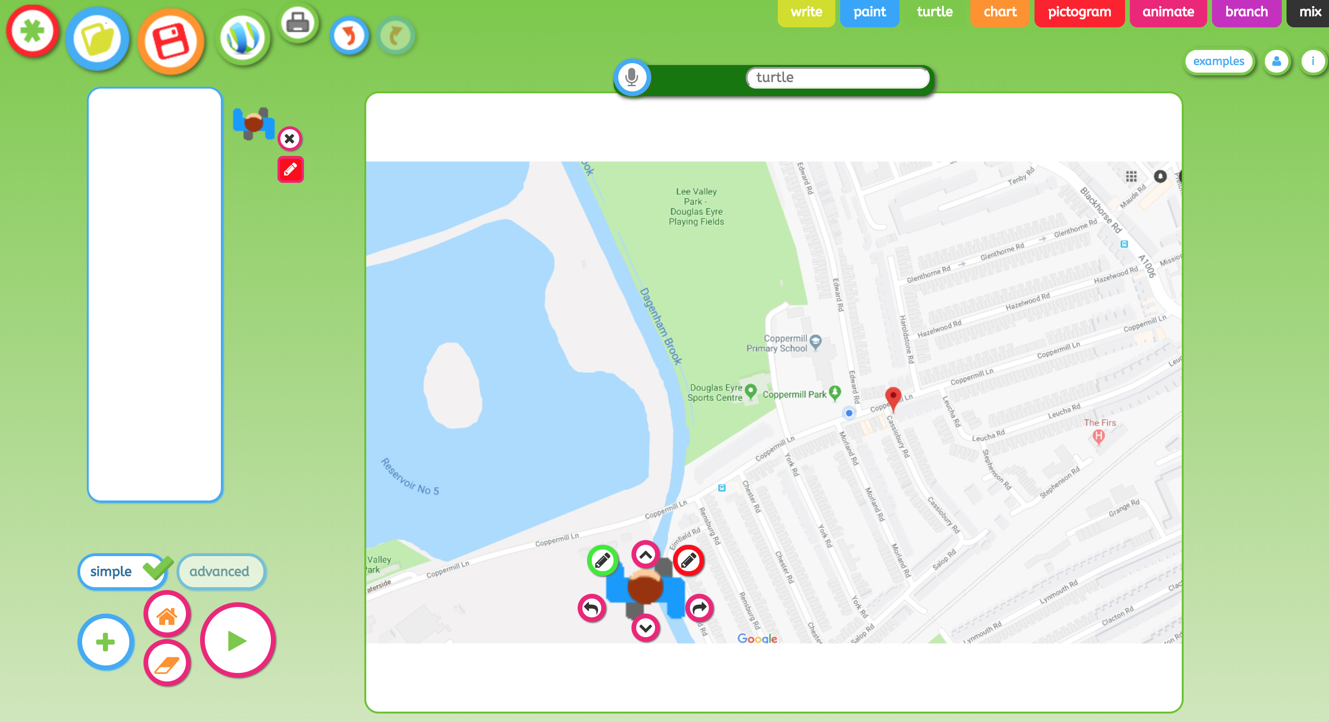 | Use JIT infant tool kit “Turtle” import a picture of you local area (or draw one in paint) use the boy/girl splits and ask your students to give the least amount of instructions/directions to get the sprite to flower. Once made get the children to create a voice over by using the microphone feature (You must be using a device which has either an in-built microphone or a microphone attached.) and give the
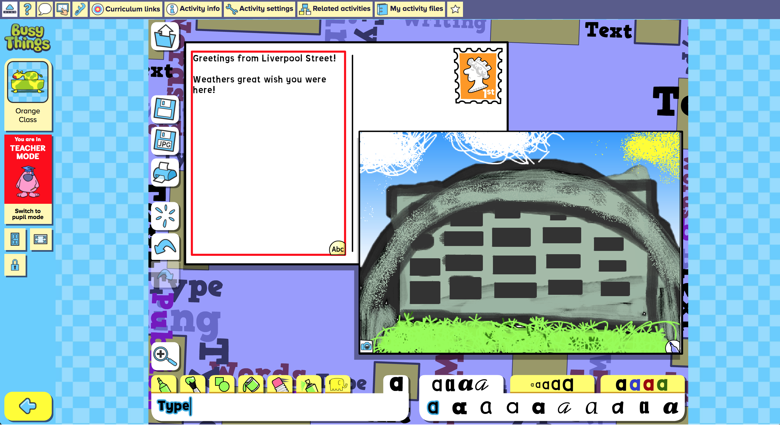 | Explore writing for a purpose and using digital tools with this Postcard from London digital activity within BusyThings.  Go on a trip around your local area. Ask your students to design a postcard from their local area and write a message, it could be a picture of the school or a local attraction
Get out the scissors, card and glue to make a 3D model of the street from the Street Scene game found within Busy Things.
First create the street and then add houses, trees, birds, clouds, characters and cars! A great resource to use within your small world or role play area.
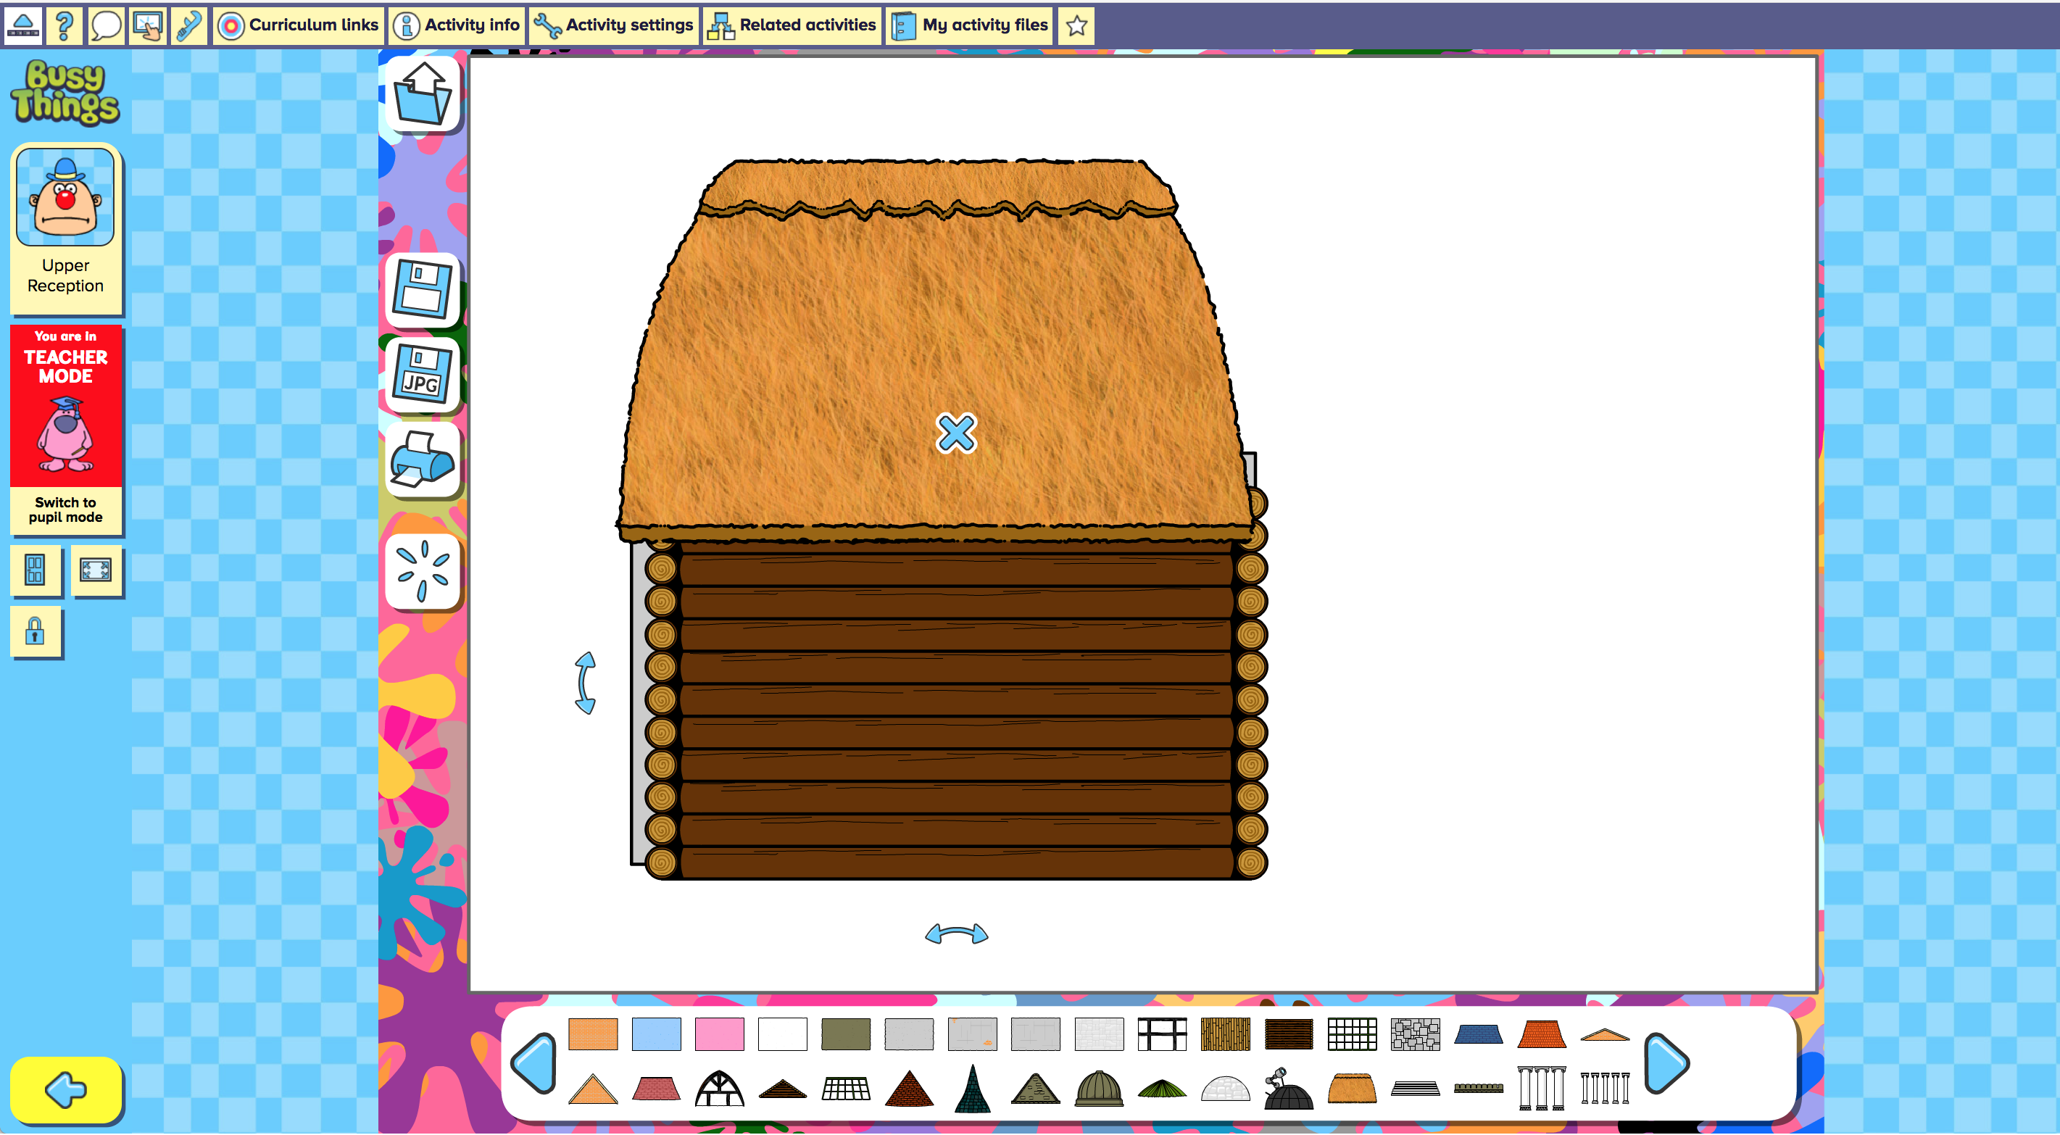 | Explore 3D shapes and using digital tools with this Flat packed buildings digital activity within BusyThings.  Design a building for a town. Drag walls, roofs, windows, pillars and much more into place!
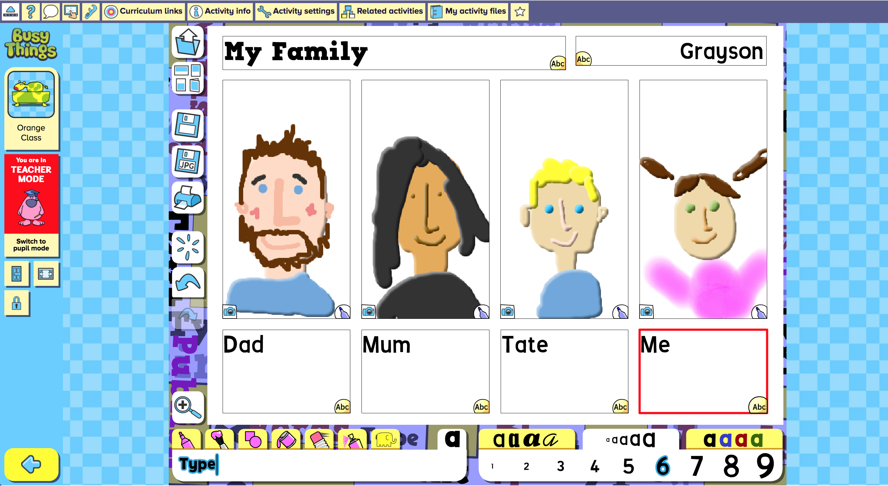 | Explore writing for a purpose and using digital tools with this My Family digital activity within BusyThings.  Draw pictures of people in your family and write about them.
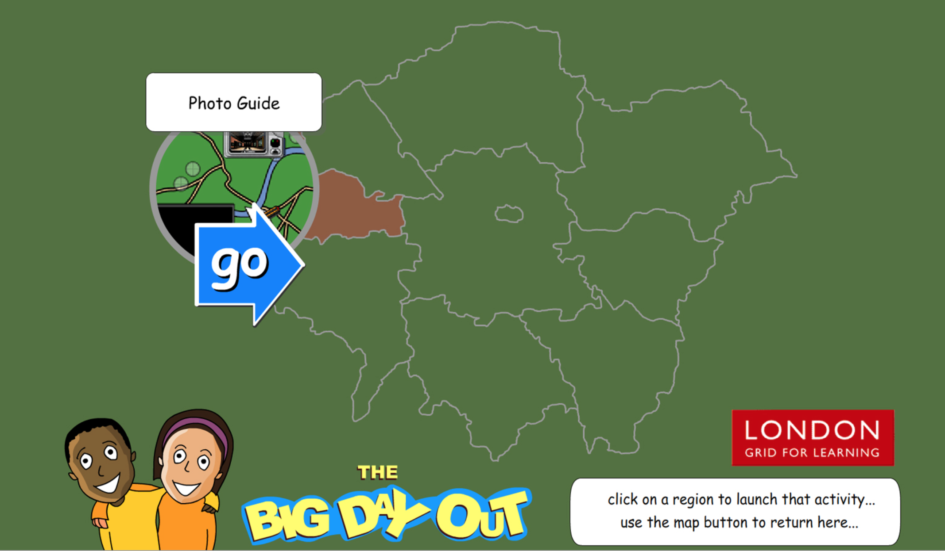 | Explore London with this interactive London map filled with fun interactive digital activities The Big Day Out.  The Big Day Out comes in two versions – one focussing on London- based activities and national version which provides a range of activities from around the British Isles. Actives within the resource incorporate Numeracy, Literacy, Geography, Science and History.
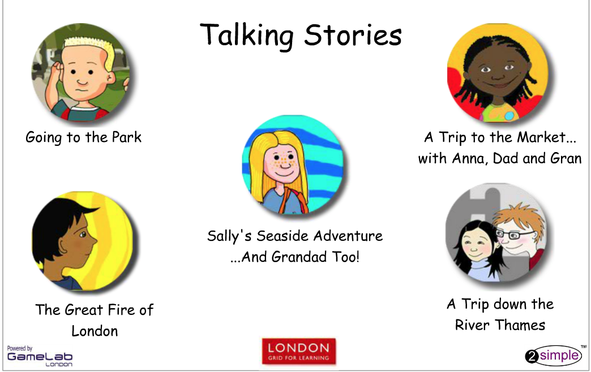 | Explore various types of trips from a “A trip to the Market” to “A Seaside Adventure” with these online talking books produced by 2simple.  The books can be translated in 9 different languages to support EAL learners within your class

