The following content providers have joined the LGfL USO Federation. Membership of the LGfLaai means that some or all of the products these companies provide can be accessed using the LGfL USO, if the school has subscribed to the product.

For further information about specific products accessible via LGfL USO from content providers – please contact the provider directly.
Content provider | Support organisation
 | microsoft.com/en-us/education
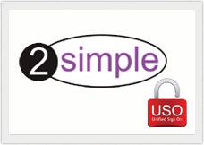 | 2simple.com/contact
 | discoveryeducation.co.uk/what-we-offer/discovery-education-espresso
 | discoveryeducation.co.uk/what-we-offer/discovery-education-secondary
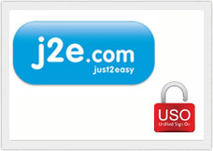 | just2easy.com/contact-us/
 | itslearning.eu/fronter-support
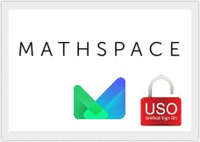 | https://mathspace.co/lgfl/

What is LGfLaai?
The London Grid for Learning manages its own access management system called the LGfL Authentication and Interoperability Federation (LGfLaai). The Federation was set up to allow schools to use the USO (unique sign-on) system to access resources and platforms they have subscribed to from third-party organisations without needing new login credentials. LGfLaai ensures that the use of data that is used between online services complies with the data Protection Act.

How does LGfLaai benefit schools?
Schools can use the LGfL USO log in to access additional, non LGfL 2.0 services, via the LGfLaai. Teachers and pupils do not need to remember more than one log in to access all their day to day online services.

What the benefits of LGfLaai to content providers?
LGfLaai members can use the ease and convenience of the existing LGfL USO service in LGfL-connected schools to provide access to their licensed content or online service.

Is there any LGfL editorial evaluation of the content provided by LGfLaai providers?
LGfL operates a strict quality assurance process on all LGfL 2.0 online learning resources via the LGfL Editorial Board. However, there is no equivalent editorial assessment on the quality, suitability or appropriateness of LGfLaai members content or services. The responsibility is on the school to ensure that any LGfLaai content provider service or resource meets the needs of their school community.

However, all members of the LGfLaai have to pass a thorough application process that ensures data security requirements that guarantee that pupil data is safe and secure and will not be viewed by anyone that is unauthorised. Performance of related online systems that provide access to the resources is also scrutinised.

What is the process to join LGfLaai?

All enquiries regarding joining LGfLaai should in the first instance be directed to contentsupport@lgfl.org.uk.

Potential LGfLaai content providers will need to complete an online registration process, which includes entering into a contract guaranteeing data security and online-safety requirements.

How much does it cost for a service provider to join LGfLaai?
There is a nominal admin charge of £300 (incl VAT) to cover the cost of joining LGfLaai. There is no further charge for LGfLaai service providers after the initial registration has been successfully completed.

What are the requirements of joining LGfLaai?
All LGfL Federation members are required to sign a non-disclosure Agreement (NDA) that covers the documents that outline the LGfLaai. The NDA must be completed before any access can be granted to the detail of the LGfL Federation framework.

Content providers will be expected to guarantee compliance with all requirements of the Data Protection Act regarding the security, validity, accuracy and completeness of all data contained within the LGfLaai. The Federated Service Provider will also be expected to provide the CRB number or Criminal Convictions Certificate of the person(s) within the content provider that will have access to data contained within the LGfLaii.

