How-To Manage Licenses
There are several options to manage licenses for users at your school. The following describes each option, starting with where to view your available licenses.

Viewing Available Licenses in the Microsoft Store for Education
- To access your licenses, sign into the Microsoft Store for Education
- After you've signed in, select Manage from the top menu
- Select Products & Services from the left-hand menu
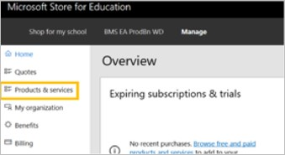

- Locate Minecraft: Education Edition from your list of products and services
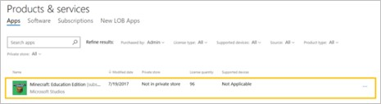
Note: You may see multiple lines for Minecraft: Education Edition depending on how M:EE licenses were purchased or many different purchases have been made. Additionally, one line for M:EE will show "Unlimited" licenses available, which indicates the Trial version of the app is available to an unlimited number of users in your organization.

Auto-Assign Licenses
Auto-assigning licenses will automatically assign a license to a user in your tenant when they sign into Minecraft with their Office 365 credentials. This is especially useful in large deployments where an entire school or school district has purchased licenses.
By default, auto subscription assignment is turned off. To turn on auto-assign, simply locate the Auto-claim a license toggle and turn it on.
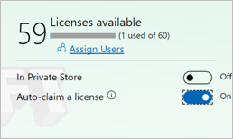
Once all of your licenses have been claimed (if you do not have org-wide licenses), students or teachers who have not yet been assigned licenses will automatically move to the trial mode of the game (25 logins for teachers and 10 for students).

Managing Licenses Individually or via Office 365 Groups
You can manage licenses individually or via Office 365 Groups in the Microsoft Store for Education.
- First, ensure that Auto-claim a license toggle is off
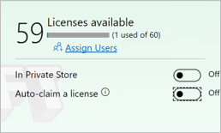
- Click Assign Users
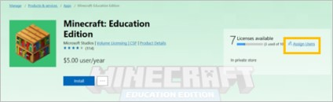
- Enter the name of students, teachers or groups to whom you would like to assign licenses.
The field will auto-complete for users/groups in your tenant
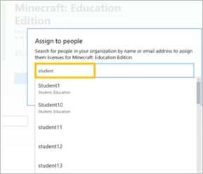

- When you have input the users or groups you'd like to assign licenses to, click Assign
You can see the list of assigned users and the list of users with a Full Version (i.e. license assigned) and a Trial Version license by switching between the tabs on the bottom of the manage page for M:EE.
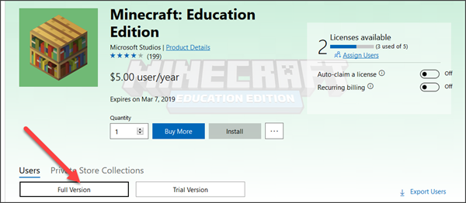

Assigning Licenses in Batches
The Microsoft Store for Business and Education provides a PowerShell module to allow an administrator to manage M:EE license assignment in batches.
For full instructions on using the PowerShell module, see
Microsoft Store for Business and Education PowerShell module

Help with Managing Licenses
If you require any type of support related to licensing (including auto-assign, powershell or O365 groups, please contact support for the Microsoft Store for Education by visiting http://aka.ms/edustoresupport.

