Installing Code Connection and Classroom mode:

Currently, Minecraft: Education Edition supports two applications designed for classroom use, Classroom Mode and Code Connection. This article will explain how to install both applications. As such, it is fairly long. If you are have already installed these applications, please visit these two pages instead: Getting Started with Classroom Mode or Getting Started With Code Connection.
Please note you can only be connected to one additional application at a time, in addition to running Minecraft: Education Edition. This article will cover:
- Classroom Mode
- Code Connection
- Additional Resources
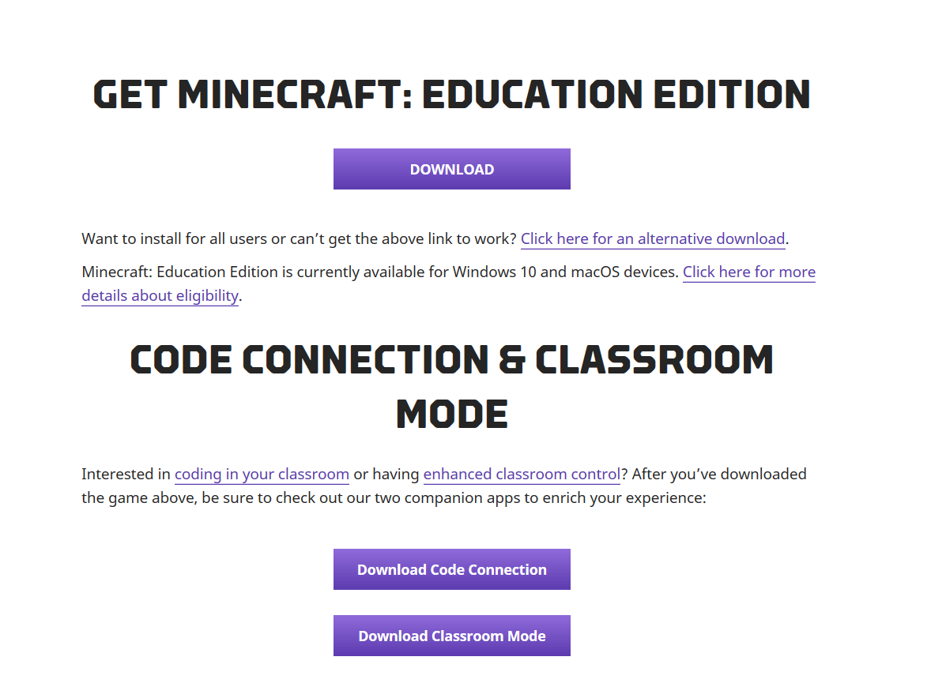
Classroom Mode
Installing Classroom Mode
- Download the latest version of the application
- Run ClassroomModeSetup.msi
- If prompted, select “More Info” and “Run Anyway”
- Install with default settings
Classroom Mode for Minecraft should place a Classroom Mode for Minecraft icon on your desktop. It will also appear in your Start Menu as “Classroom Mode for Minecraft” under a folder titled “Minecraft Education Edition”. Now you are ready to get started or continue to installing Code Connection.

Code Connection
Installing Code Connection (Windows 10)
- Please make sure you are running the latest version of Minecraft: Education Edition (1.0.28)
- Go to the Minecraft: Education Edition download page. Select the “Windows 10” button for Minecraft: Education Edition. Download the software.
- After downloading the installation files, simply run codeconnection.msi to install. It will walk you through the install wizard for Code Connection.
- If you are prompted by a “user account control window”, you should click “yes”.
- If you receive a Windows Firewall prompt, you should click “allow access”.
- You’re ready to check out our article about Getting Started With Code Connection.

Additional Resources
- Download Classroom Mode, Code Connection, or both for Windows 10 and macOS
- Getting Started With Code Connection for links and ideas to try with your new Agent
- Code Connection: API Documentation
- Getting Started with Classroom Mode and setting up Multiplayer Games

