This guide will cover:
- Step-by-step installation instructions for Windows
- Additional Resources

1. Head to: https://education.minecraft.net/get-started/download/
2. Select "Download"
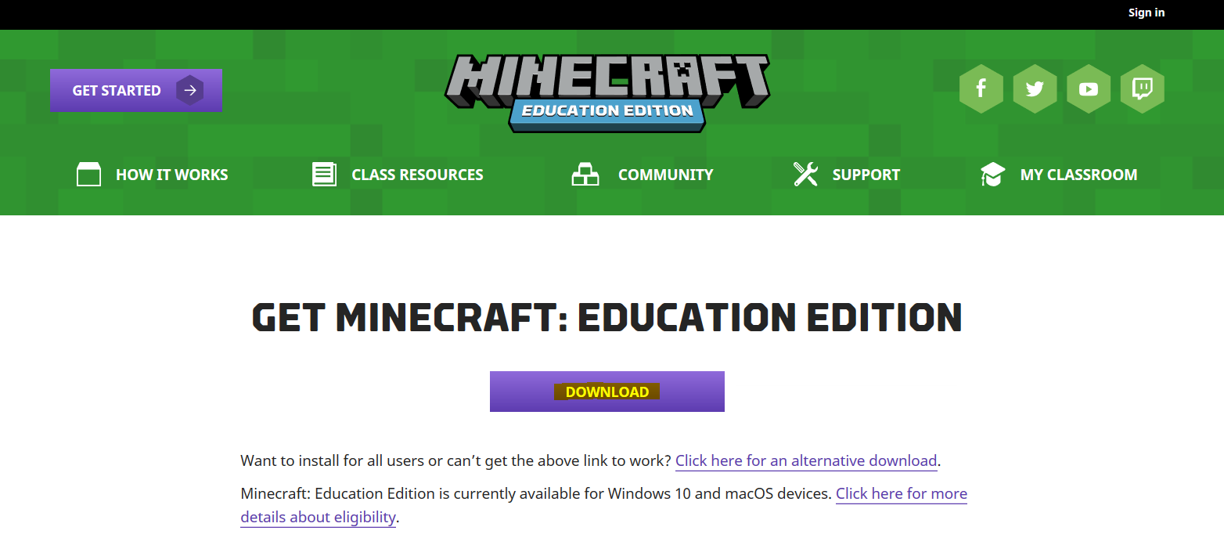
3. A window will pop up asking if you want to install. Select "Install". Ensure launch when ready is checked
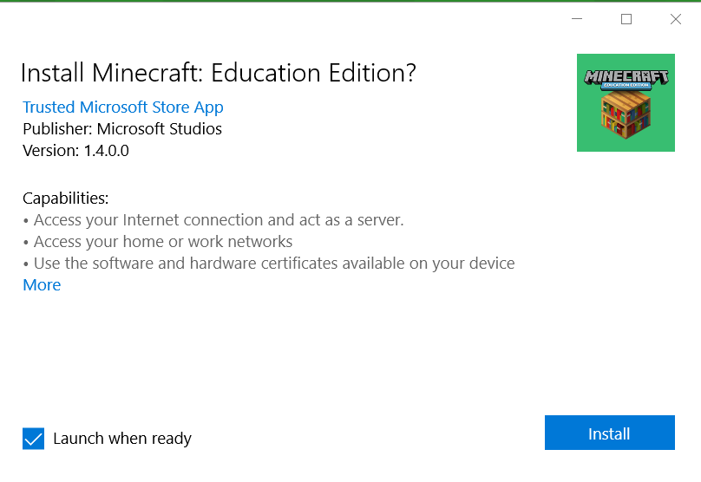
4. Wait for the application to finish installing
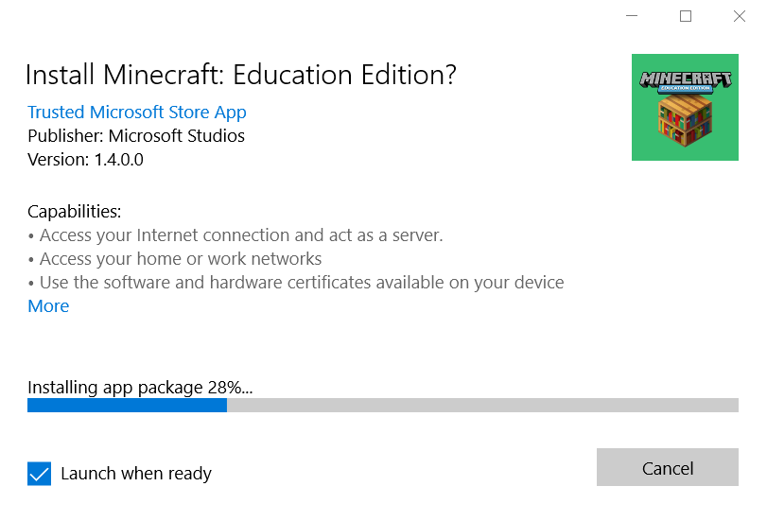
5. Upon completion the game will launch and ask for sign in credentials. Sign in with your Office 365 account to access the game.
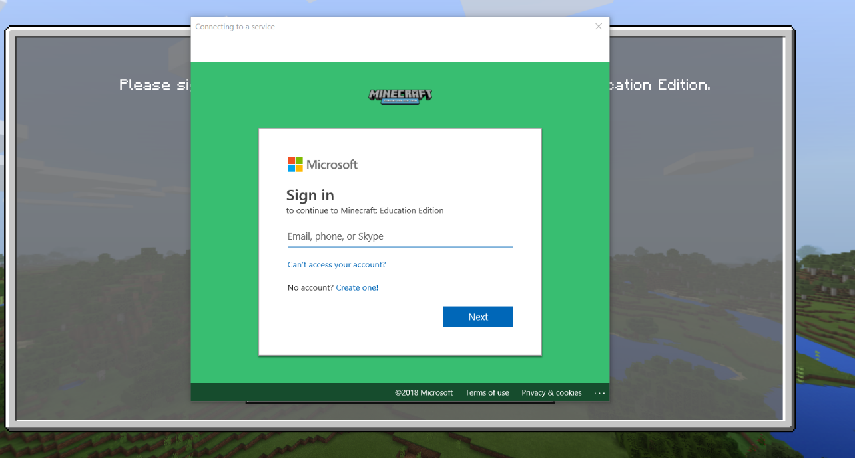
6. A successful sign on will bring you to the M:EE start screen
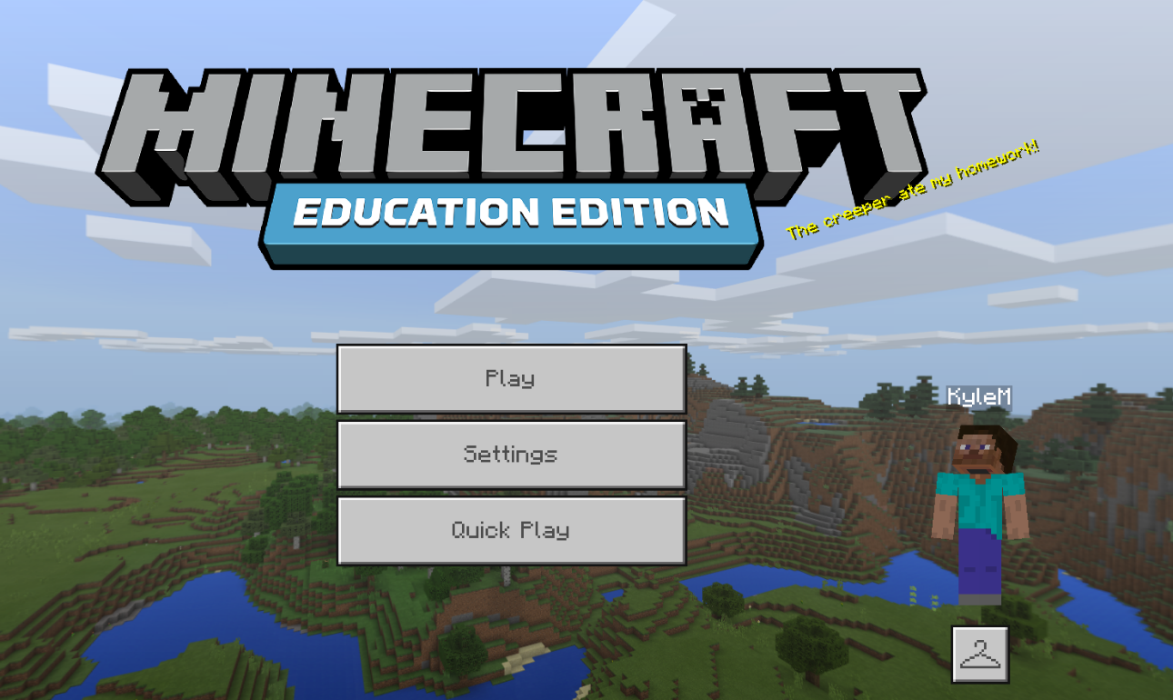
7. In order to download Classroom Mode or Code Connection. Access the same link listed in Step 1: https://education.minecraft.net/get-started/download/. Select "Download Code Connection" Or "Download Classroom Mode" and select "Run"
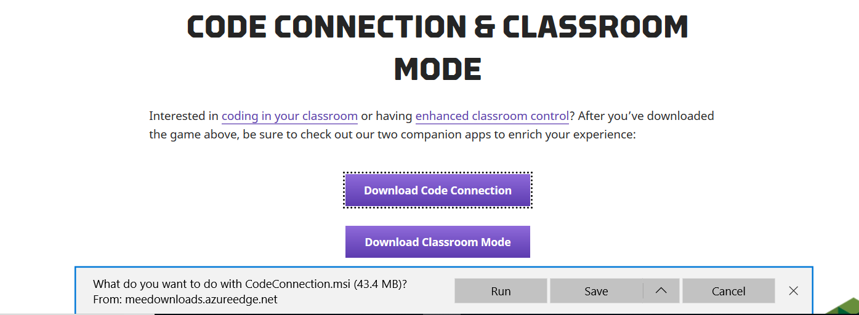
8. Select "Next"
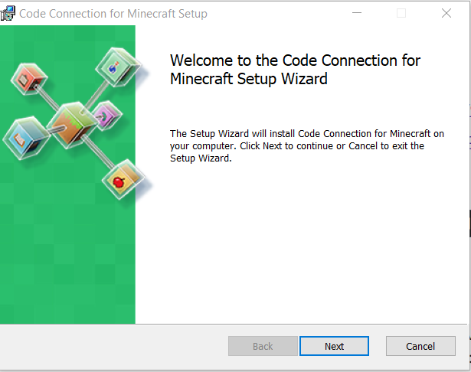
9. After Download completes select "Finish"
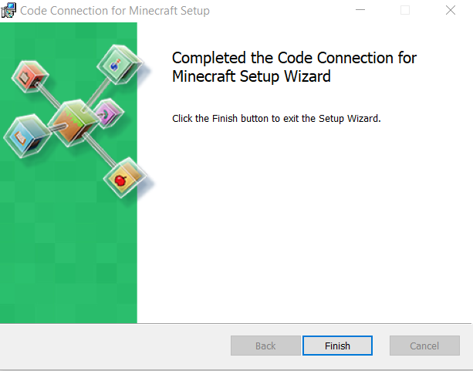

Additional Resources
For more information you can check out our supported platforms and specifications article.
Windows 10 can be purchased as a digital download or a boxed product from the online Microsoft Store, with special savings for students, parents, and faculty. To upgrade to Windows 10, you can click here for information.
Need to troubleshoot? You may always contact support if you run into any technical issues, or the issue you are seeing is not covered in our Basic Troubleshooting Knowledge Base article.

